2B AZURE ACCOUNT CREATION AND PRACTICE

DEFINITION :
- What is Subscription
- A subscription is an agreement between you (or your organization) and Microsoft to use Azure services. It provides:
  - Access to Azure resources (like virtual machines, storage, databases, etc.)
  - A billing boundary, meaning all usage and costs within that subscription are billed together.
  - A security and management boundary, meaning you can assign roles, policies, and access controls per subscription.

- What is Spot Discount
- A Spot discount in Microsoft Azure means you can rent unused cloud capacity at a much cheaper price.

Here’s how it works:
- Azure has extra computing power (VMs) that isn’t being used.
- You can “bid” or use these machines at a big discount (often up to 80–90% cheaper).
- But — if Azure needs that capacity back, your spot VM can be stopped or deleted at any time.

Advantage = Pros: Much cheaper.
Disadvantage = Cons: Not guaranteed — your workload might be interrupted anytime.

- What is Tag in Resource Group
- A Tag in an Azure resource group is like a label you attach to help you organize and manage your resources.

Each tag is made of two parts:
- Name (key) → like a category (e.g., Environment)
- Value → the specific detail (e.g., Production)

- While creating account you can use password or public key
- Key will be downloaded in ,ppm format change to .ppk to load and login

==================================================================================

- How to Create an Azure Account (Free Tier)

- How to Create an Azure Account.
- Enter portal.azure.com in URL
- Click on Create account
- You can Open https://portal.azure.com/auth/login/ page

Follow the steps :-

- Requirements
Before you start, you’ll need:

- A Microsoft account (Outlook/Hotmail).
If you don’t have account
- Create one account : https://signup.live.com

- A credit/debit card (for identity verification only — you won’t be charged unless you upgrade).

- VISA or Master Card only

- A phone number for verification.

- Multiple users can use a single account.

- 🧭 Step-by-Step Guide

- Go to Azure Free Account Page
- Search for “Azure Free Account” or go to:
https://azure.microsoft.com/free
- Click Start free.

- Sign in with your Microsoft Account
- If you don’t have one, you can create it on the same page.

- Fill in your Identity Details
Microsoft will ask for:
- Your name
- Country/Region
- Preferred email

- Verify Your Phone Number
- Choose SMS or Call, enter the verification code.

- Verify Your Credit/Debit Card
This is required to prevent fraud.
Microsoft will place a small temporary authorization (₹2 or $1) and refunded in 2 days.
No charges unless you manually upgrade.

- Accept the Agreement
Review and accept:
- Microsoft Azure Agreement
- Offer terms
- Privacy statement
- Click Sign up.

- Start Using Azure Portal
You’ll now be redirected to the Azure Portal:
https://portal.azure.com

You’ll get:

- 🎁 Free Benefits
- $200 (₹16,500 approx.) credit for 30 days, on 31st day it will be deactivated
- 12 months of free services, such as:
- Azure VMs (Linux/Windows — specific sizes)
- Azure Blob Storage
- SQL Database (limited)
- Functions
- Key Vault

- Always-free services, like:
  - Azure DevOps
  - Static Web Apps
  - App Service (Free tier)

- 🧪 After Account Creation — What to Do?

Here are recommended practice areas:
- Create a Virtual Machine
- Deploy a web app using Azure App Service
- Create a Storage Account
- Use Azure Functions (serverless)
- Create VNets and Subnets
- Try Azure DevOps Pipelines

==============================================================================

Microsoft Entra tenant can have multiple subscriptions, with the limit being
300 license-based subscriptions and
unlimited Azure subscriptions.

Resource Group = Logical object = Logical Boundary
1 Subscription = 980 Resource Groups
1 Resource Group = 1000 Virtual Networks
1 Virtual Networks = Size of the Virtual Networks address space or 3000 Subnets
1 Subnet = 251 VM

To run VM we need CPUs and RAM
For free account limit is 4 CPUs, 4 Cores and 8GB RAM

But VM needs Ram and CPU
So practically we need high RAM and CPUs and it needs high cost

===============================================================================

- Software required to login Virtual Machine depends on OS
- To login for Windows VM you need to select Windows server and use any one of these
  - RDP (default in Windows)
  - Moba XTerm

- To login ubuntu/ Linux use Software
  - Putty
  - MobaXteam

- In Linux after logging you can observe
  - $ - Normal user
  - # - root user

LAB PRACTICE

- CREATE VIRTUAL MACHINE
- Requirement
- Create Resource Group
- Select Subscription Name or id :
  - For free tier : select the default
  - For paid : having multiple your choice
- Resource Group name : any
- Region : any Region.
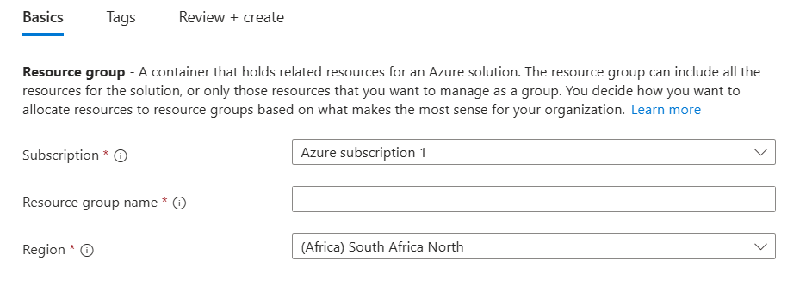

- Click on create Resource Group

- Create a Virtual Network
- Select Subscription : Free account ( Default one ), Paid ( Your choice )
- Resource Group : Your choice or nothing present create one
- Virtual Network Name : any
- Region : any

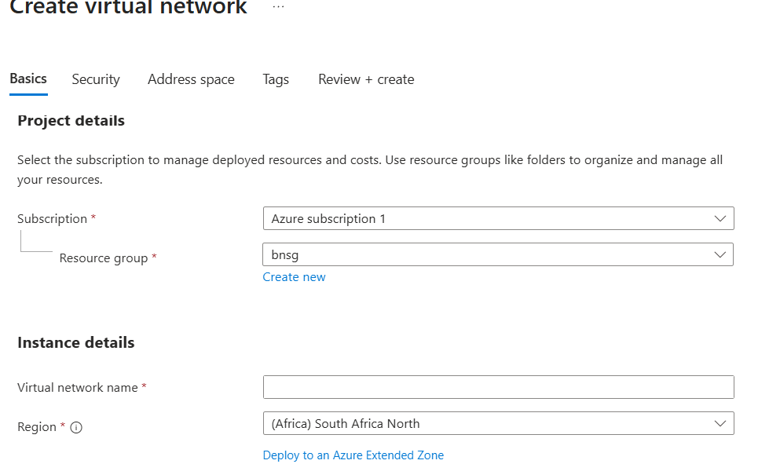

- Private range : ( 10.0.0.0/16, 172.16.0.0/16, 192.168.0.0/16 )
- Under subnet section :
  - Subnet name : any
  - Subnet range : based on virtual network range /24

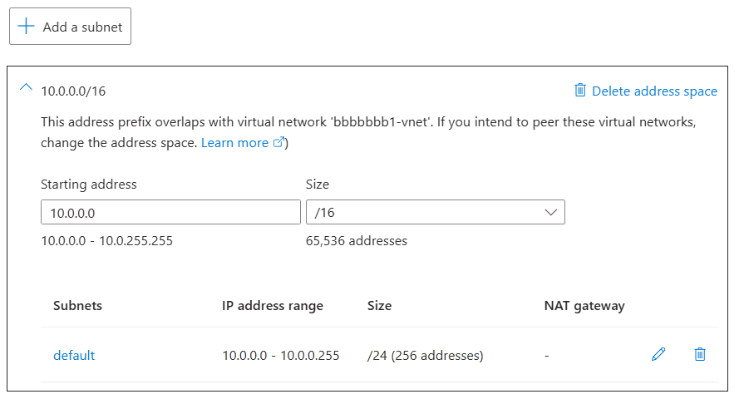

- To add more subnets, click on Add a subnet

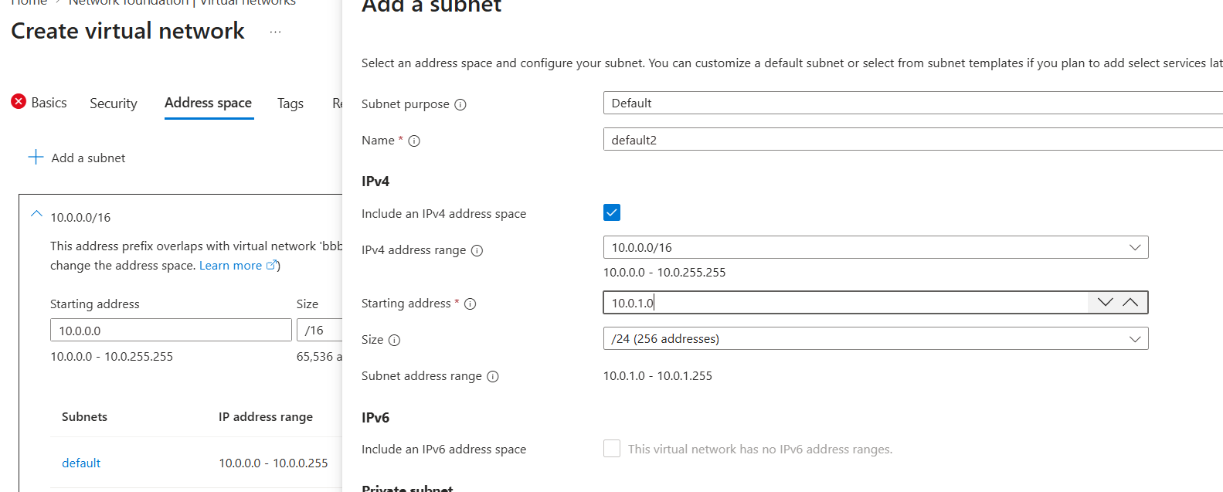

  - From 3rd octet like 3rd number you can change any number

- While creating VM
- Follow these steps
- Under Basic Tag
- Subscription : select your Sub
Ex : Azure subscription 1
- Resource group : Select yours or click on Create new for instant creation

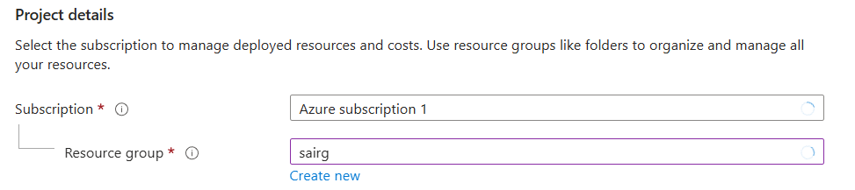

Instance details
- Virtual machine name : Provide name
- Region : Select Region ( for practice East Asia, Japan or India )
- Availability options : No infra
- Security type : Standard

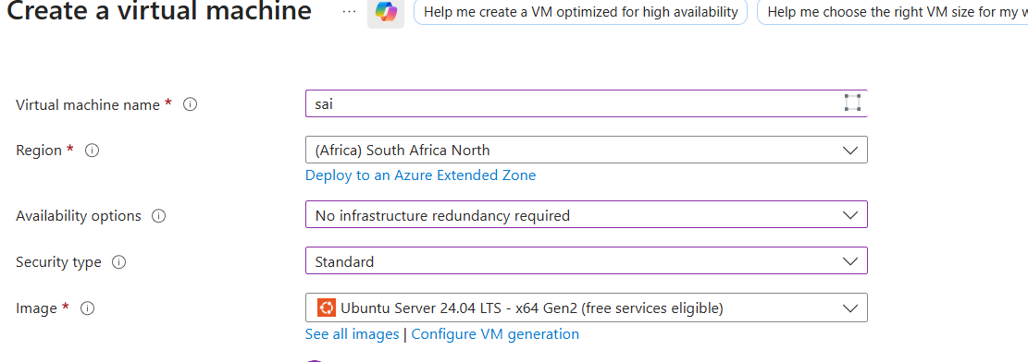

- Image : Ubuntu Server 24.04 LTS - x64 Gen2(free services eligible)
or for windows
Click on See all images type windows , you can find in this way

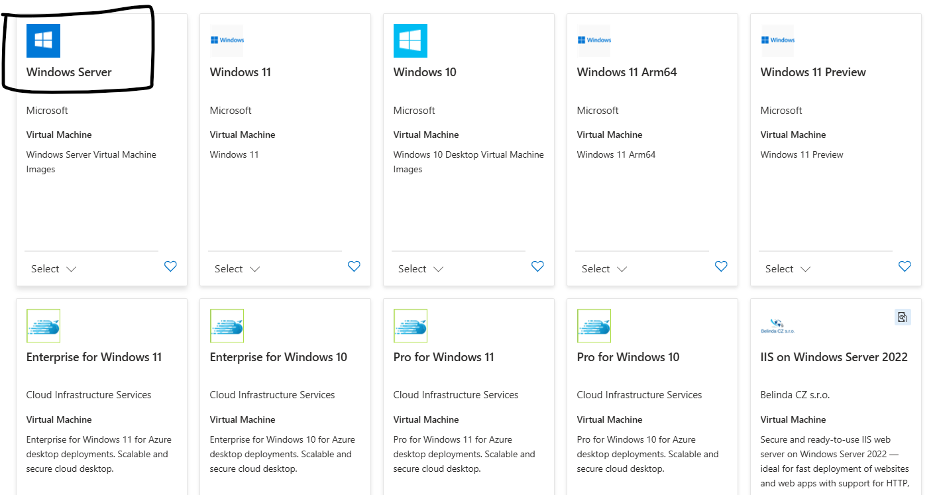
Normal Windows 10/11 are for normal use for laptop or desktop.
We need to type Windows Server or select Windows Server for VM which is marked.
Windows Server 2022 Datacenter - x64 Gen2(free services eligible)

Leave it : VM architecture, Run with Azure Spot discount.
- Size : Standard_B1s - 1 vcpu, 1 GiB memory (US$10.66/month) (free services eligible)
1GB or 2GB or 4Gb or 8GB from B or D family

Administrator account
- Authentication type : Key or Password
If key create and use pem key
if password, create on your own
- Username : Provide Username
- Password : Enter Password
- Reenter Password : Reenter the same password
- Inbound port rules : allow RDP for windows and SSH for Linux

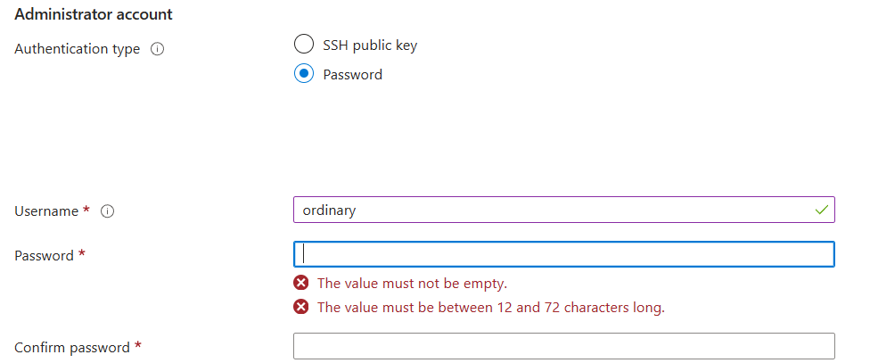

Under Disks Tag
OS disk :
- OS disk size : Image default (127 GiB)
- OS disk type : Standard HDD ( SSD is more costlier )

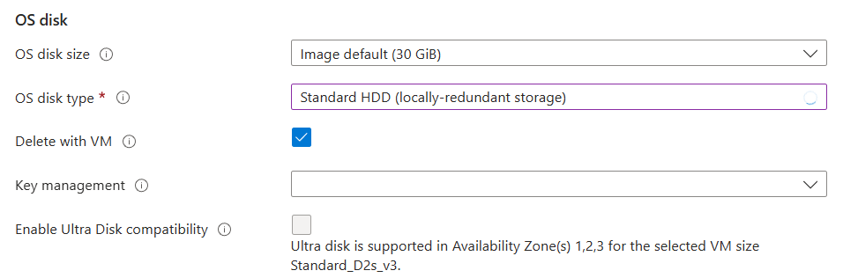

Under Networking Tag
Network interface :
When creating a virtual machine, a network interface will be created for you.
- Virtual network : Select Vnet you created
Ex : SaiVNet1 (SaiRG)
If you want to create VNet : Edit virtual network :
- Select your Subnet : Select subnet you created
Ex : SaiSub1
If you want to Create click : Edit subnet10.0.1.0 - 10.0.1.255 (256 addresses)
- Public IP : it takes automatic
Ex : (new) SaiVM2-ip
Else create New : Create new
- NIC network security group : Select Basic for normal, For asg None
- Public inbound ports : Select Allow selected ports for login
- Select inbound ports : RDP (3389)

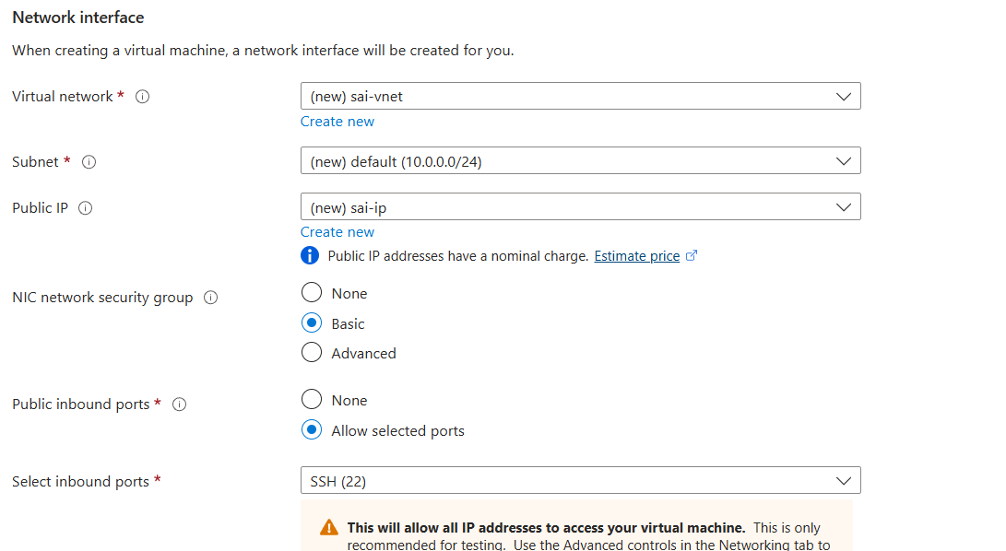

To connect to a OS using port name and number, check below

Type of OS | Common Connection Method | Default Port Number | Protocol / Service Name | Example Usage
Linux / Unix | SSH (Secure Shell) | 22 | ssh | ssh user@<vm-ip>
Windows | Remote Desktop Protocol (RDP) | 3389 | rdp | Connect with “Remote Desktop Connection” (mstsc)
Any OS (with Web Server) | HTTP | 80 | http | Access via browser: http://<vm-ip>
Any OS (with HTTPS) | HTTPS | 443 | https | Secure web access: https://<vm-ip>
Windows (File Sharing) | SMB / CIFS | 445 | smb | File sharing between machines
Linux (File Sharing) | NFS | 2049 | nfs | Network File System access
Database (example) | MySQL | 3306 | mysql | Connect to MySQL database
Database (example) | PostgreSQL | 5432 | postgres | Connect to PostgreSQL database
macOS (Apple OS) | Virtual Network Computing | 5900 | VNC | Screen Sharing / Remote Desktop

While selecting OS Normal Windows for Laptop
Windows Server for VM

- TO CHECK PEERING (COMMUNICATION BETWEEN OS)

- Create Resource Group
- Create Virtual Network
- Create Subnet under VN
- Create Virtual Machine

After login using username and password

Check with ping command using private IP address

- For connecting to virtual network with same region
Peer from Virtual network 1 -> settings peer
Select RG and Virtual Network 2

- For connecting to virtual network with different region
Peer from Virtual network 1 -> settings peer
Select RG and Virtual Network 2

- For connecting to virtual network with different Subscription
Peer from Virtual network 1 -> settings peer
Select Subscription, RG and Virtual Network

Note : If you want to create peering private address must be unique
If it is same error occurs

- HOW TO INSTALL NGINX AND TOMCAT

- What is Nginx
- NGINX is a high-performance web server and reverse proxy designed to handle large amounts of traffic efficiently.
- It is widely used for load balancing, serving static content, and acting as a gateway for backend applications

  - To install Nginx in windows
- Click on https://nginx.org/en/download.html
- Download nginx for windows latest
- Extract all and Open Nginx application file
- Open chrome and Type localhost in url
- Else you can check
- Nginx.conf page to check and edit
- Now Nginx runs on 80 but url you can just type localhost

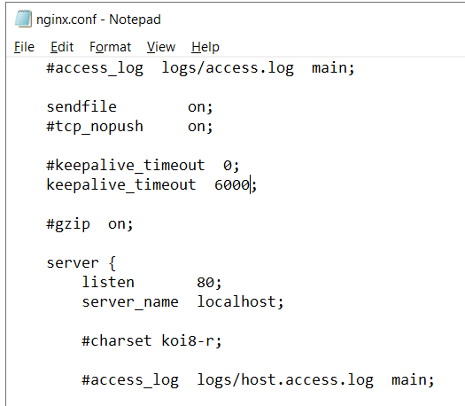

- open cmd cd .. for change folder or directory
- cd nginx-i.24.0
- nginx -s reload

- If Nginx runs you can find welcome to nginx

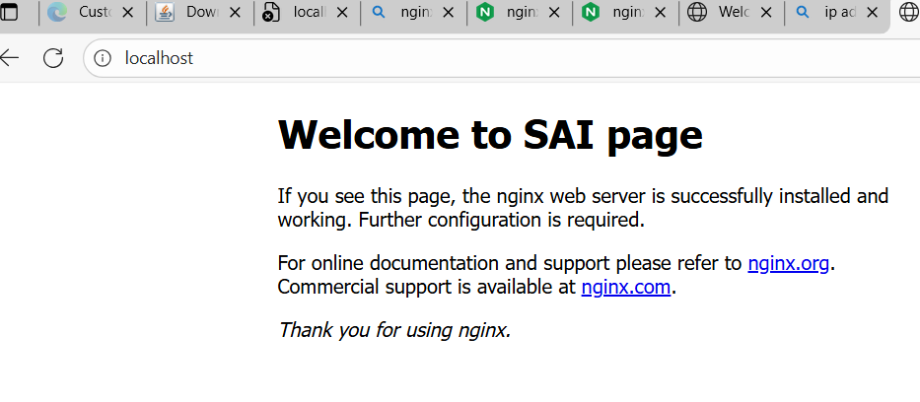

- To edit file you can follow these steps
  - Open nginx file
  - Open html folder
  - Open index file in notepad mode
  - You can edit now

  - To Install Nginx in Linux
- Follow these scripts or commands
- For normal user $ symbol
  - Sudo apt update
  - Sudo apt install nginx -y
- For root user # symbol
  - Sudo su
  - Apt update
  - Apt install nginx -y

  - To install Tomcat in Windows

- Install Java (JDK)
- Tomcat needs Java.
If you don’t have JDK, install it from:
https://www.oracle.com/java/technologies/downloads/
- After installing, verify:
Java version

- Download Tomcat
- Go to the official site:
https://tomcat.apache.org
- Click Tomcat 10 / Tomcat 9 (recommended).
- Under Binary Distributions → Windows, download:
- "32-bit/64-bit Windows Service Installer" (EXE file).

- Run the Installer
- Double-click the downloaded .exe file.
- Click Next → I Agree.
- Keep all default settings (recommended).
- Enter these if prompted:
  - Username: admin
  - Password: your choice
- Choose Java directory (installer usually auto-detects).

- Complete Installation
- Click Install → Finish.
- The installer will start Tomcat automatically.

- Verify Tomcat
- Open your browser and go to:
👉 http://localhost:8080
- You should see the Apache Tomcat welcome page.

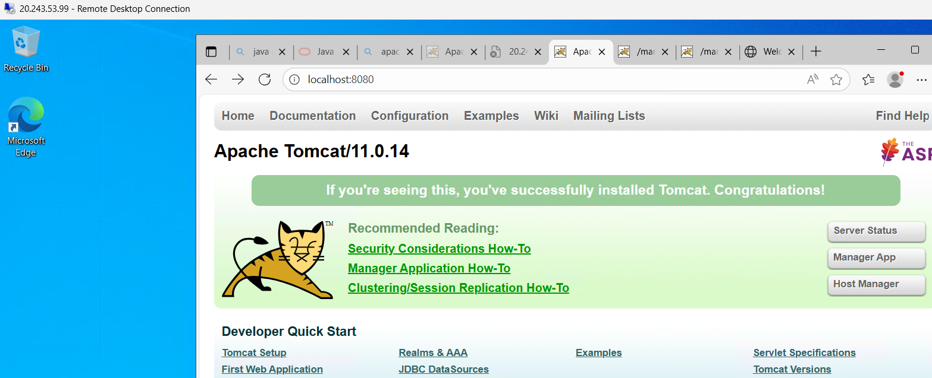

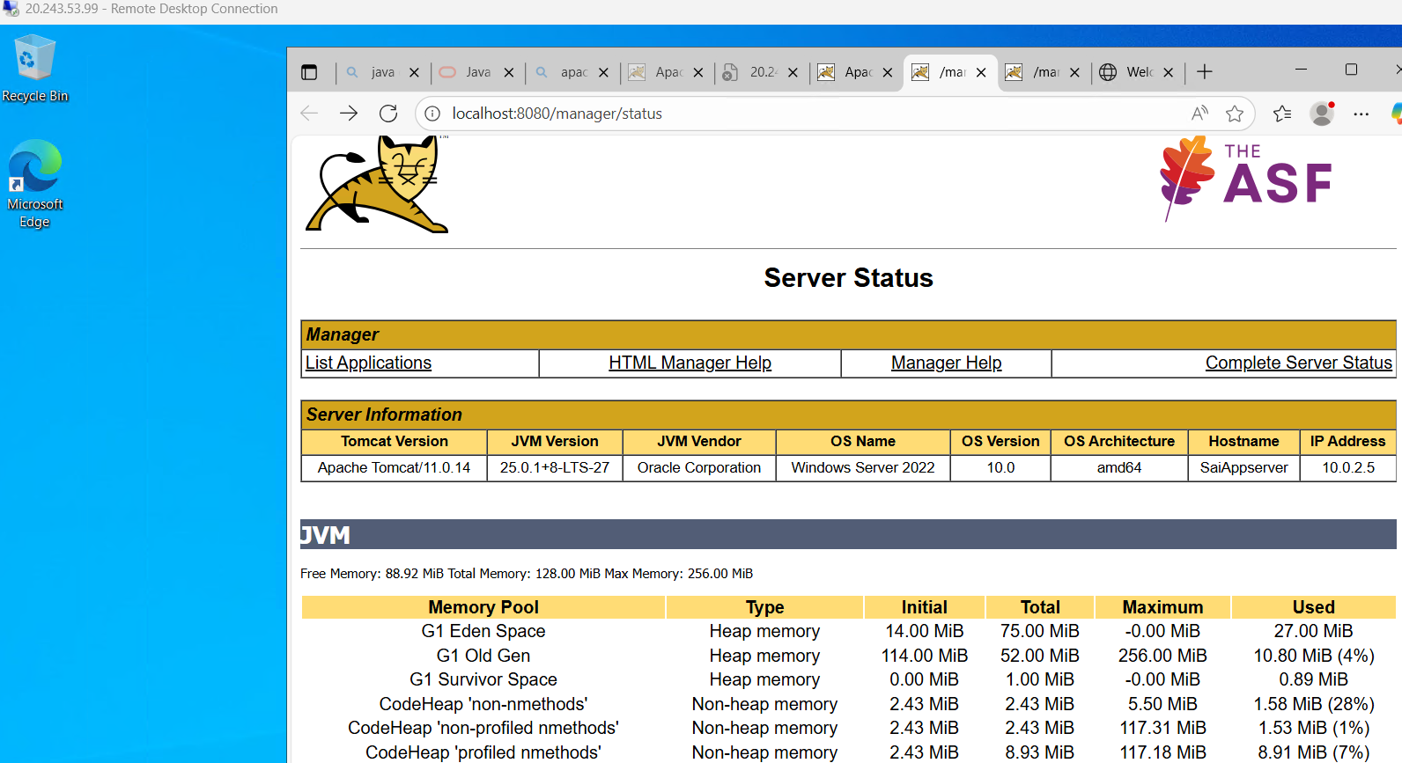

- TO CHECK NSG ( NETWORK SECURITY GROUP )

- Create Resource Group
- Create Virtual Network 3
- Create Subnet under VN
- Create Virtual Machine

- While creating VNet -> in IP address tag create Subnets
- Click on Add a subnet and edit name in name place and
- IP address in IPv4 -> starting range ( provide private address range from IP 10 or 172 or 192)

- Create VM1 Linux
- Create VM2 Windows
- Create VM3 Linux

For Mysql server min requirement is 2 or 8gb ram but it is not sufficient
Hence proceed with Linux

- Nsg with only VM1 SSH, VM2 RDP and VM3 SSH
You can login into account but unable to check server in web
Until http permission is given

- After login using username and password
From azure virtual machine and network settings
Check inbound security
Check out bound security

- Before peering no communication
Install nginx
Now launch nginx
Only self system can check nginx in brower

- After peering
1st VNet Linux can browse 2nd vnet Linux

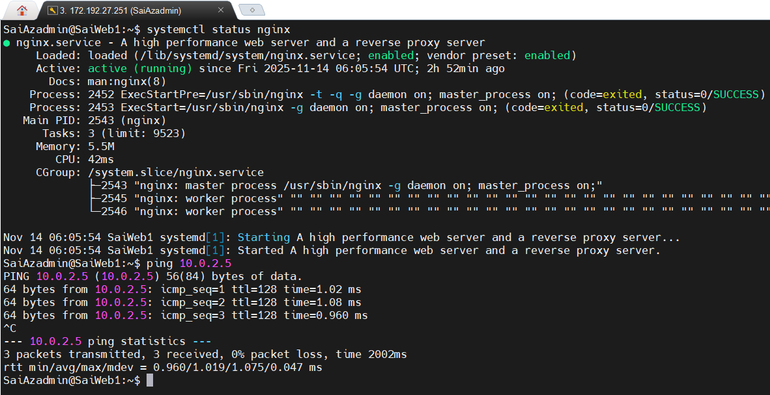

but Windows can not
Until you allow ssh and http request from advance security defender
Windows can launch nginx but other machine can not access
Allow 8080, 80 and ICMPv4

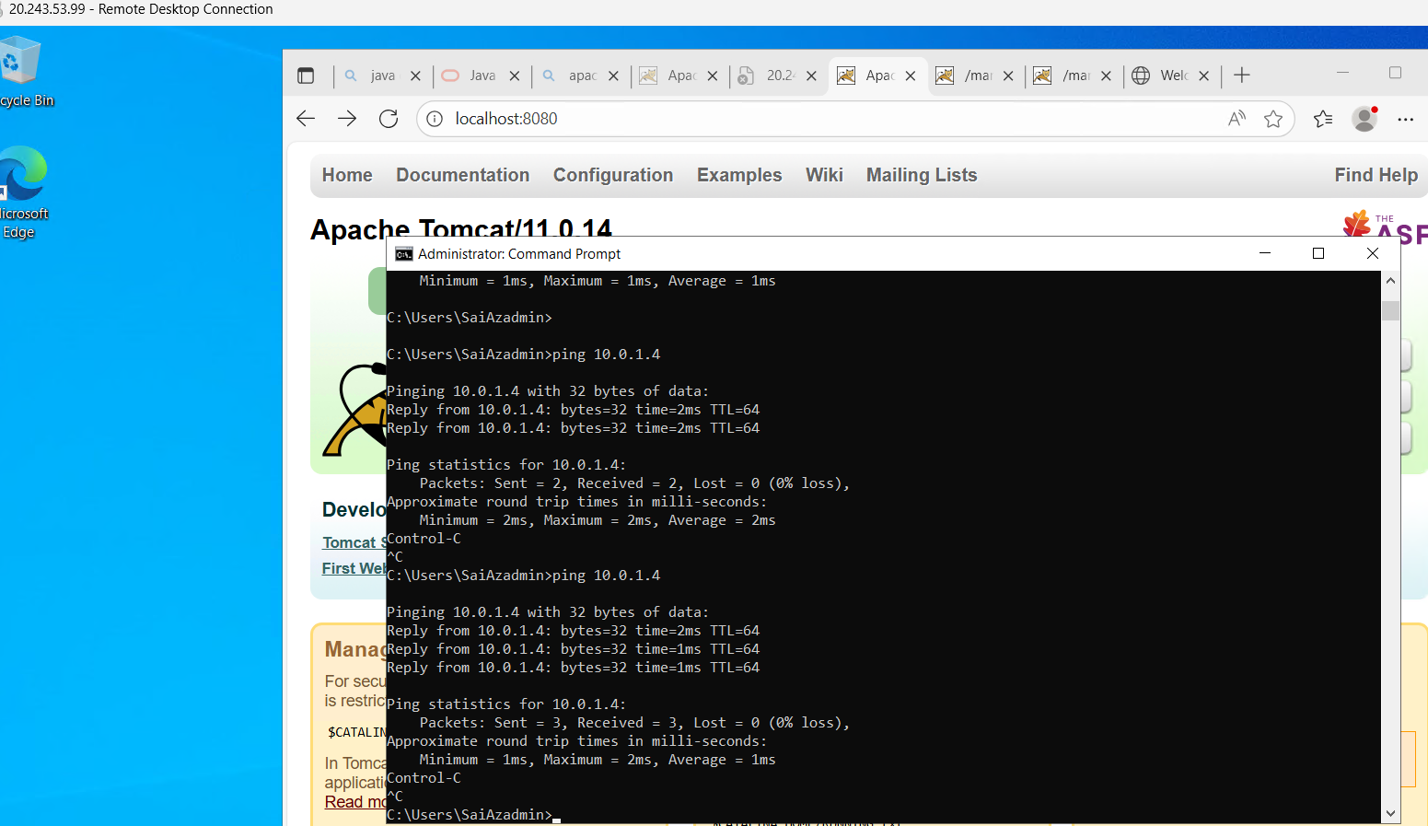

And from VM2 to VM3 also

- If all 3 systems are Linux
- You can login from VM1 to VM2
Using ssh username@privateip
Ex : ssh SaiAzadmin@10.0.2.4

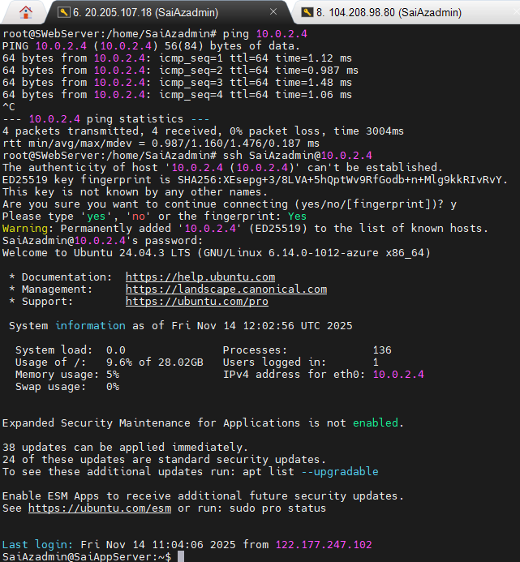

From Vm2 to VM3

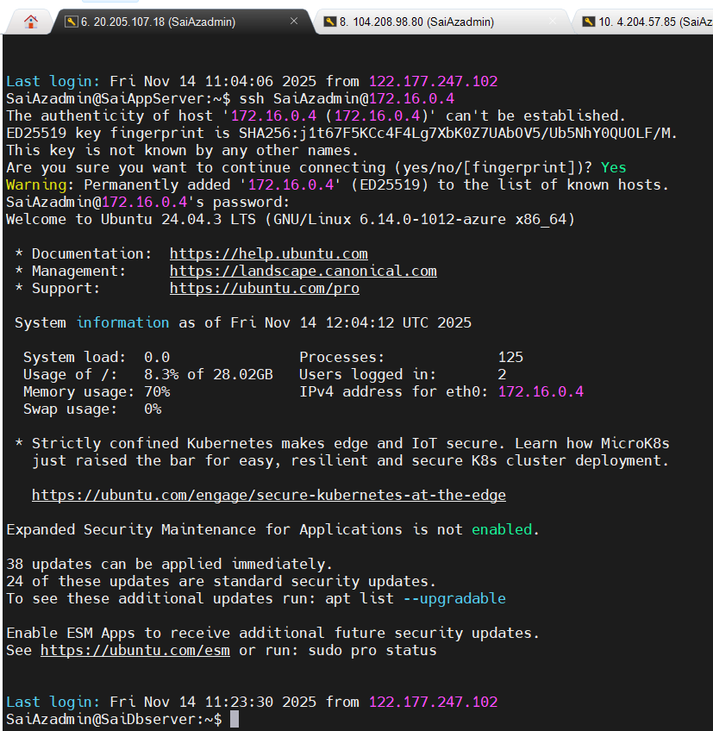

And you can exit as well

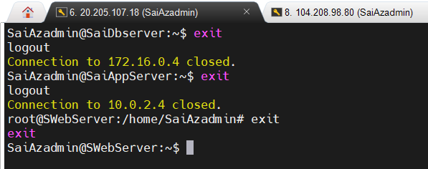

Linux rdp 8080 80

Note : For Windows and tomcat more than 2 GB ram is required after that due to limited resource unable to create 3rd VM

- TO CHECK NSG ( NETWORK SECURITY GROUP ) IN SUBNET LEVEL

- Create Resource Group
- Create Virtual Network
- Create 3 Subnet under VN
- Create 6 Virtual Machine
- Create 3 NSG

- For each subnet we will create 2 virtual machines
- Without NIC NSG or Or disable NIC while creating
Network Interface Card , Network Security Group

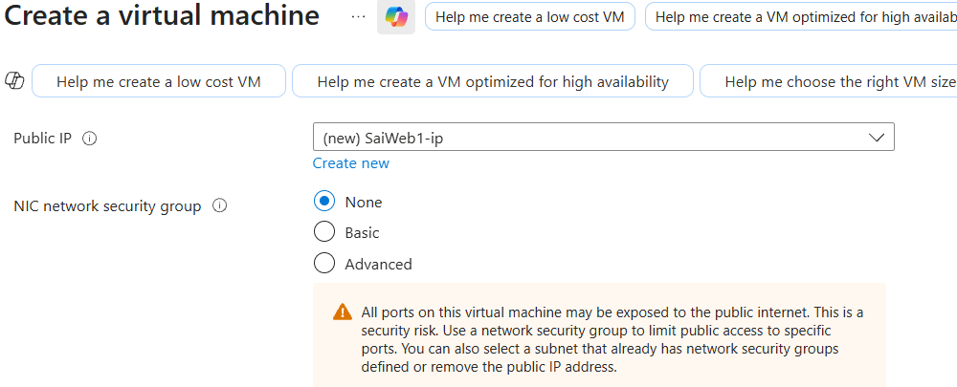

VM11 and VM12 in Subnet 1 with No Nic
VM21 and VM22 in Subnet 2 with No Nic
VM31 and VM32 in Subnet 3 with No Nic

- After creating Virtual Machine you can not login for Windows / Linux because we are not attached NSG
- As NSG allow ports, IP address etc. as
- We need RDP 3389 to login for windows, and SSH 22 to login for Linux.

- Create NSG
- Create NSGs for attaching Subnet
- Create NSG as it appears default

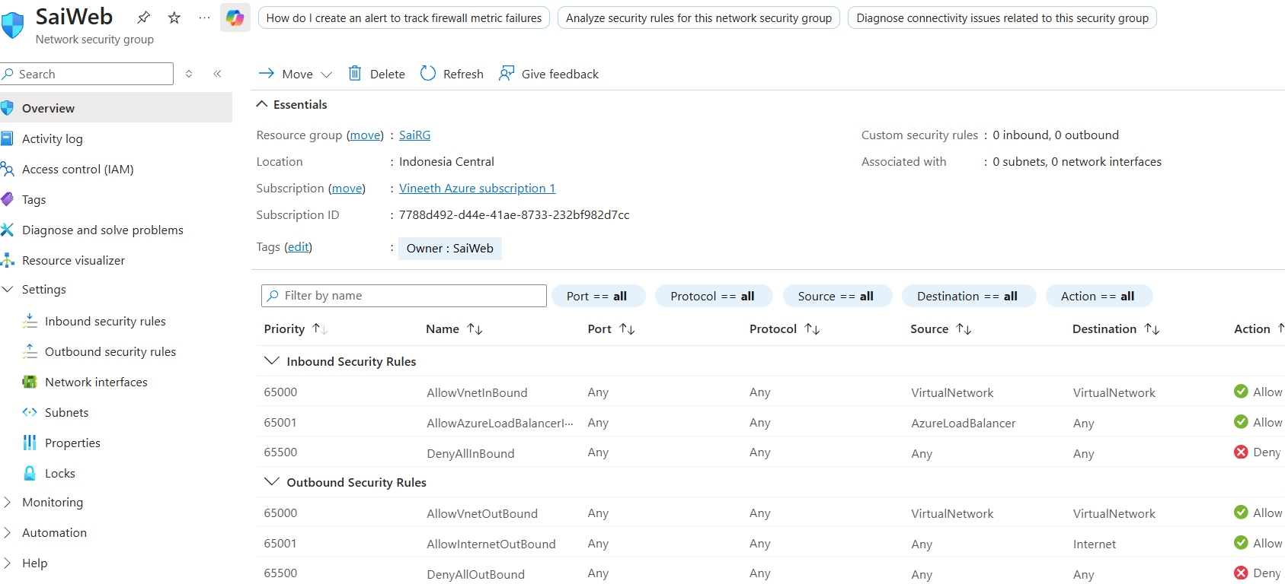

It appears default like this for all NSG ( Just name changes )

- Now Assign NSG to Subnet so that 1 NSG can be allotted to 2 VMs
- For Web server attaching under settings -> Subnets

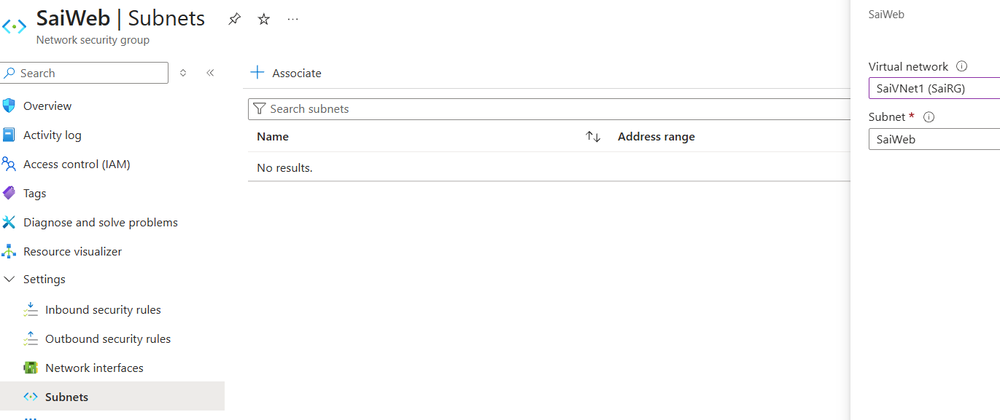

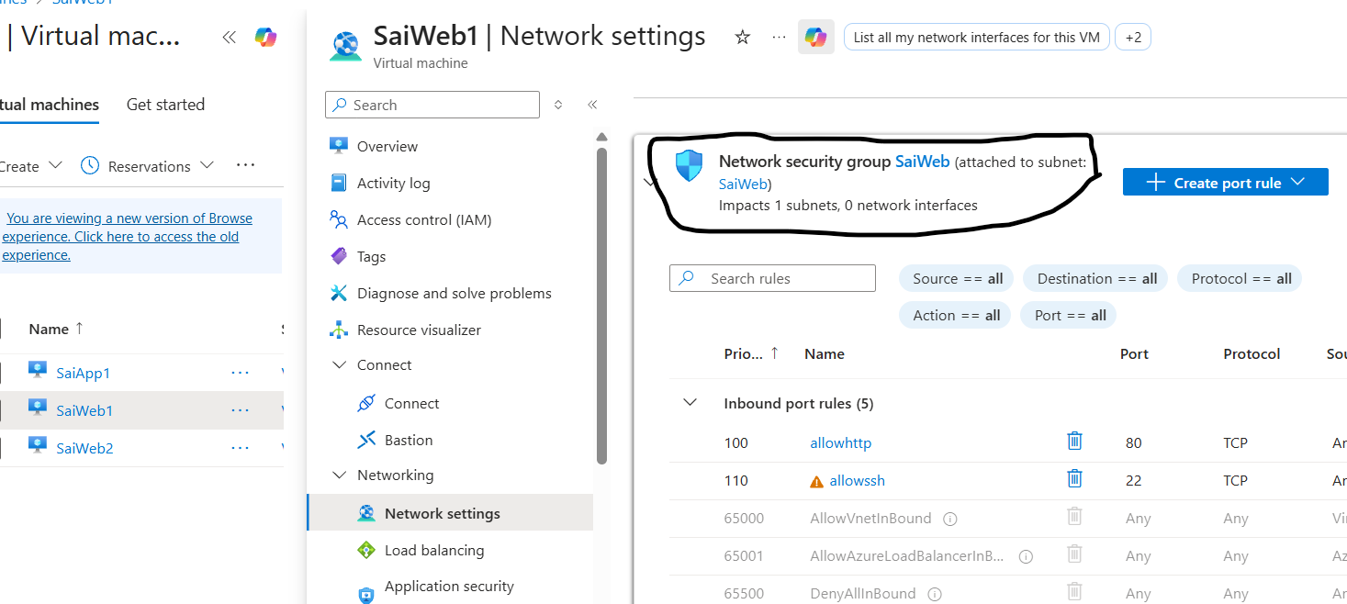

- Now Assign App NSG to Web Subnet so that 1 NSG can be allotted to 2 VMs

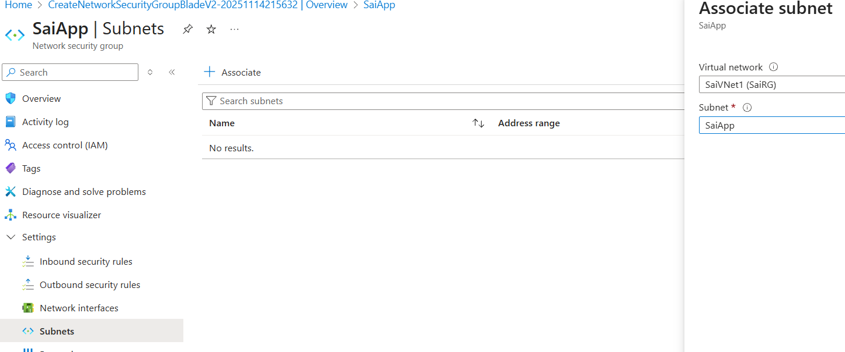

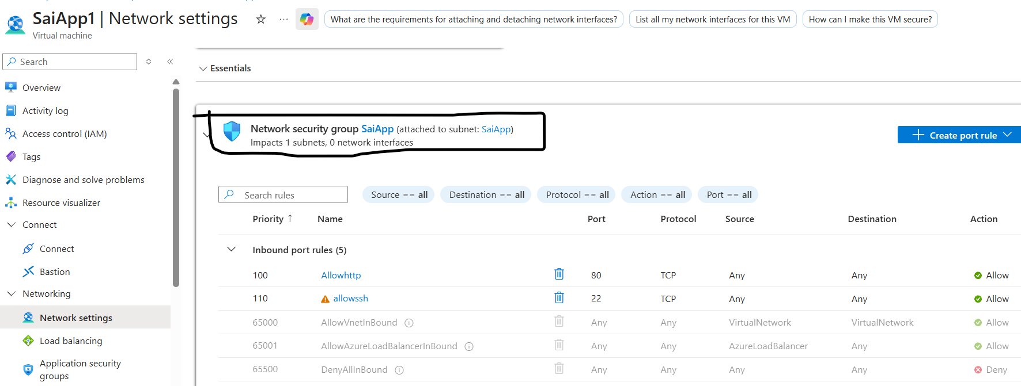

- Now Assign Web NSG to Web Subnet so that 1 NSG can be allotted to 2 VMs
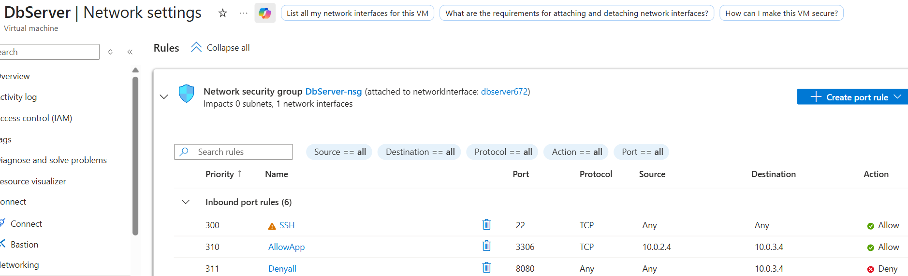

- Create inbound port rule as allow SSH to login and source as Subnet Private Ip address.
- Now Login into VMs and install Nginx

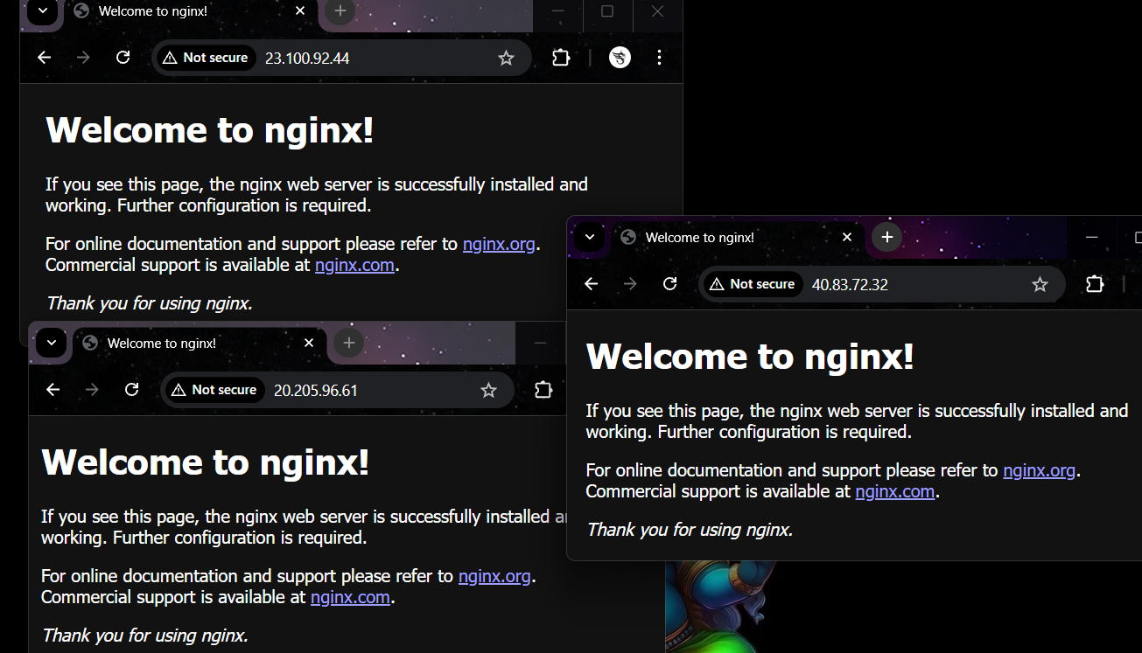

- We can login using public IP address as it allocated while creating.

- Now we can ping
- From Subnet 1

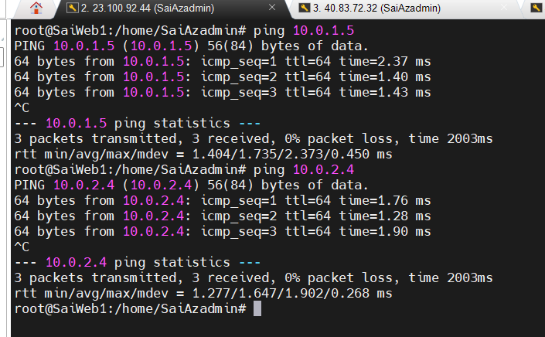

- From Subnet2

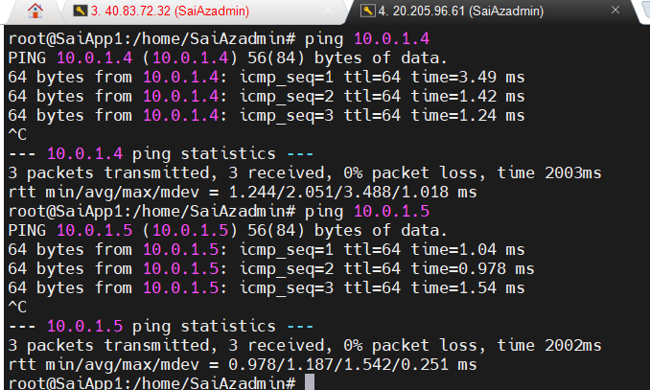

- From VM3 it is from Db named as Web
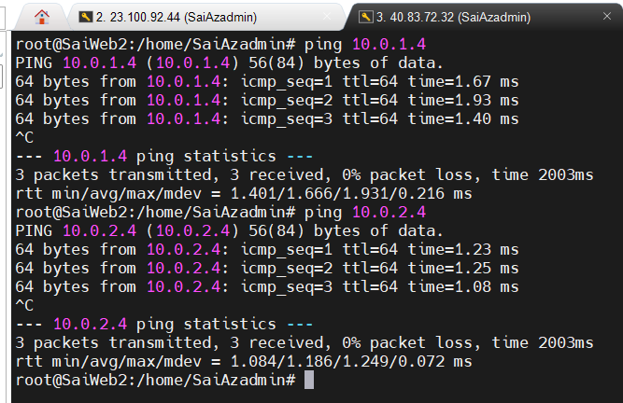

- ASG – APPLICATION SECURITY GROUP
- Requirement
- Create Resource Group
- Create VNet
- Create 3 Subnets
- Create 3 VMs
- Create 3 ASG – Application Security Group
- Create 1 NSG

- Process
- 1st create Resource Group
- Then VNet with 3 Subnets

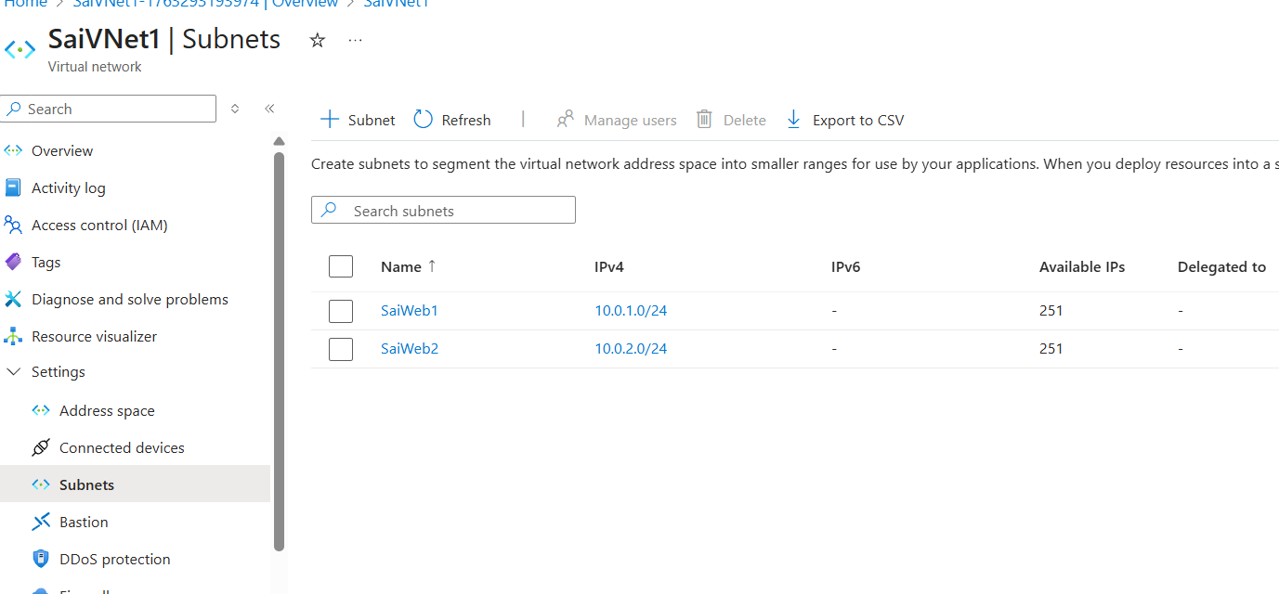

- Then Create 3 Virtual Machine under each subnet and while creating click on no for NIC

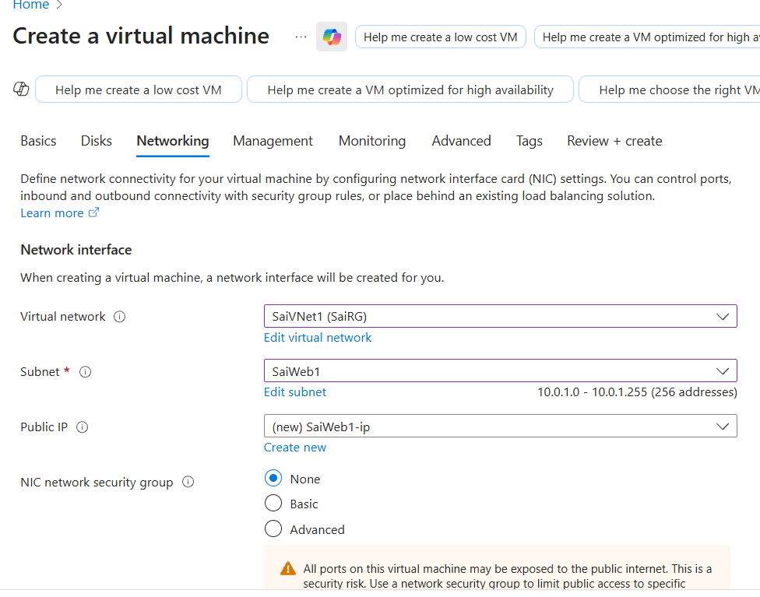

- Create Application Security Group

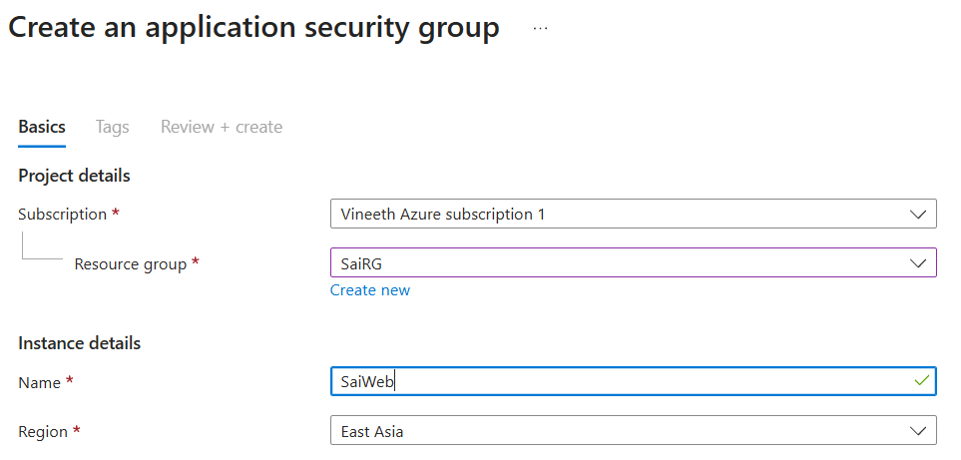

- After creating Virtual Machine
- You can add ASG to virtual machine from Networking -> ASG

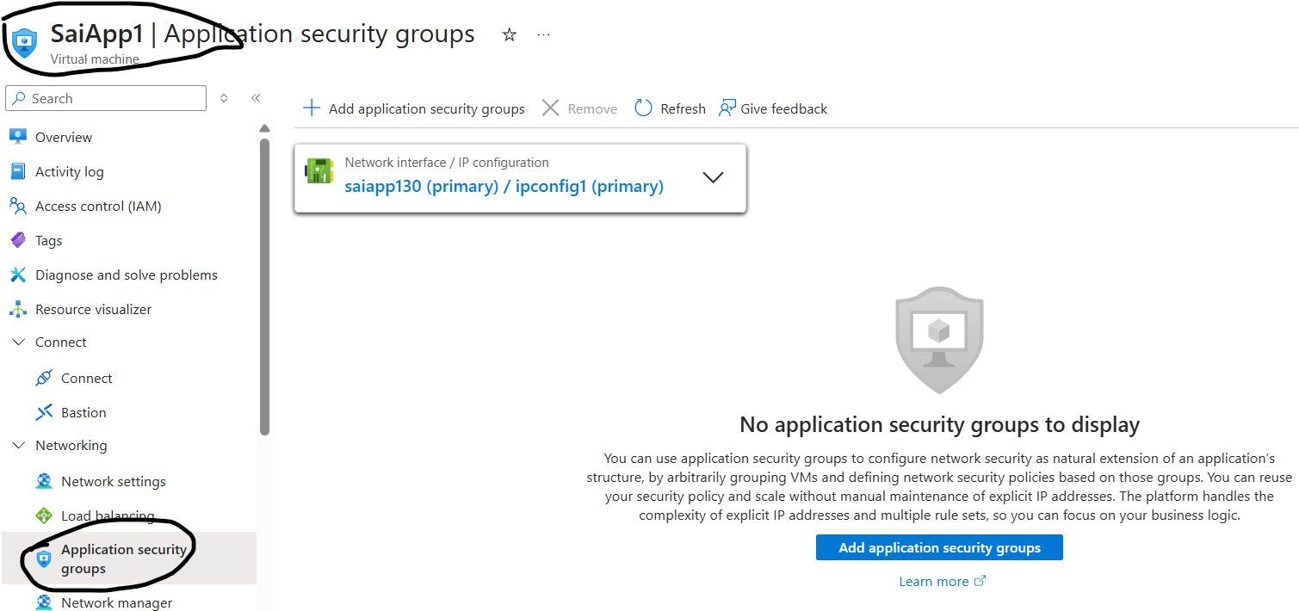

- Under ASG click on + Add ASG
- It will show ASG which are under same network ( Does not support for different VNets )

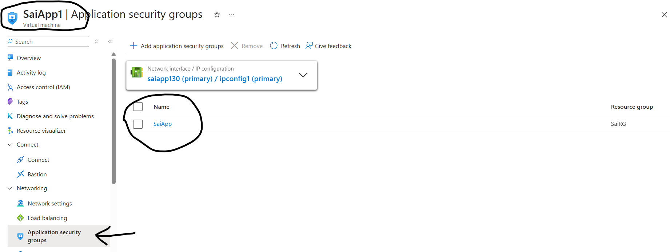

- If you want to add Multiple machines to ASG
- Open ASG -> in Overview only you can find + Add symbol
- After clicking add private ip address it shows as VM present in Subnets of same Vnets
- Click on add at bottom and VMs are added to ASG

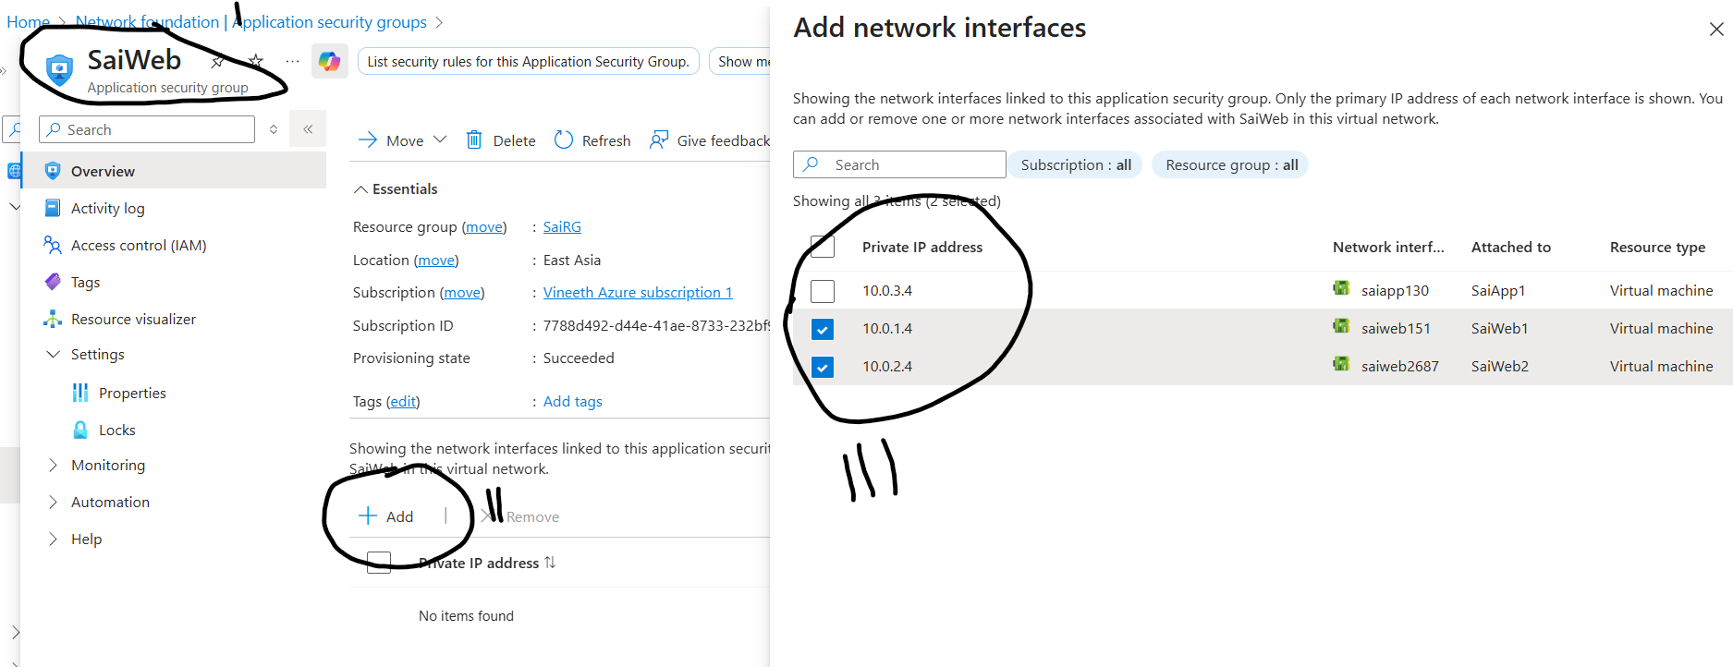

- Now Create NSG
- In same region
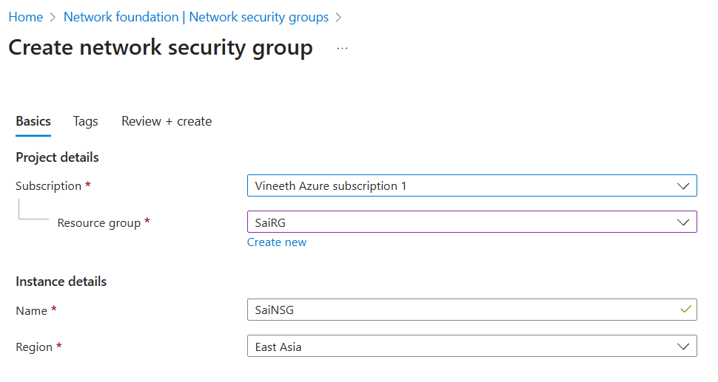
- After creating NSG
- Now you can add Inbound rules under settings -> Inbound Security Rules

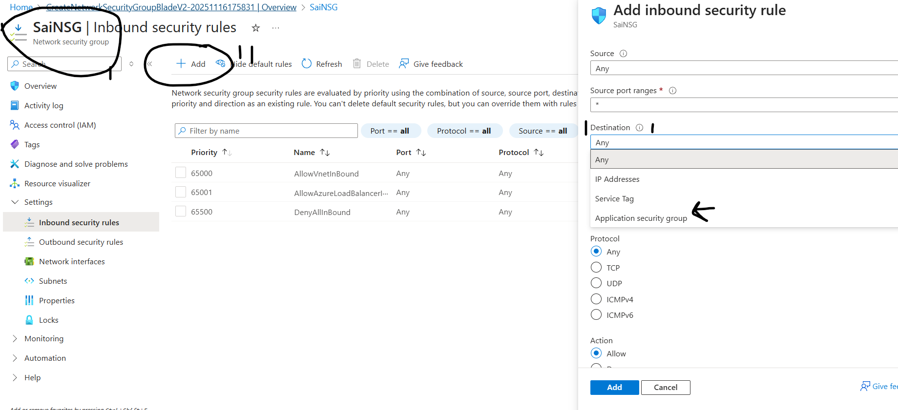

- Add you can allow any input traffic to Web ASG by selecting Source : any
- Selecting Destination : ASG , Under ASG : Web ASG
- Port any
- Action allow and name it

- Now add one more rule only Web traffic should go to app and rest deny
- Source : ASG -> ASG : Web, Dest : ASG -> App ASG, Port : any, Action : allow and name it
- Now add one more rule that no traffic is allowed to app expect Web after 1 rule

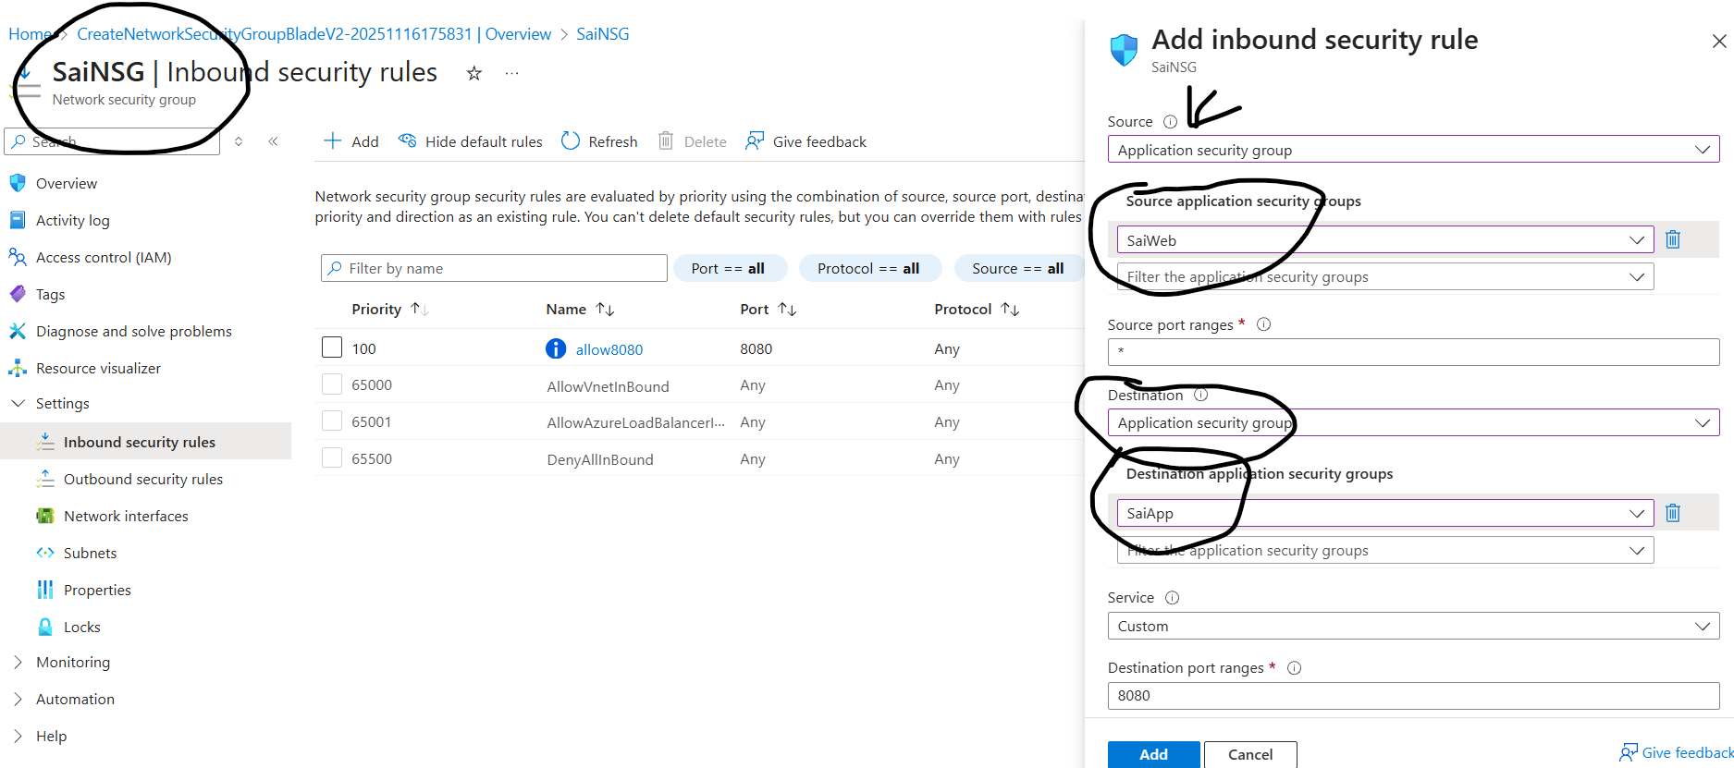

- Now check whether the rules are reflecting in ASG with Private IP address, Subnet.

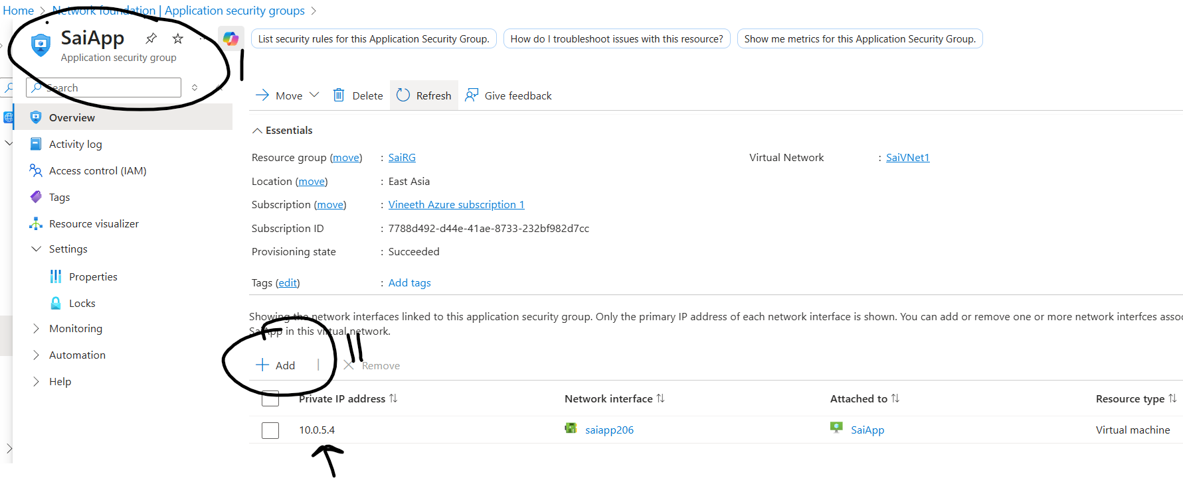

- Now check whether its reflecting in VM or not

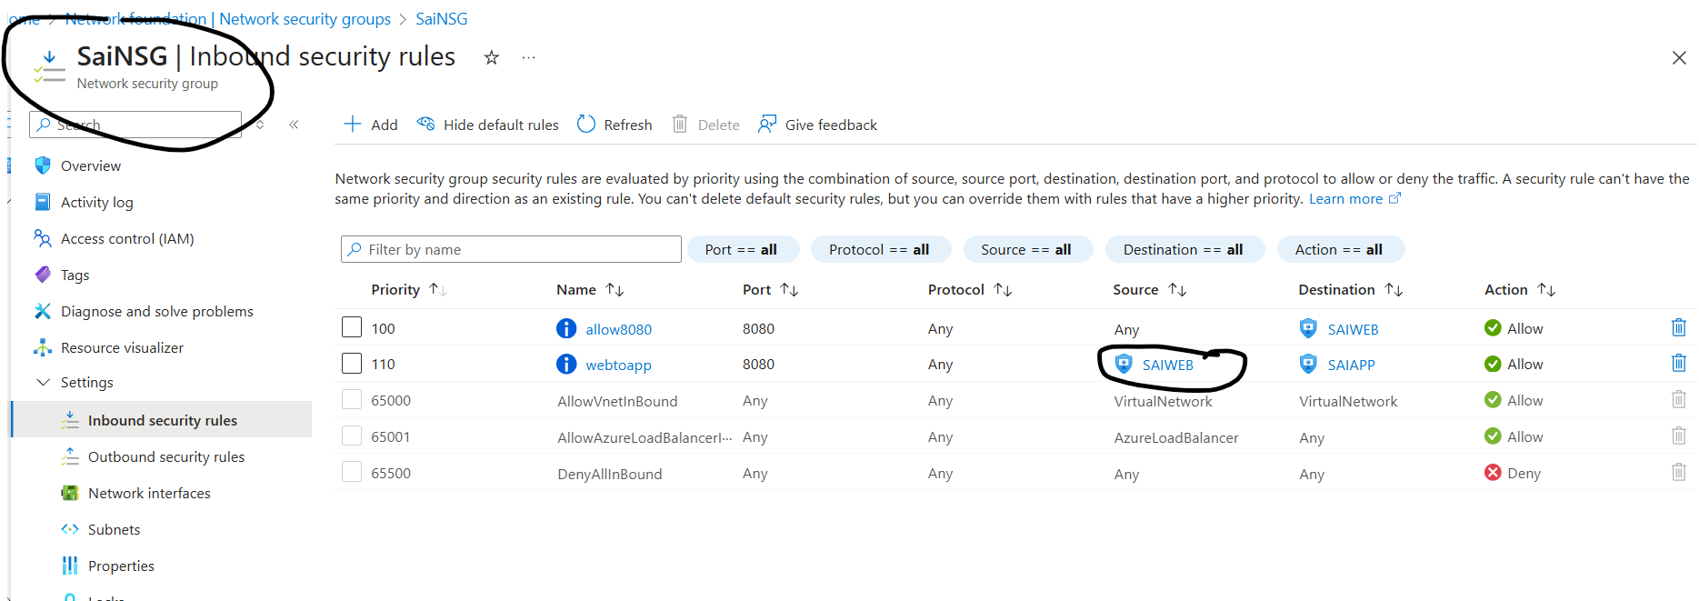

- From nsg create a rule to allow ssh port so that you can login to VMs
- How ever all Vms under same Vnet hence communication happens as usual until you create rules to deny.

- LOAD BALANCER
- Requirement
- Create Resource Group
- Create VNet
- Create 3 Subnets
- Create 2 VMs
- Create 1 Load Balancer

- Create 3 Subnets
- One for Load balancer and rest 2 for Vms

- Creating 2 VMs by default nginx install

- Create Load balancer
- Instance details
  - Name : Provide LB name
  - Region : East Asia
  - SKU : Standard
- Standard (Distribute traffic to backend resources)
- Gateway (Direct traffic to network virtual appliances)
  - Type : Public
- Public for external
- Internal for internal applications
  - Tier : Regional
- Regional – Same region
- Global – Different regions

- Front IP configurations :
  - Click on add a front end ip :
  - Name : any name
  - Add public : some name
  - Add it

- After creating now open load balancer
  - Under settings -> front end ip, check ip available or not
  - Backend pools : name : any
  - VNet : select Vnet
  - Add from down : Add IP configurations to backend pool
  - Select VMs and click on Add
- Health Probes : to check server status
  - Name : any name
  - Protocol : TCP
  - Port : 8080
  - Interval : 5 seconds ( To check condition )

If VM1 is down it should automatically redirect to VM2

- APPLICATION GATEWAY
- Requirement
- Create Resource Group
- Create VNet
- Create 3 Subnets
- Create 2 VMs
- Create 1 App gateway

- Create Gateway
- Under Basics
  - Resource group : Select your RG ( SaiRG )

Instance details :
  - Application gateway name : Enter Gateway name
  - Region : Select Gateway same as RG created (East Asia )
  - Tier : Standard V2
  - Enable autoscaling : Yes, No_/
  - Instance count : 2
  - IP address type : _/ IPv4 only, Dual stack (IPv4 & IPv6)
  - HTTP2 : Disabled, Enabled _/
  - FIPS (Federal Information Processing Standard) mode 140-2 : _/ Disabled, Enabled
Configure virtual network :
  - Virtual network : Select Vnet name (SaiVNet1)
  - Create new If you want to create New vnet
  - Subnet : SaiGate (10.0.2.0/24)

Under Frontends
  - Frontend IP type : Public
  - Public IPv4 address : click on create new and enter name

Under Backend
  - Click on Add a backend pool and give a dummy name with no targets

Under Configuration
  - Add routing rule
  - Rule name priority name : adb
  - Rule no : 00
Listener :
  - Listener name , port
Backend targets :
  - Backend target : adb
  - Backend settings : create new

- Open gateway after creating
- Click on settings -> backend pool
Add -> target type : VM
Target : VM1

- Open backend settings
- Click on add and allow 80 port as home.

- Open Listener and click on add
- Name : any
- Port : 80
- http
- allow

- Open health probe and add
- Name : any
- Host : VM1 Public IP address
- Path : /
- Add

- Name : any 2
- Host : VM2 public IP address
- Path : /personal/ ( depends on folder )
- Add

- Open rules and add

That’s it done

- TRAFFIC MANAGER
- Requirement
- Create RG
- Create VNet
- Create Subnets
- Create Traffic manager
- Create VMs

- After creating VMs
- Open VM
- Click on DNS which is not configured

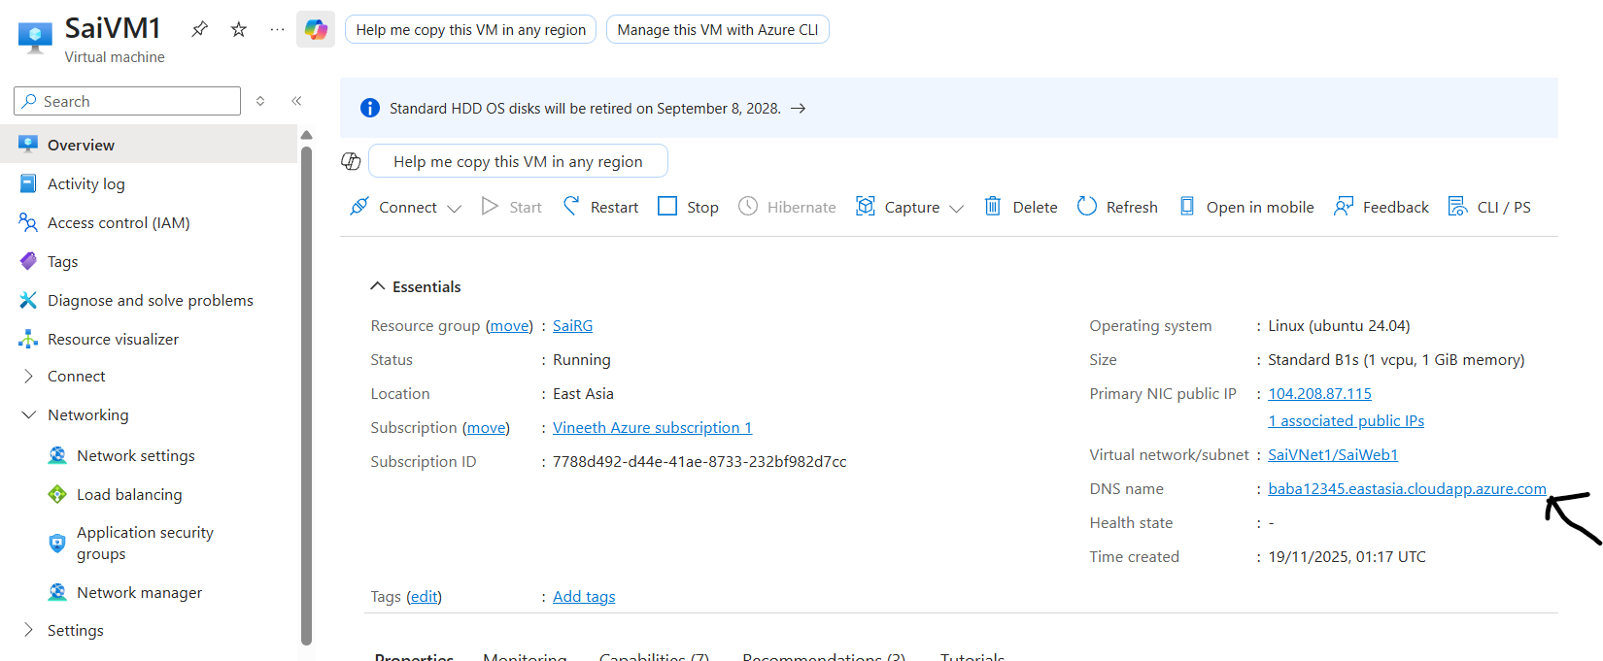

- Type a name which is not configured

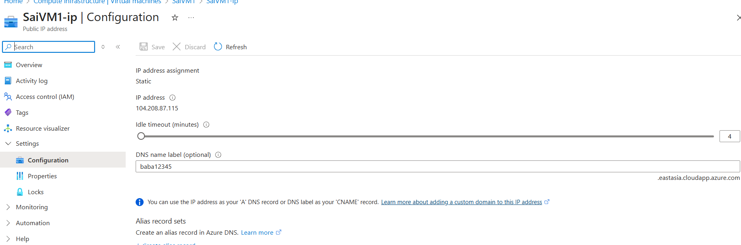

- Done

- Search for Traffic Manager
- Resource group : Select your resource g

Instance details
- Name: enter any name
- Routing method : priority ( depends on use case )
After creating TM open it
- Under Settings add endpoints
- Name : any name
- Target resource type : public ip address
- Target resource : select vm1 or any target.
- Add multiple servers or vms in the same way

- Now open TM copy dns name and paste in url and check it

- Change configure settings from settings and change routing method and save

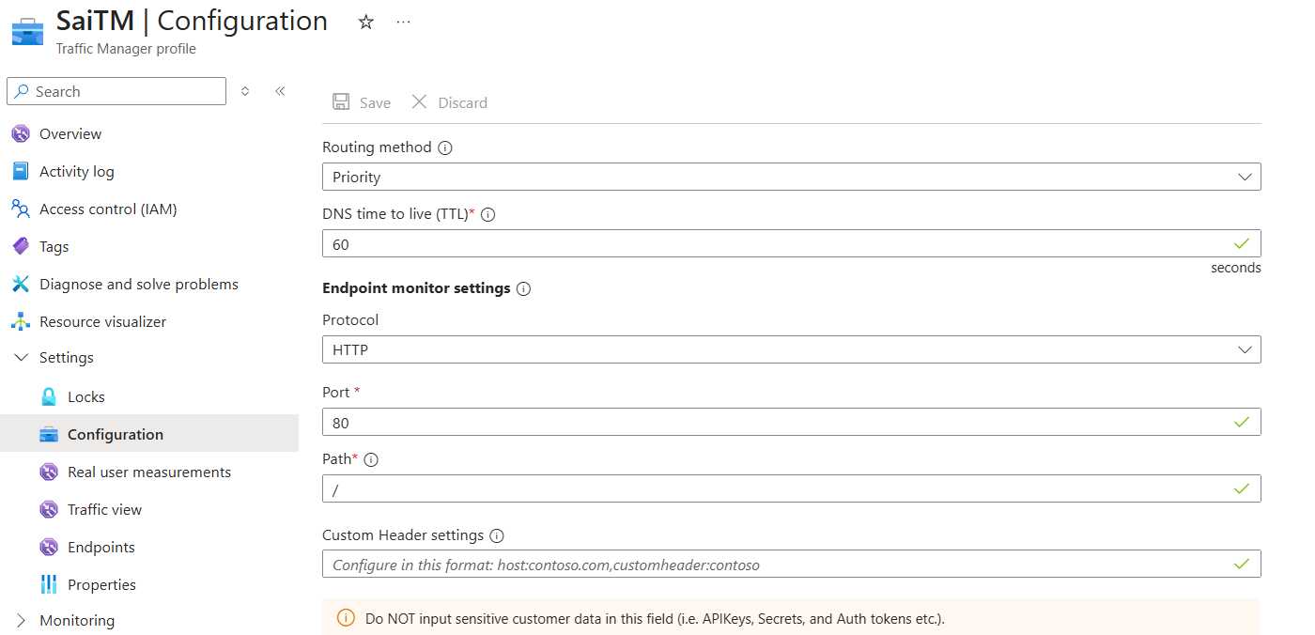
- Now access endpoints and you can change weightage no in endpoints also.

- APP SERVICE
- Requirement
- Create RG, VNet, Subnets

- App service
- Click on create Web App
- Resource Group : Create new or select one ( SaiRG)

Instance Details
- Name : enter any name – ( it will shown and add automatic later .azurewebsites.net )
- Publish : Code, Container ( select depends in practice code )
- Runtime stack : ASP.NET V4.8
- Operating System : Linux, Windows.
- Region : Canada Central

Pricing plans
- Windows Plan (Canada Central) : ASP-vineethcanadarg-8379 (B1)

- After creating app service
- Under deployment -> Deployment Center
- Settings :-> Source : Github
- Github :
  - Sign in as : using personal access
  - Provide username and password
  - In github click on settings from top right profile
  - Developer settings - > Personal access
  - Token classic -> generate a new new token
  - Generate new token
  - For confirming provide password
  - Token name : any
  - Repository access : All
  - Under account you can see permissions at right side : select all
  - Generate token

- From github up you can check change provider
  - From github actions to app service build service
  - SCM basic authentication is disabled for your app default it will show this
  - But you don’t have permission you need to enable this

- Under settings Configuration Preview
- Select SCM basic authentication public : active or tick mark

- Click on overview -> default domain copy it and paste in url
- Select deployment slots under deployment and click on add slot
- Name : any
- Clone settings from selected git

- AZURE FRONT DOOR
- Requirements
- Create RG
- Create Vnet and Subnets
- Create Web app, Front Door and WAF

- Create Web app ( App Services )
- Click on create Web App
- Resource Group : Create new or select one ( SaiRG)

Instance Details
- Name : enter any name – ( it will shown and add automatic later .azurewebsites.net )
- Publish : _/ Code, Container ( select depends in practice code )
- Runtime stack : depends on github code lang ( java / ASP.NET V4.8)
- Operating System : Linux, Windows.
- Region : Canada Central

Pricing plans
- Windows Plan (Canada Central) : ASP-vineethcanadarg-8379 (B1)
- Pricing Plans : Free F1

- Under settings Configuration Preview
- Select SCM basic authentication public : active or tick mark

- After creating app service
- Under deployment -> Deployment Center
- Settings :-> Source : Github
- Change Provider : from app service -> App service build service
- Github :
  - Sign in as : using personal access
  - Provide username and password

Now select
- Organization : Github Username
- Repository : Project name
- Branch : main
- Save it below setting tag from top

If you create 2nd web app follow same process as II

- Create Front Door
- Click on create
- Default it would selected Azure front door, Quick create leave it
- Click on Continue to create front door
- Resource Group : select yours
- Name : any name
- Tier : Standard ( WAF wont work properly ), premium _/
- End point : any name
- Origin type : App service
If you are using normal IOS use public IP address
- Origin host name : select app service name
- WAF Policy : create new
- Review and Create

- After creating front door
- In overview
  - You can find properties in middle and copy endpoint host name
  - Paste in new tab url
- Select Settings -> Origin groups
  - Select default origin group
- You can see Update Origin Group
  - Add an origin
    - Name : 1st app service name
    - Origin type : App service
    - Host name : select from shown
    - Add it
  - Click on update
- Click on Front door manager under settings
  - Click on add a route
    - Name : any name
    - Domain : already selected
    - Pattern to match : /path
type anything after / ( /about )
    - Accepted protocols : http and https
Origin group
    - Origin group : add a new origin group
      - Name : any
      - Click on add an origin
        - Name : any
        - Origin type : app services
        - Origin host header : select from it
        - Click on Add
      - Status Enable health probe
      - Path : /about
      - Protocol : Http
      - Click on Add
    - Origin path : same as pattern to match
    - Click on add

- Create WAF ( Web Application Firewall )
- Type WAF Policies
- Default one is created and click on it
- Enable it
- If you are detection mode it just logs in but not block
- If you switch to prevention mood then it blocks
- Under settings : Managed rules
  - You can find default rules as it maintained by MS
- Click on Custom Rules under settings
  - Add a custom rule
    - Custom rule name : any name
    - Status : enabled
    - Rule type : match
    - Priority : assign a number
Conditions if
    - Match type : Geo location / Ip address
    - Match variable : remote country / remote IP
    - Operation : does contain
    - Country : any country
/ Ip address : enter any policy
- If you are enabled prevention mode then customs rules or policy rules get enabled

- STORAGE ACCOUNT

- Requirement
- Create RG
- Create Storage Account

- While creating
Under Basics
- Resource group : Select your RG
Else Create new

Instance details
- Storage account name : name must be unique with lower case letters and number ( 3 – 24 )
- Region : select any
- Preferred storage type : Azure Blob storage / Azure file / other ( queues and Tables )
- Performance : _/ Standard: Recommended for most scenarios (general-purpose v2 account)
Premium: Recommended for scenarios that require low latency.
- Redundancy : LRS

Under advance and security
Make sure all are selected :
Require secure transfer for REST API operations
Allow enabling anonymous access on individual containers
Enable storage account key access

Under Data Protection
- Disable soft delete

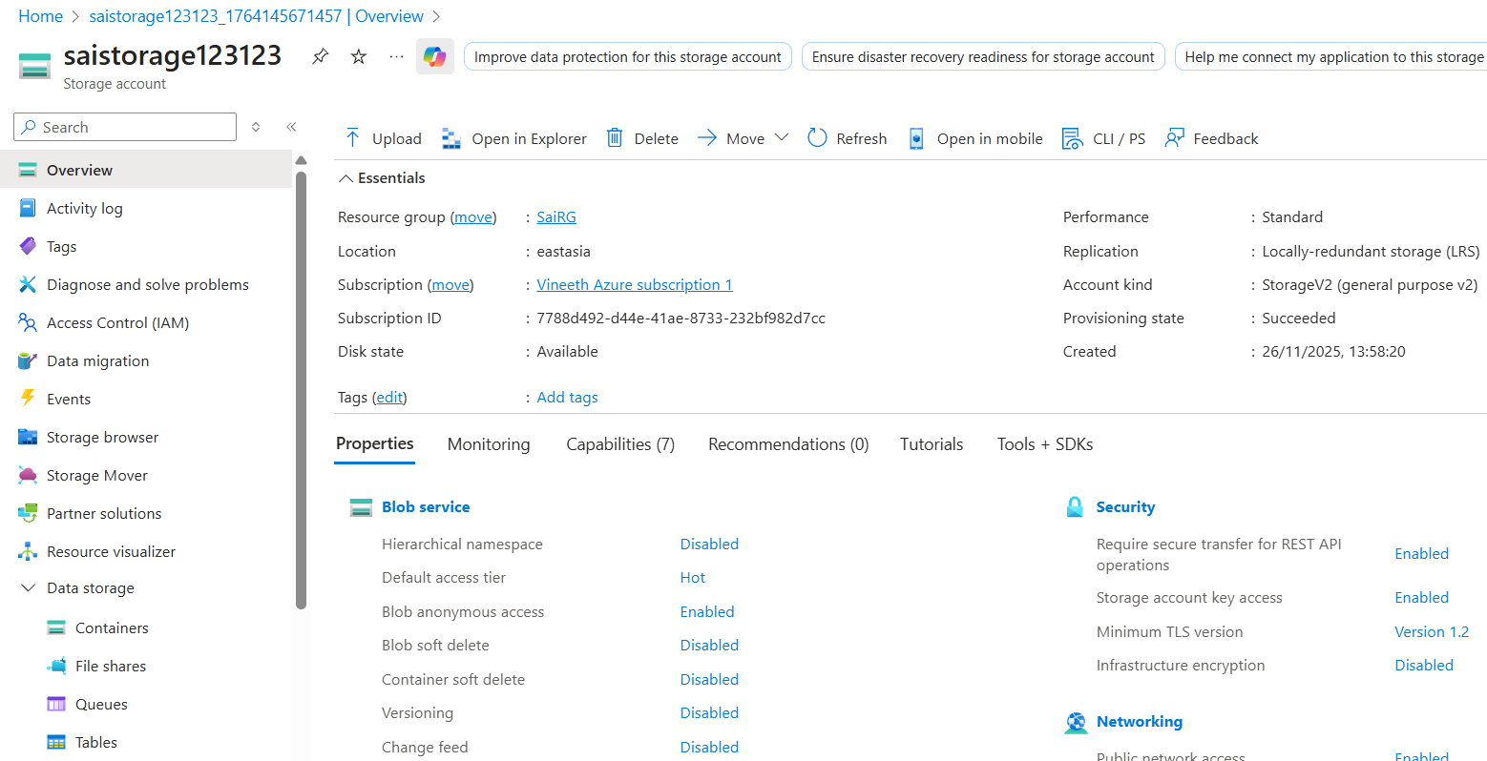

- After creating
- You can check Container, Files, Queues and Tables under Data Storage

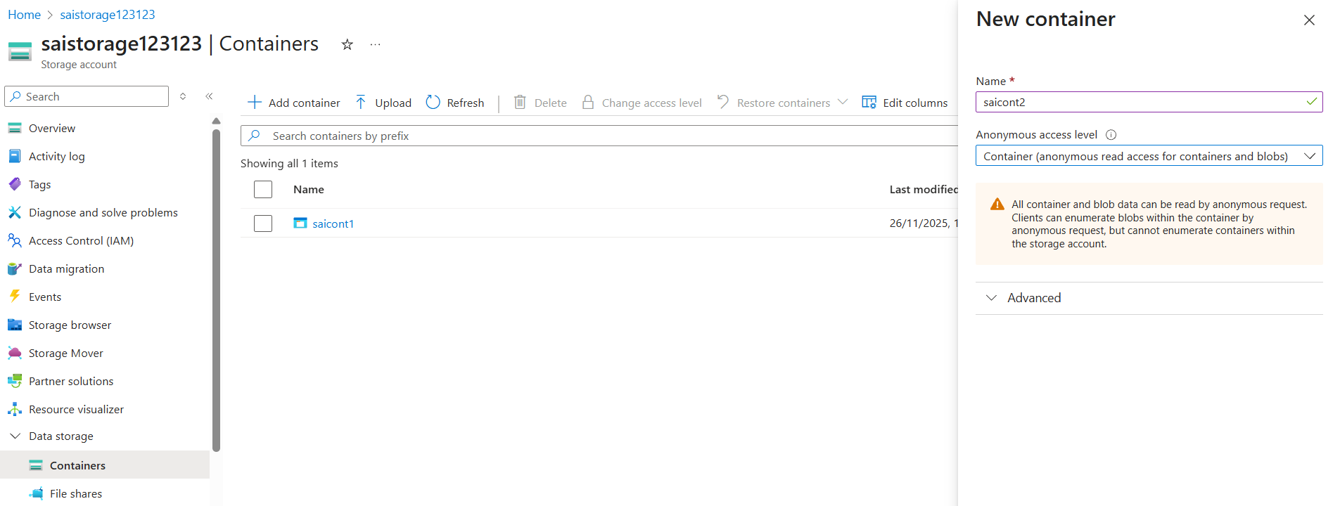

- Click on 2 Container and Add container
  - Name : any only in small
  - Anonymous Access level : Private( No one ), Blob ( Public ), Container ( Public for both c and b )
  - Create 1 container as blob and 2nd with container

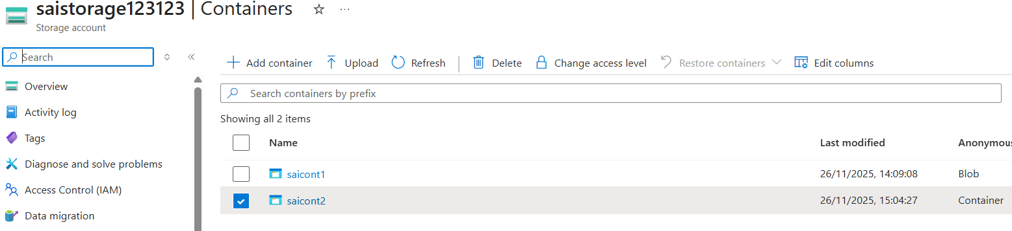

- To upload use option Upload
- To access after upload, click three dots at right and select Copy URL

URL : https://saistorage123123.blob.core.windows.net/saicont1/a0b556920a8f880bc1c813b7be999a99.jpg

Storage account ID : saistorage123123
Storage account endpoint : saistorage123123.blob.core.windows.net
Inside storage Container name : saicont1
File name : /a0b556920a8f880bc1c813b7be999a99.jpg
Combined all with / symbol

- If you want to list all files from container using url provider after storage name : ?restype=container&comp=list
- If it is blob list will not appear
- If it is container list will appear.

- To Save Code in web format
Before enabling static web

- Under Data Management, static website.
- Default it would be disabled you need to enable it
- Index doc name : any
- Error doc path :
- Done
After enabling static web

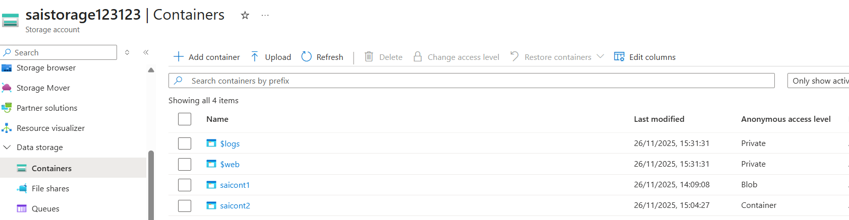

- Go to Container
- Default there would be $web folder and you can upload files in it
- Upload using upload option

- Copy url from static website under data management
- Copy private endpoint url and paste in new tab url bar
- It does not come/appear
- Change access from private to blob in

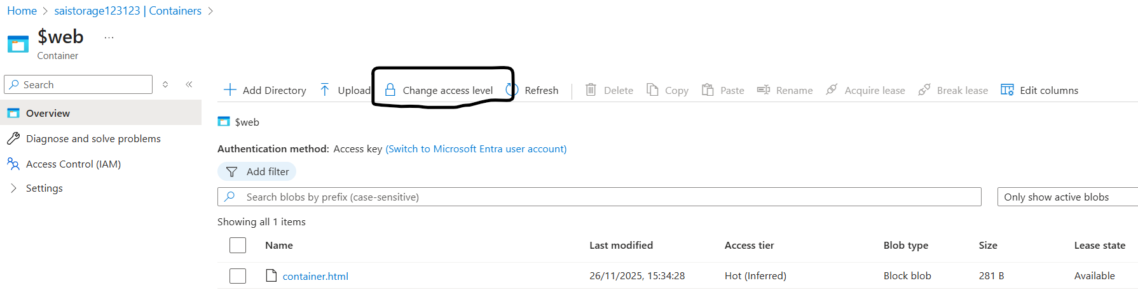

Now website appears.

- Public IP of storage account is and it cannot be seen in azure

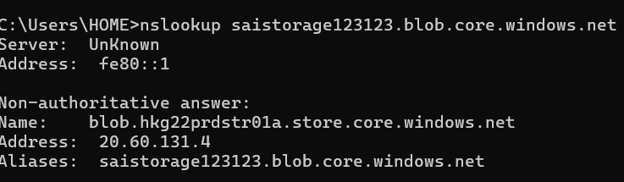

- To access from VM or private endpoint
- Create VM with windows
- Now enable permission at storage account -> security & networking -> networking -> manage
Select selected network
- Select VM from existing VM and PC IP
- Now only VM and self pc can be assessed rest can not accessed.

- IDENTITY MANAGEMENT IN STORAGE ACCOUNT
( STORAGE ACCOUNT ACCESS )
Types of access storage access :
- Access keys => admin level access to everything
- SAS keys ( Shared Access Signature ) :
To which block access is provided like : blob container, table
What level of access : Write, Read, Delete, list
Provide to whom : IP address
Schedule time : 1 hour
- RBAC ( Role Based Access )
- Identity ( Resource to Resource )

Download Azure storage explorer

On opening of Azure storage explorer
It looks like

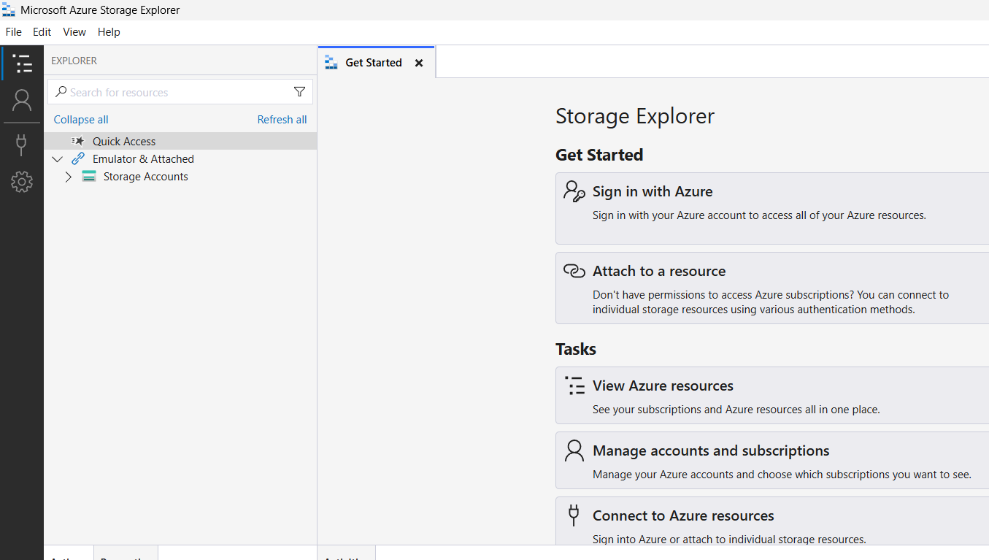

- Access Key

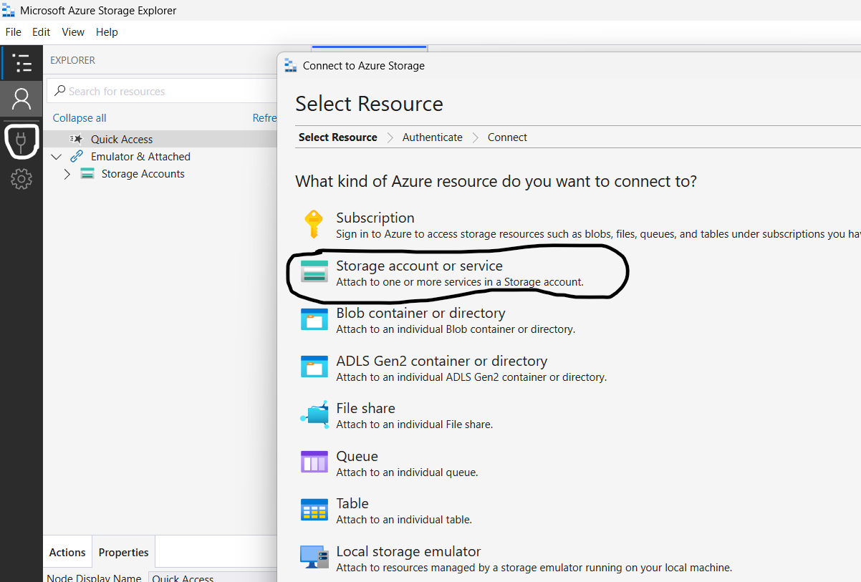

Storage account or service ->
How will you connect to the storage account : Account name and key

Display name: anything
Account name: storage account id
Account key: azure -> security + networking -> access keys -> key 1 -> key copy

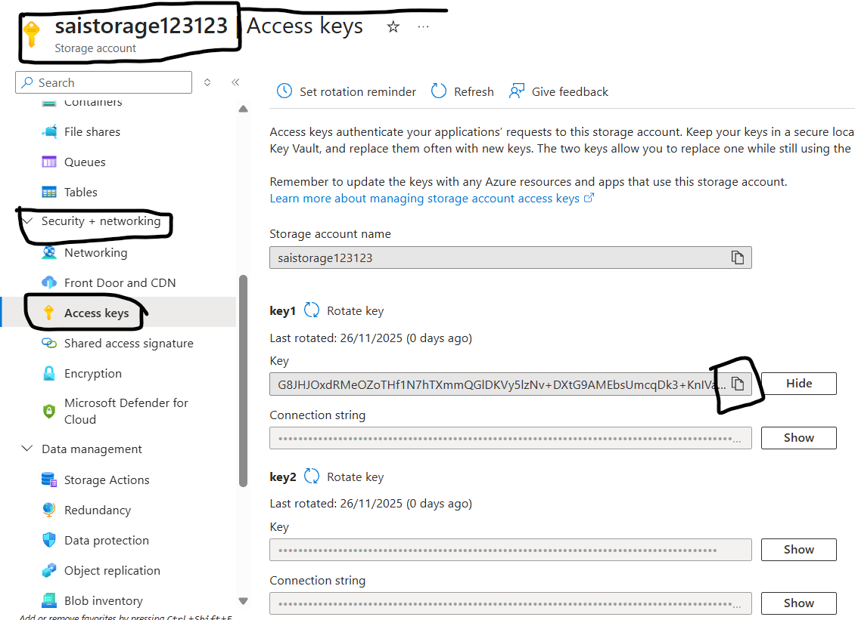
Storage domain: Azure (core.windows.net)

Next and connect

Expand and select cont 1 and it shows
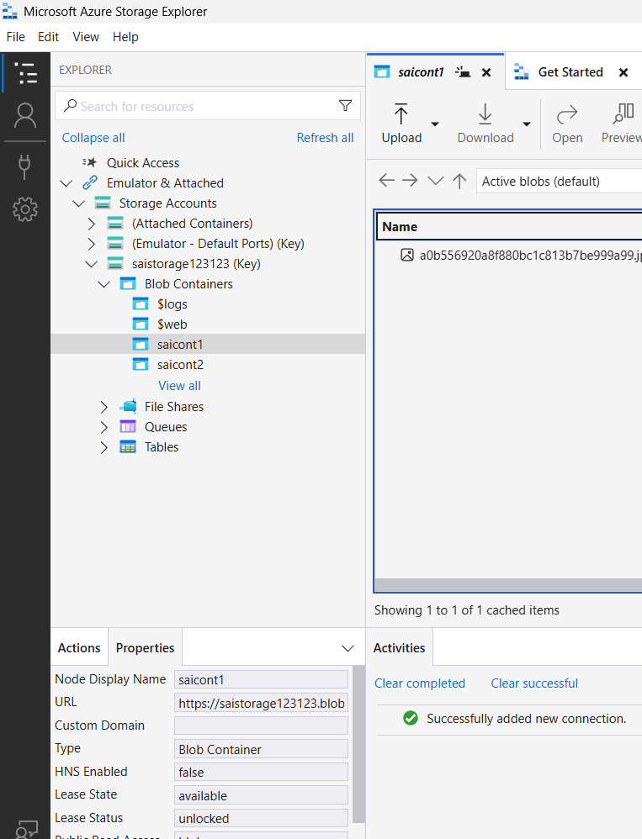

Done
If key1 expires, use key2 and rotate key1 to reuse
Now you can upload files from storage explorer software/app also

- SAS keys :
Storage account or service ->
How will you connect to the storage account : SAS key
Display name: anything
Service URL:

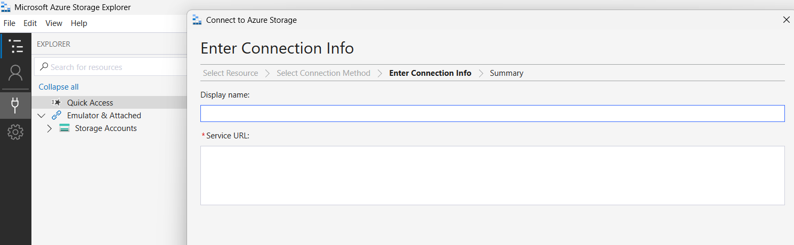

For SAS key
Service URL : azure -> security + networking -> SAS
Edit the following as per requirement :
Allowed services : Blob, File, Queue, Table
Allowed resource types : Service, Container, Object
Allowed permissions : Read, Write, Delete, List, Add, Create, Update, Process, Immutable storage, Permanent delete
Blob versioning permissions : Enables deletion of versions, Allowed blob index permissions, Read/Write

Filter
Start and expiry date/time : Start, End (UTC+05:30) Chennai, Kolkata, Mumbai, New Delhi
Allowed IP addresses :
Allowed protocols : HTTPS only, HTTPS and HTTP
Preferred routing tier :

Copy blob service url :

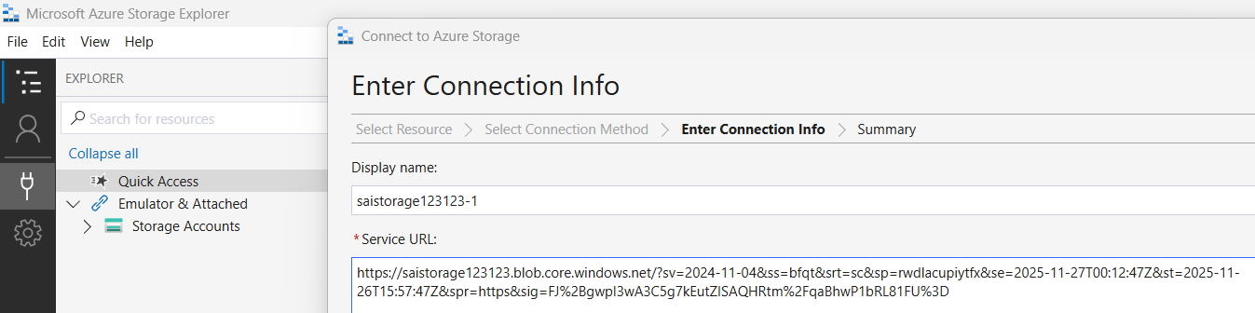

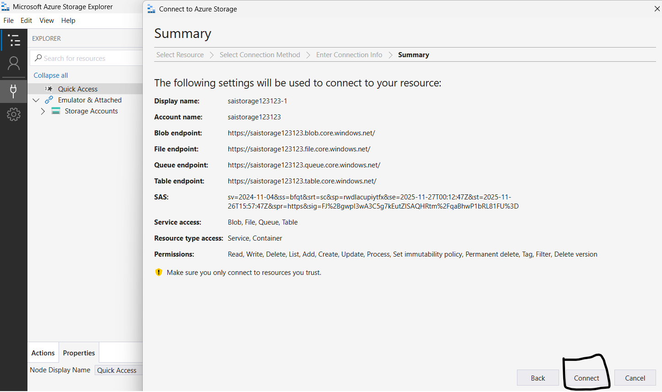

Click on connect to connect
Done and you can observe SAS as side

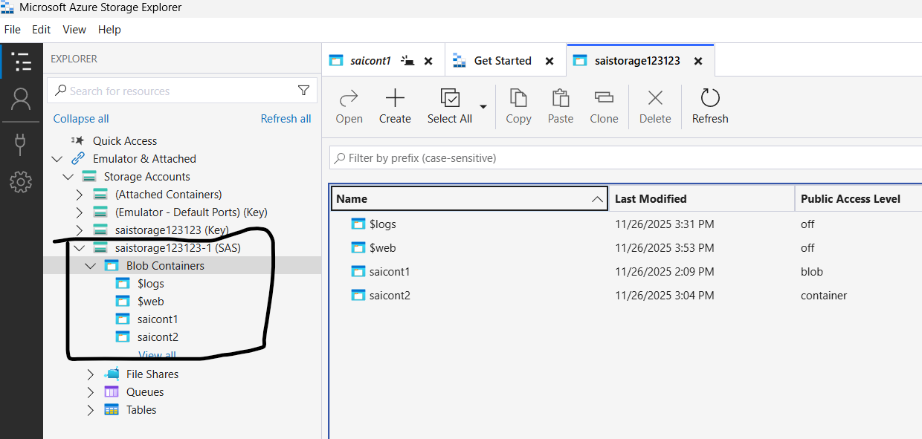

- Create a VM with windows

- Resource to Resource
From VM
Under Security -> Identity -> System assigned status as On and Save

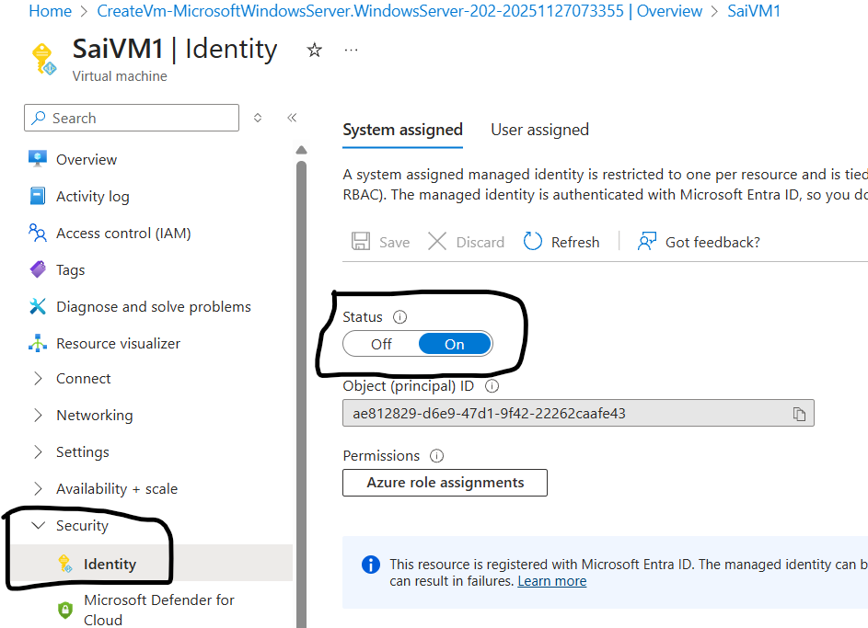

From Storage Account

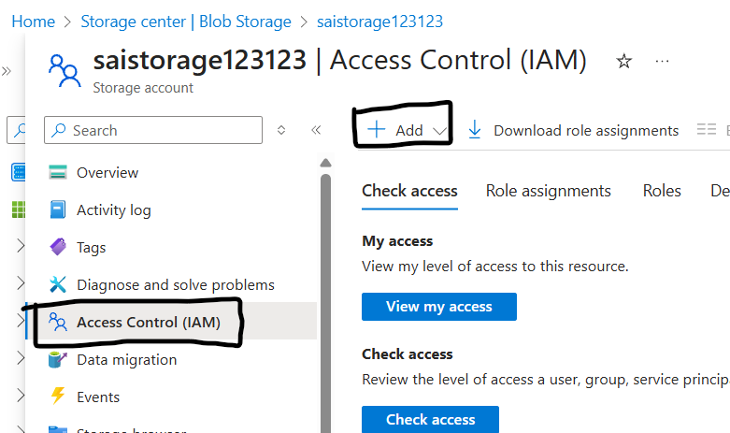

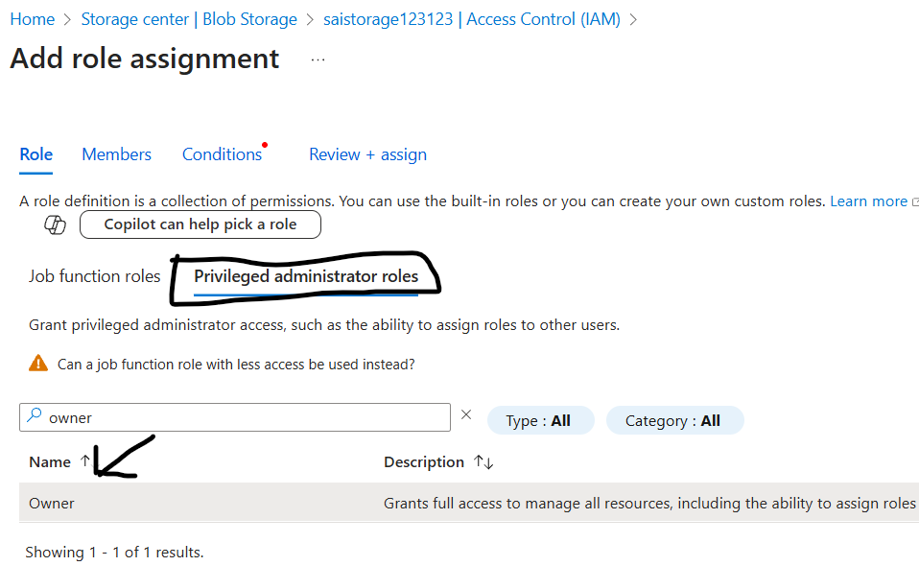

3.
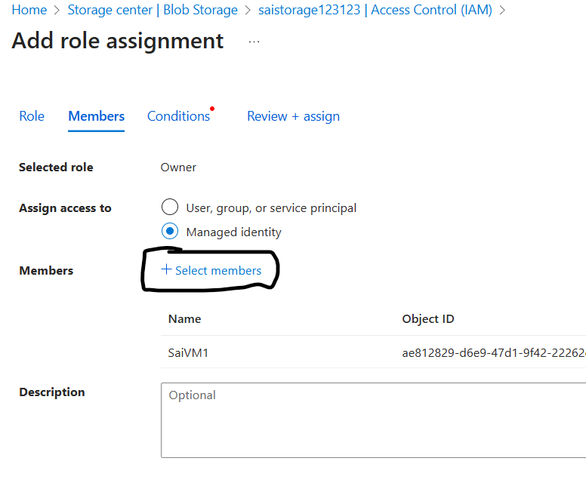

4. click on select members

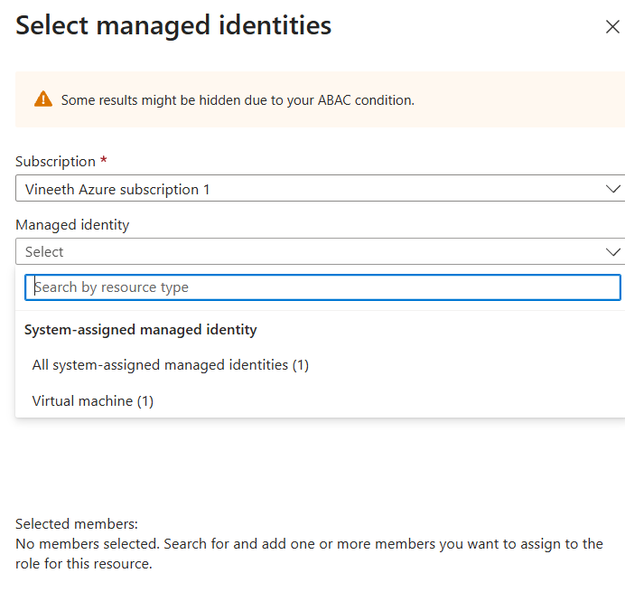

Under Managed identity : select VM ( which is enabled only after enable Identity from VM )
Select VM and click on select option

5.
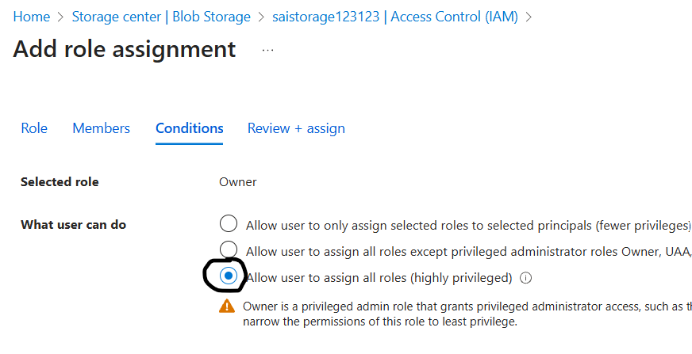

Next and done

- RBAC ( Role to Role ) :
Same as Resource process
While adding role instead of owner, reader is assigned

- File share

- Add file
- Under Basics :
  - Name : any
  - Access tier : transaction optimized
Performance
  - Maximum IO/s : 20000
  - Maximum capacity : 100 TiB

Disable backup -> review and create

- You can add folders from overview -> add directory or
- In Browse also you can provide
- Using connect you can add drive to VM storage drive :
  - Drive letter : Z,
  - Authentication method : storage account key
  - From VM : Open power shell
  - Paste the code and enter
  - Now you can observe drive added in file manager

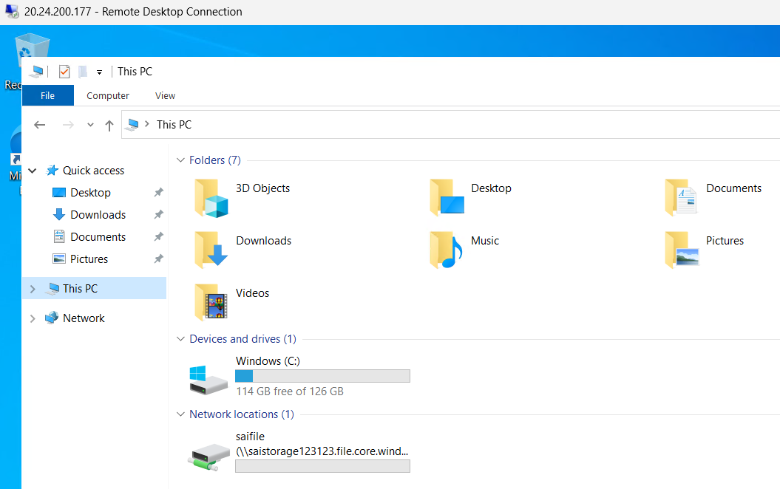

  - You can access, add
- Using upload you can upload
- Edit quota to edit storage space

- You can provide access for queue and tables also.

- IMAGE CREATION
- Requirement
- Create RG, VNet, VM
- Create VM using Image

- Create VM
- Download and install chrome and putty

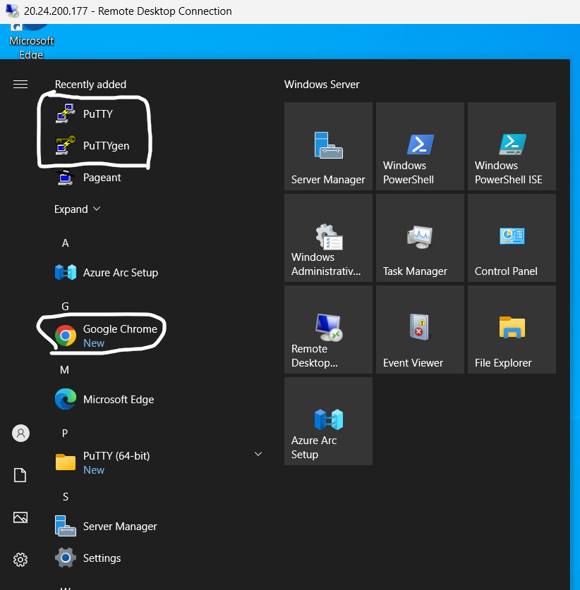

- Press windows + R or Type in Start as Run for Run command and type sysprep

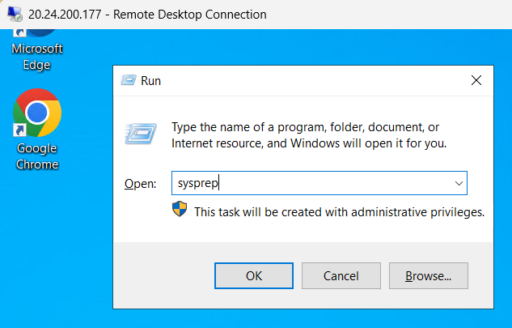

- Run sysprep tool -> OOBE, Generate, Shutdown

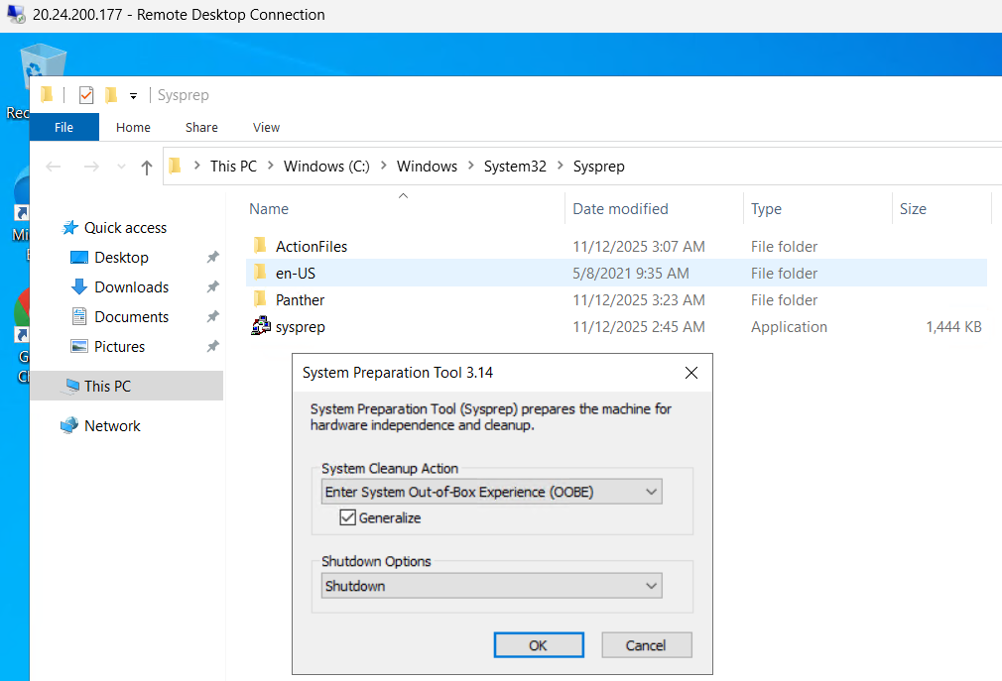
- Done

- From azure generate Image from VM

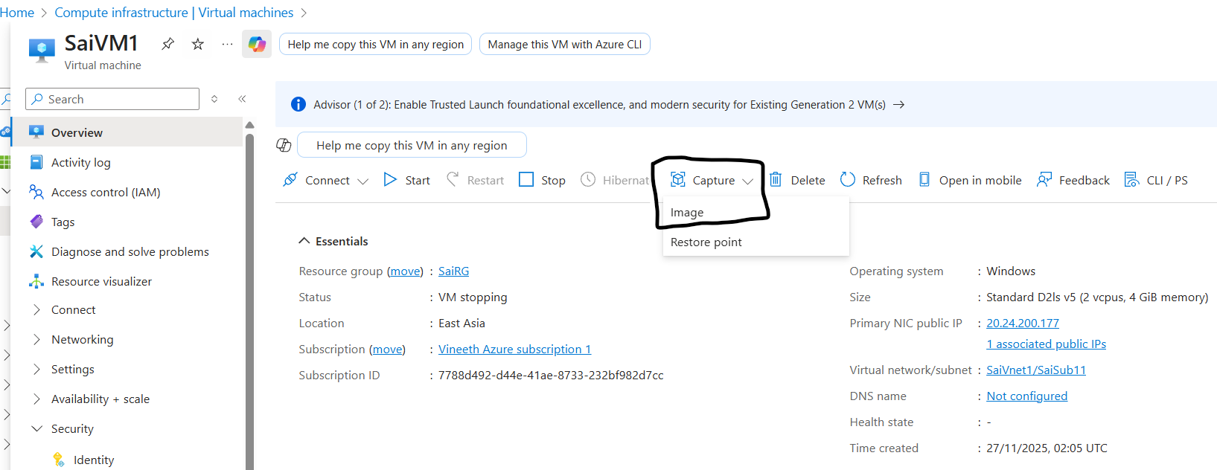

- After clicking
  - Share image to azure compute gallery : Yes, share it to a gallery as a VM image version.
  - Tick “ automatic delete the VM after creating the image.

  - Gallery details :
  - Target azure compute gallery : enter any name
  - Operate system state : generalized
  - Lock deleting Replicated Locations will be enable : deselect it
  - Version number : any ( ex: 0.0.1)
  - After creating Image
  - Now create VM using this image

- Download Packer Tool but do not install

- For Windows : Windows image creation using packer

- You can observe JSON format code for windows
- The code as follows for windows in json format :

{
"builders": [{
"type": "azure-arm",

"client_id": "xxxxxxxx-xxxx-xxxx-xxxx-xxxxxxxxxxx",
"client_secret": "ppppppp-pppp-pppp-pppp-ppppppppppp",
"tenant_id": "zzzzzzz-zzzz-zzzz-zzzz-zzzzzzzzzzzz",
"subscription_id": "yyyyyyy-yyyy-yyyy-yyyy-yyyyyyyyyyy",

"managed_image_resource_group_name": "myPackerGroup",
"managed_image_name": "myPackerImage",

"os_type": "Windows",
"image_publisher": "MicrosoftWindowsServer",
"image_offer": "WindowsServer",
"image_sku": "2016-Datacenter",

"communicator": "winrm",
"winrm_use_ssl": true,
"winrm_insecure": true,
"winrm_timeout": "5m",
"winrm_username": "packer",

"azure_tags": {
"dept": "Engineering",
"task": "Image deployment"
},

"build_resource_group_name": "myPackerGroup",
"vm_size": "Standard_D2_v2"
}],

"location": "East US",
"vm_size": "Standard_DS2_v2"
}],

"provisioners": [{
"type": "powershell",
"inline": [
"Add-WindowsFeature Web-Server",
"while ((Get-Service RdAgent).Status -ne 'Running') { Start-Sleep -s 5 }",
"while ((Get-Service WindowsAzureGuestAgent).Status -ne 'Running') { Start-Sleep -s 5 }",
"& $env:SystemRoot\\System32\\Sysprep\\Sysprep.exe /oobe /generalize /quiet /quit",
"while($true) { $imageState = Get-ItemProperty HKLM:\\SOFTWARE\\Microsoft\\Windows\\CurrentVersion\\Setup\\State | Select ImageState; if($imageState.ImageState -ne 'IMAGE_STATE_GENERALIZE_RESEAL_TO_OOBE') { Write-Output $imageState.ImageState; Start-Sleep -s 10 } else { break } }"
]
}]
}

- Explanation :
- Purpose (High level)
- Packer creates a temporary Azure VM
- Installs/configures software on it (IIS in this case)
- Generalizes the VM using Sysprep
- Saves it as a managed image in Azure
- You can later use that image to create new VMs

- builders section (How the VM is created)
  - "builders": [{
"type": "azure-arm"
}]
- This tells Packer to use Azure Resource Manager (ARM) to build the image.

  - Authentication
"client_id": "...",
"client_secret": "...",
"tenant_id": "...",
"subscription_id": "..."
- These are Azure service principal credentials used by Packer to: Create resource groups, Create VMs, Save images

  - Image output :
"managed_image_resource_group_name": "myPackerGroup",
"managed_image_name": "myPackerImage"
The final image will be saved as:
Resource group: myPackerGroup
Image name: myPackerImage
- This is the reusable Azure Managed Image.

  - Base OS
"os_type": "Windows",
"image_publisher": "MicrosoftWindowsServer",
"image_offer": "WindowsServer",
"image_sku": "2016-Datacenter"
- This defines the base image : Windows Server 2016 Datacenter
  - From Microsoft’s official Azure marketplace

  - Communicator (How Packer connects)
"communicator": "winrm",
"winrm_use_ssl": true,
"winrm_insecure": true,
"winrm_timeout": "5m",
"winrm_username": "packer"
- Uses WinRM over HTTPS to connect to the VM
- winrm_insecure: true allows self-signed certificates
- packer is the admin username Packer logs in with

  - Azure tags
"azure_tags": {
"dept": "Engineering",
"task": "Image deployment"
}
- Adds tags to Azure resources for : Billing, Organization, Resource management

  - Build VM settings
"build_resource_group_name": "myPackerGroup",
"vm_size": "Standard_D2_v2"
- Temporary VM is created in myPackerGroup
- VM size: 2 vCPUs, 7 GB RAM

  - Location and RAM
"location": "East US",
"vm_size": "Standard_DS2_v2"
}],

- provisioners section (What happens inside the VM) :
- Provisioners configure the VM after it starts.

  - PowerShell provisioner
"type": "powershell"
- Runs PowerShell commands inside the VM.

  - Install IIS
Add-WindowsFeature Web-Server
- Installs IIS (Web Server).

  - Wait for Azure services
while ((Get-Service RdAgent).Status -ne 'Running') { Start-Sleep -s 5 }
while ((Get-Service WindowsAzureGuestAgent).Status -ne 'Running') { Start-Sleep -s 5 }
- Ensures:
  - Azure Remote Desktop Agent
  - Azure Guest Agent
  - are fully running before continuing.
  - This prevents image corruption.

  - Run Sysprep (VERY important)
Sysprep.exe /oobe /generalize /quiet /quit
- Generalizes the OS
- Removes machine-specific data
- Prepares it for cloning
- Required before capturing an image

  - Wait for Sysprep to finish
while($true) {
$imageState = Get-ItemProperty HKLM:\SOFTWARE\Microsoft\Windows\CurrentVersion\Setup\State | Select ImageState
if($imageState.ImageState -ne 'IMAGE_STATE_GENERALIZE_RESEAL_TO_OOBE') {
Write-Output $imageState.ImageState
Start-Sleep -s 10
} else {
break
}
}

- Polls Windows registry
- Confirms Sysprep completed successfully
- Prevents Packer from capturing the image too early

- End result : After this template runs:
- A Windows Server 2016 image , IIS pre-installed, Fully generalized
- Stored as myPackerImage, Ready to deploy multiple Azure VMs

- Common use cases : Golden images, Faster VM provisioning, Standardized environments
- Dev/Test or production VM templates

- Packer for Windows image creation
- To create service principal account
- Login in to azure portal => search Entra ID => Manage => app registration => new registration ( remember name for applying role in Subscription role)
  - Type any name and register
  - Now you can get : app id, object id, tenant id,
- Now copy client id, tenant id from azure and paste in vs code
- Search Subscription in search bar from azure and select the subscription
- Now you can get Sub id
- Now click on entra ID -> under manage -> app registration -> select your id
Again manage -> certificate and secrets -> add a client secret
  - Enter any name :
  - Click on add
- Now copy value instead of secret id,

- Last step provide Entra id role access from Subscription -> add role
  - Priviledge admin role : owner
  - Assign access to : user group or service principal
  - Select members : packer id
  - What user can do : highly priviledged

- Open cmd and type cd ..
- Until you come to user outside and enter packer folder : Cd foldername
- Check the json file present or not
- Verify version as : packer –version
- Type : packer.exe build windows.json
Ex : C:\Packer>packer.exe build windows.json

- You will face error 1st time for vscode as :
Error: Failed to initialize build "azure-arm"

The builder azure-arm is unknown by Packer, and is likely part of a plugin that
is not installed.
You may find the needed plugin along with installation instructions documented
on the Packer integrations page.
https://developer.hashicorp.com/packer/integrations?filter=azure

- just execute this code : packer plugins install github.com/hashicorp/azure

- Result : Installed plugin github.com/hashicorp/azure v2.5.0 in "C:/Users/HOME/AppData/Roaming/packer.d/plugins/github.com/hashicorp/azure/packer-plugin-azure_v2.5.0_x5.0_windows_amd64.exe"

- Now try to execute : C:\Packer>packer.exe build linux.json
- It starts execution : azure-arm: output will be in this color.

After login in VM windows and you can observe in server manager

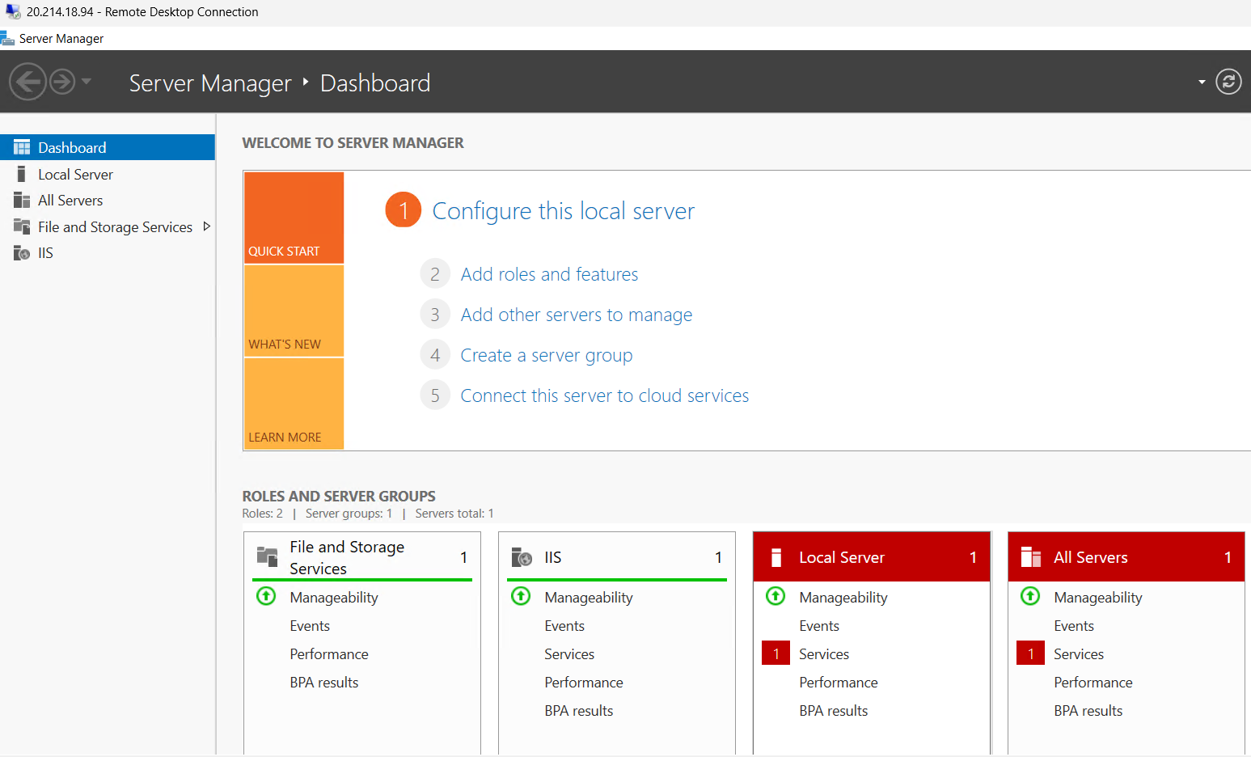

After allow http in inbound rules and outbound
Enter public ip in chrome url bar and same in vm Windows

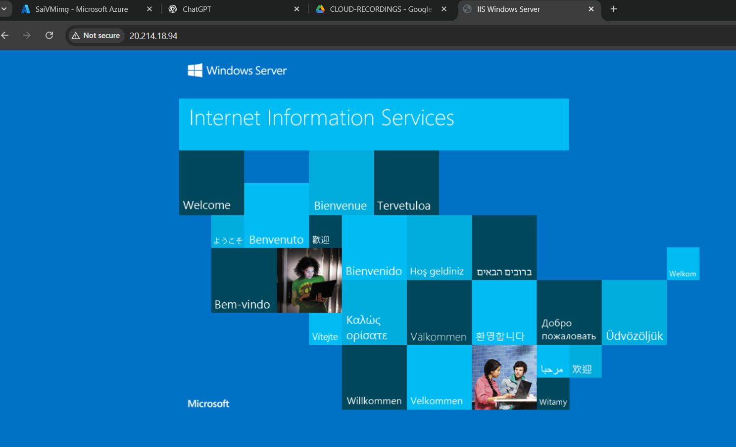

If you can click on any box you can observe this

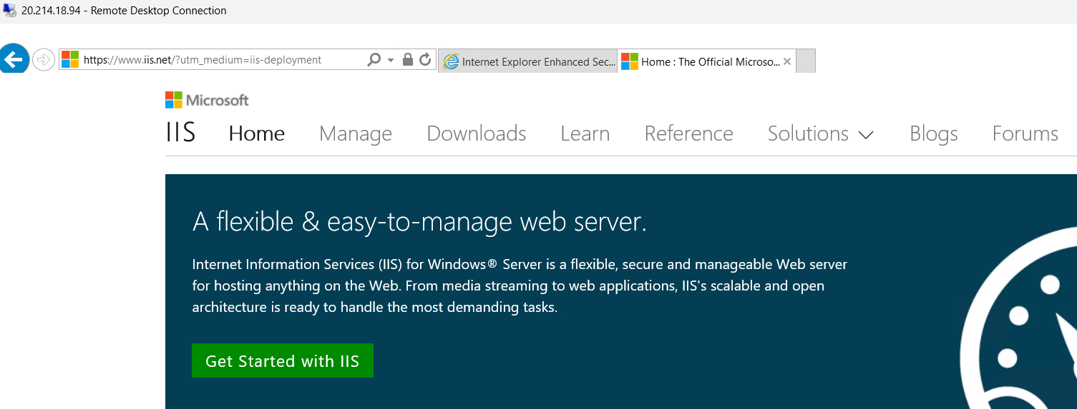

- For Linux
- After creating Linux VM get update and install nginx
- Remove dependencies using
  - apt-get autoremove -y
  - apt-get clean
  - rm -rf /var/lib/apt/lists/*
- Close the VM linux using exit command
- Step to create image from linux

- Code
- You can observe JSON format code for Linux
- The code as follows for windows in json format :

{
"builders": [{
"type": "azure-arm",

"client_id": "00001111-aaaa-2222-bbbb-3333cccc4444",
"client_secret": "0e760437-bf34-4aad-9f8d-870be799c55d",
"tenant_id": "aaaabbbb-0000-cccc-1111-dddd2222eeee",
"subscription_id": "xxxxxxxx-xxxx-xxxx-xxxx-xxxxxxxxxxx",

"managed_image_resource_group_name": "myResourceGroup",
"managed_image_name": "myPackerImage",

"os_type": "Linux",
"image_publisher": "canonical",
"image_offer": "0001-com-ubuntu-server-jammy",
"image_sku": "22_04-lts",

"azure_tags": {
"dept": "Engineering",
"task": "Image deployment"
},

"location": "East US",
"vm_size": "Standard_DS2_v2"
}],
"provisioners": [{
"execute_command": "chmod +x {{ .Path }}; {{ .Vars }} sudo -E sh '{{ .Path }}'",
"inline": [
"apt-get update",
"apt-get upgrade -y",
"apt-get -y install nginx",

"/usr/sbin/waagent -force -deprovision+user && export HISTSIZE=0 && sync"
],
"inline_shebang": "/bin/sh -x",
"type": "shell"
}]
}

- Code Explanation :
- Code runs in JSON format in azure-arm template
- Packer is 3rd party tool and need to connect to azure then code executes
"type": "azure-arm",

- Authentication method / Service account authentication method
"client_id": "00001111-aaaa-2222-bbbb-3333cccc4444",
"client_secret": "0e760437-bf34-4aad-9f8d-870be799c55d",
"tenant_id": "aaaabbbb-0000-cccc-1111-dddd2222eeee",
"subscription_id": "xxxxxxxx-xxxx-xxxx-xxxx-xxxxxxxxxxx",

- Resource group name in which image need to be created
"managed_image_resource_group_name": "myResourceGroup",

- Image Name as it will create : "managed_image_name": "myPackerImage",

- Raw image or OS code
"os_type": "Linux",
"image_publisher": "canonical",
"image_offer": "0001-com-ubuntu-server-jammy",
"image_sku": "22_04-lts",

- Location of OS : "location": "East US",
- Image Size : "vm_size": "Standard_DS2_v2"

- After OS created code executes as to execute code inside of OS :
"execute_command": "chmod +x {{ .Path }}; {{ .Vars }} sudo -E sh '{{ .Path }}'",
"inline": [

- For updating : "apt-get update",
- For upgrading : "apt-get upgrade -y",
- For installing nginx : "apt-get -y install nginx",

- After OS and softwares installed it deletes dependencies : "/usr/sbin/waagent -force -deprovision+user && export HISTSIZE=0 && sync"
- By this script complete code does the work of OS creation, software install and dependency delete automatically

- Packer for Linux image creation
- To create service principal account
- Login in to azure portal => search Entra ID => Manage => app registration => new registration ( remember name for applying role in Subscription role)
  - Type any name and register
  - Now you can get : app id, object id, tenant id,
- Now copy client id, tenant id from azure and paste in vs code
- Search Subscription in search bar from azure and select the subscription
- Now you can get Sub id
- Now click on entra ID -> under manage -> app registration -> select your id
Again manage -> certificate and secrets -> add a client secret
  - Enter any name :
  - Click on add
- Now copy value instead of secret id,

- Last step provide Entra id role access from Subscription -> add role
  - Priviledge admin role : owner
  - Assign access to : user group or service principal
  - Select members : packer id
  - What user can do : highly priviledged
- Final code
- "managed_image_resource_group_name": "SaiRG", : enter your resource group in which it need to be created
- "managed_image_name": "Saiimage1", : enter image name to be named

- select region : "location": "East Asia",
- Select Size : "vm_size": "Standard_B1s"

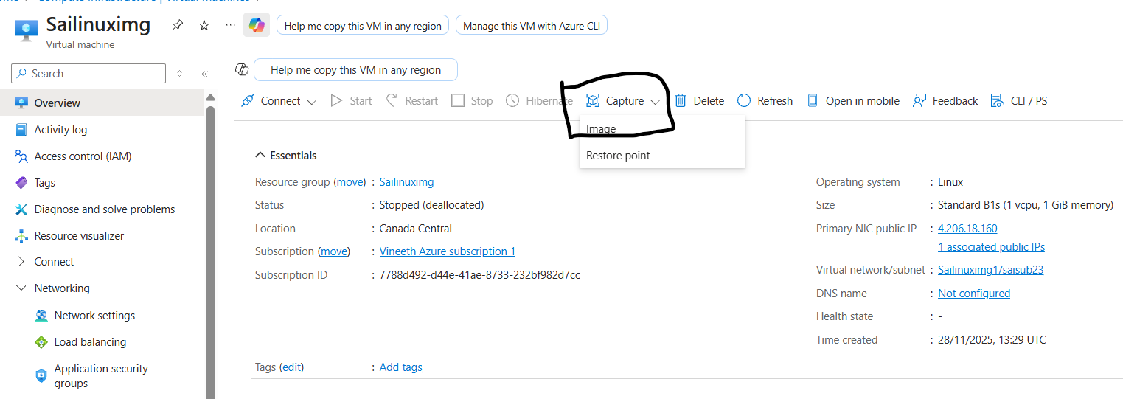

- While creating
- Same as windows
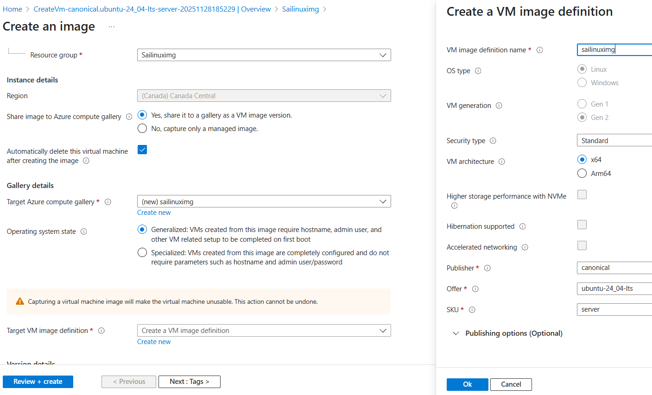

- Packer for OS image creation
- To create service principal account
- Login in to azure portal => search Entra ID => Manage => app registration => new registration ( remember name for applying role in Subscription role)
  - Type any name and register
  - Now you can get : app id, object id, tenant id,
- Now copy client id, tenant id from azure and paste in vs code
- Search Subscription in search bar from azure and select the subscription
- Now you can get Sub id
- Now click on entra ID -> under manage -> app registration -> select your id
Again manage -> certificate and secrets -> add a client secret
  - Enter any name :
  - Click on add
- Now copy value instead of secret id,

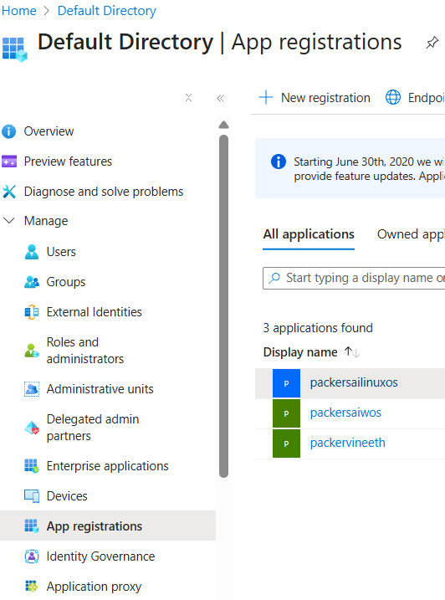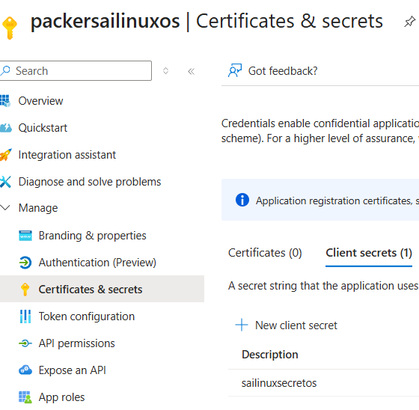

- You can observe client id, tenant id
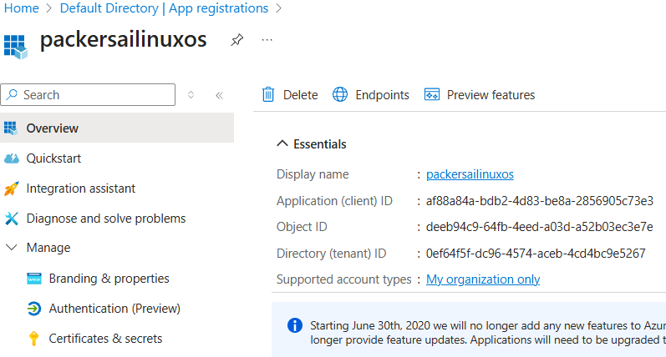

- Last step provide Entra id role access from Subscription -> add role
  - Priviledge admin role : owner
  - Assign access to : user group or service principal
  - Select members : packer id
  - What user can do : highly priviledged

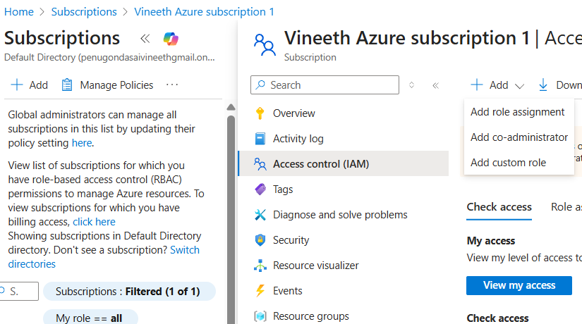

- Open cmd and type cd ..
- Until you come to user outside and enter packer folder : Cd foldername
- Check the json file present or not
- Verify version as : packer –version
- Type : packer.exe build linux.json
Ex : C:\Packer>packer.exe build linux.json

- You will face error 1st time for vscode as :
Error: Failed to initialize build "azure-arm"

The builder azure-arm is unknown by Packer, and is likely part of a plugin that
is not installed.
You may find the needed plugin along with installation instructions documented
on the Packer integrations page.
https://developer.hashicorp.com/packer/integrations?filter=azure

- just execute this code : packer plugins install github.com/hashicorp/azure

- Result : Installed plugin github.com/hashicorp/azure v2.5.0 in "C:/Users/HOME/AppData/Roaming/packer.d/plugins/github.com/hashicorp/azure/packer-plugin-azure_v2.5.0_x5.0_windows_amd64.exe"

- Now try to execute : C:\Packer>packer.exe build linux.json
- It starts execution : azure-arm: output will be in this color.

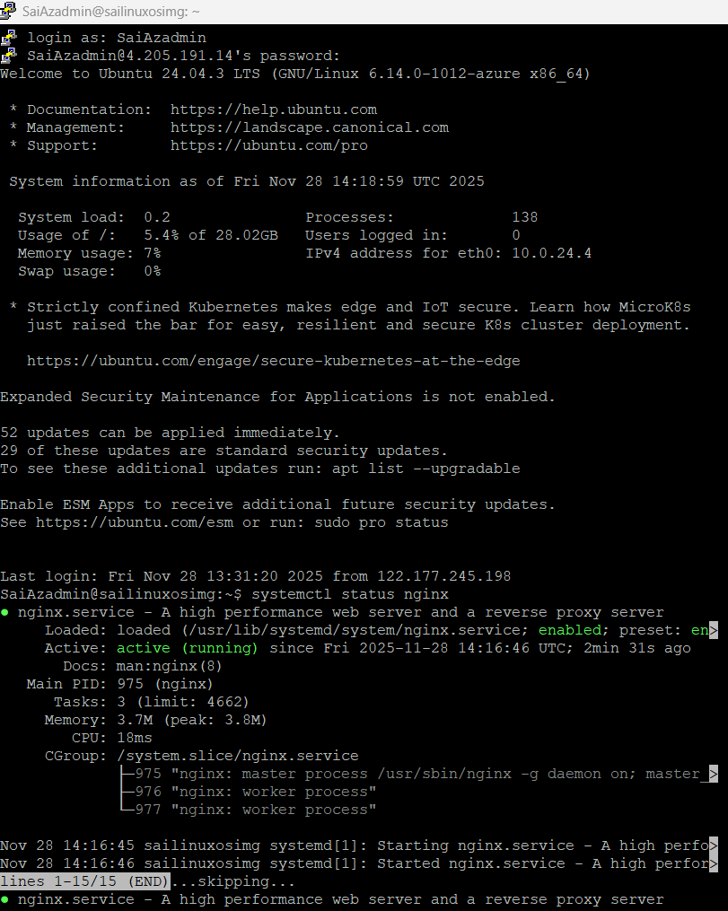

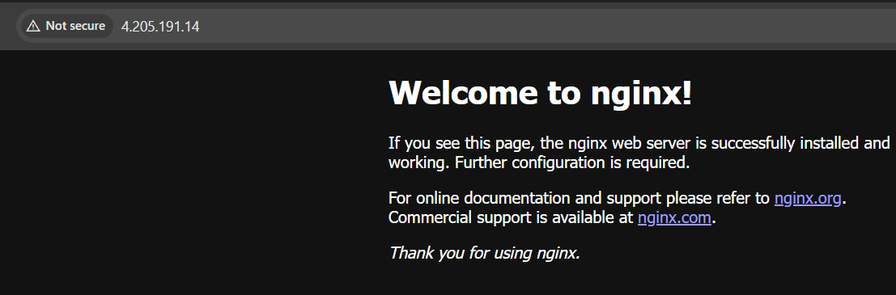

Done.

- VMSS – VIRTUAL MACHINE SCALE SET
- Vertical scaling : Upgrade of H/W size : from 1cpu and 1Gb ram to 2cpu and 8gb ram
- Requirement
- Create : RG, Vnet, VM with Linux ( 1cpu and 1gb ram )

- After creating VM with Linux
- Now stop the virtual machine
- In Overview under properties you can find size Option

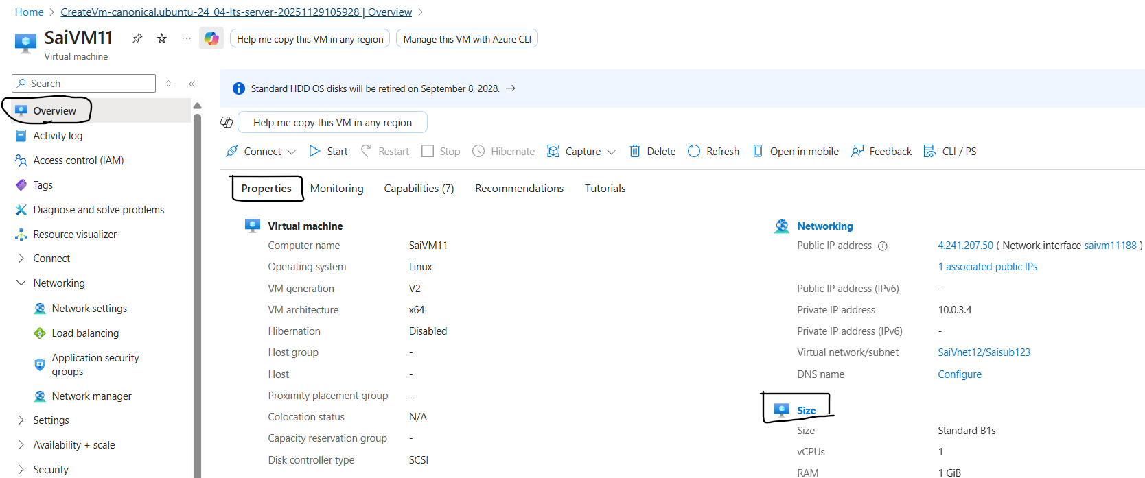

- Select size B2ms version, 2cpu and 8gb RAM
( you can change while it is in running also but takes long time )

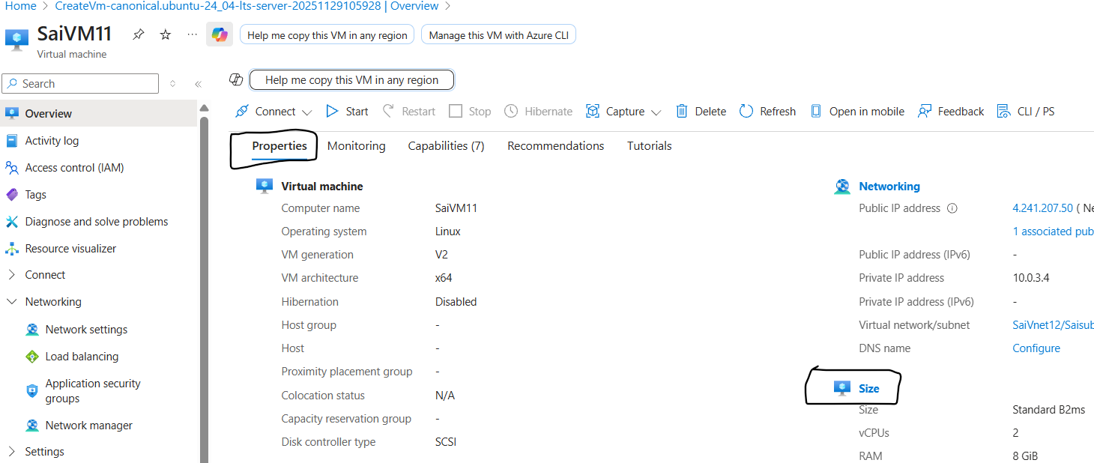

- Horizontal Scaling : adding up machines to distribute
Depends on load machines get increased to balance load
If load decreases, machines reduce.

    - Use custom image to create vm
- Use vmss while creating
Scale set details
  - Virtual machine scale set name
  - Orchestration mode : Flexible
  - Scaling : Scaling mode : Autoscaling
- Instance details : Image : select your custom image.
Administrator account
- Username : enter any user name
- Password = Confirm password : enter any

Under networking
- Vnet and subnet : select any thing
- Create a load balancer
- Review and create

- After creation
- You can check VMs under instances
- Under Availability + Scaling : Scaling : scroll down you can find instance limit
- Set rules for increasing at average percentage CPU >80 click on it and edit according to requirement
  - Operator : greater than
  - Metric threshold : 40
  - Duration : 1 min ( increases after 5 mins )
  - Time aggregation : max
  - Operation : increase count by
  - Instance count : 3
- Set rules for decreasing at average percentage CPU <20 click on it and edit according to requirement

- Login to VM

- LOGIN USING BASTION
- Requirement
- Create RG,, Vnet with Subnets 2 ( 1 for bastion special )
- Create VM without NIC

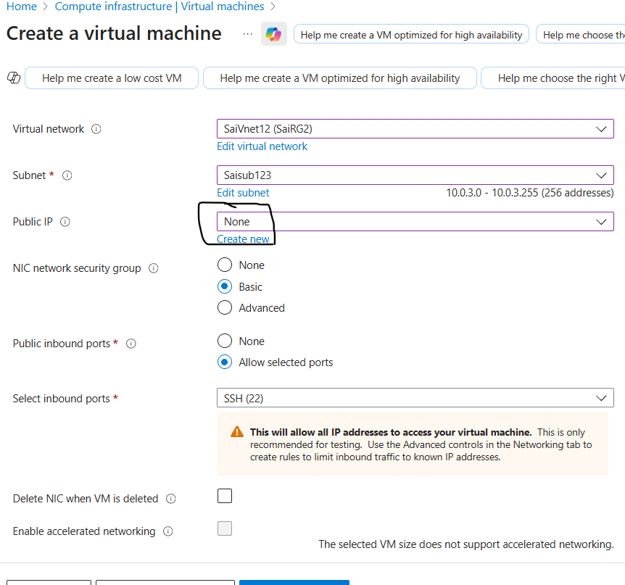

- After creating VM now create Bastion
Instance details
- Virtual Network : SaiVnet12 (SaiRG2)
- While creating subnet there is option known as purpose select bastion it generates name directly
Subnet : if you create AzureBastionSubnet name as it is it creates else automatic new names create. : (New) AzureBastionSubnet
- Range : Edit subnet10.0.0.0 - 10.0.0.63 (64 addresses)

Public IPv4 address
- Public IP address : Create new, Use existing

- Azure Bastion Subnet Requirements (Simple)
- Subnet name must be: AzureBastionSubnet
(The name must match exactly — no changes allowed.)
- Minimum subnet size: /26
(Larger is allowed: /25, /24, etc.)
- Must be in the same VNet where your VMs are located.
- No NSGs should be directly attached to the AzureBastionSubnet
(You can use NSGs on other subnets.)
- Requires a public IP (Standard SKU) for the Bastion host.
- No UDRs (User Defined Routes) that block required Bastion traffic.

- After creating Bastion
- Now connect VM to Bastion using Connect option

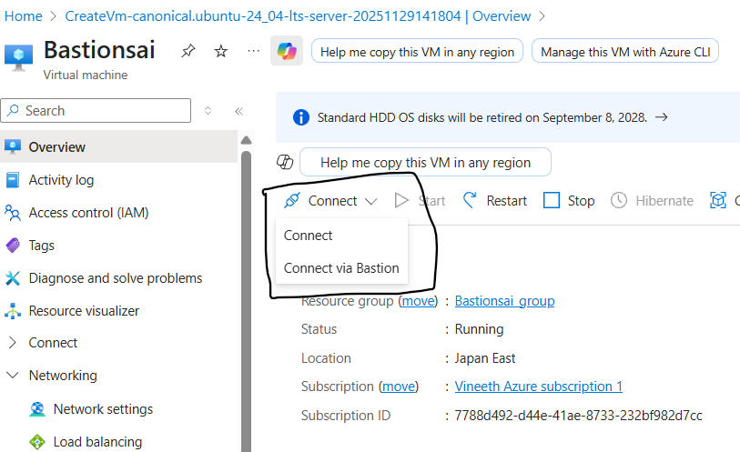

- If VM is windows use RDP or Linux use SSH
- Set up username and password

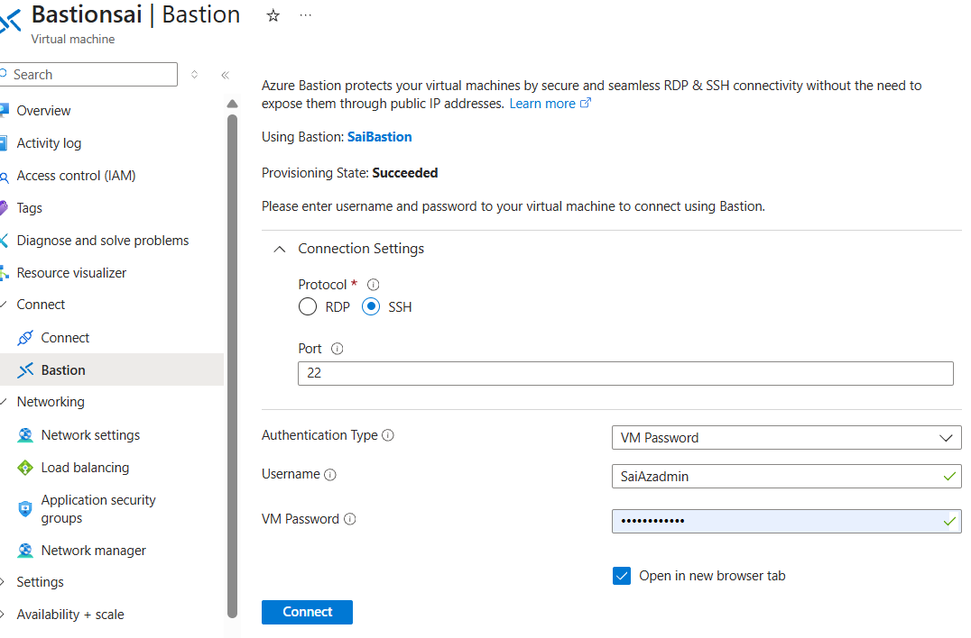

- After connecting VM to Bastion
- If you click on connect it will open in a new tab
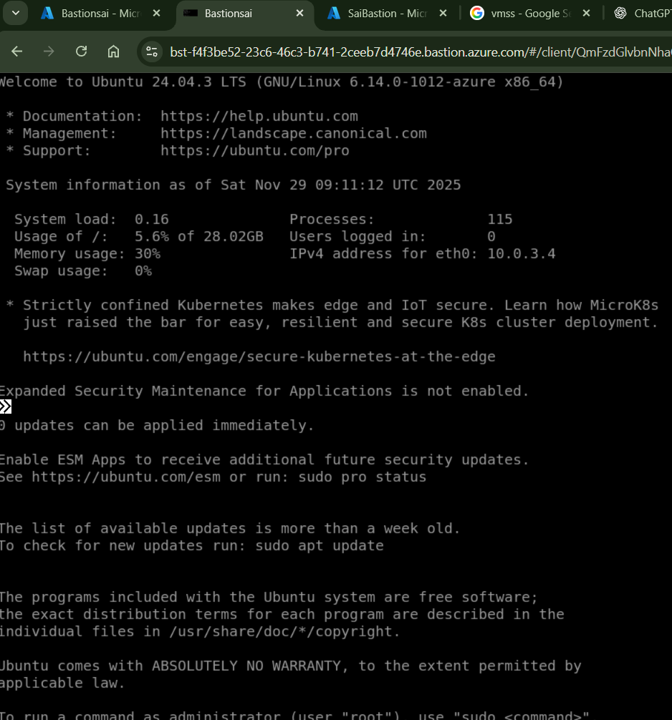

- Once you connect
- Type exit and disconnect VM
- Now you can connect via Overview -> Connect or
Connect -> Bastion

- RECOVERY SERVICE VAULT
- Recovery
- Requirement
- Create RG, VNet, Subnet and VM in region1 ( Japan )

- Create Service recovery vault in another region 2 ( Australia )
- Create RG, VNet, Subnet and service recovery vault
- Type recovery service vault and create one
  - Select RG,
  - Service name : any
  - Region : Australia
  - Backup storage redundancy : LRS

- After creating Recovery service vault
- Under getting started -> Site recovery -> Enable Replication

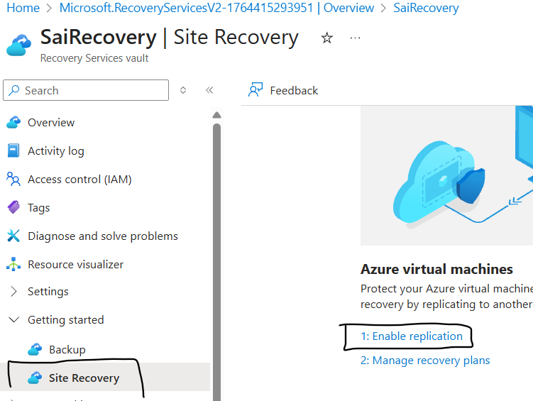

- Source
  - Select region : Japan
  - Select RG : SaiRG2
- Virtual Machine : Sairestore
- Replication settings : select region : target region ( if created select it else create new )
  - Select resource group and Vnet
- Manage : if you want to manage updates also select allow asr to manager
Else manage manually _/
- Last step : Review and allow replication

- If you want to check every update or step :
- Under recovery service vault account : Monitoring -> site recovery Jobs
- You can check

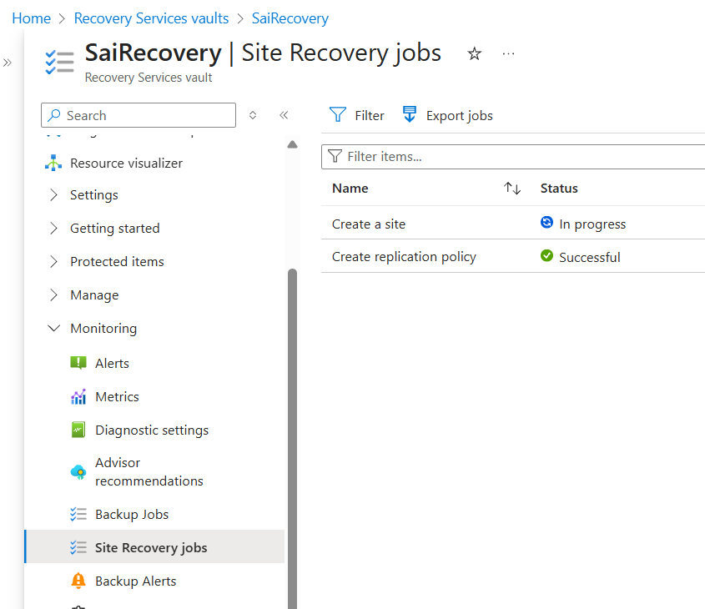

- If you want to check health and update
- You can check under : Protected items -> Replicated Items
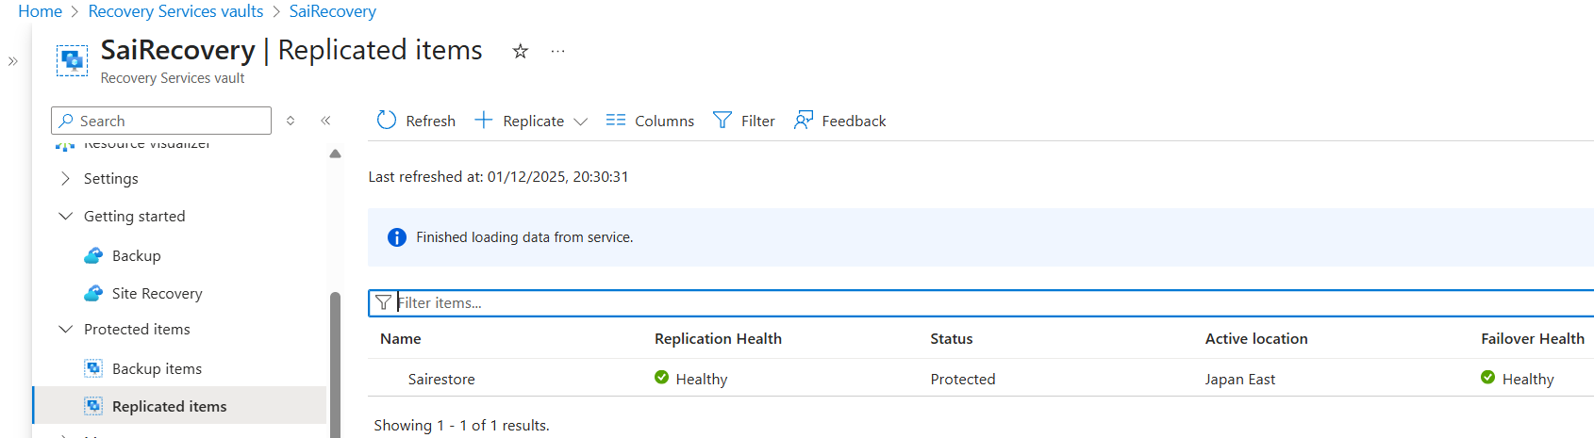

- BACKUP
- Requirement
- Create RG, VNet, Subnet and VM in region1 ( Belgium )
- Create Service recovery vault
- Type recovery service vault and create one
  - Select RG,
  - Service name : any name
  - Region : France
  - Backup storage redundancy : LRS

- After creating Recovery service vault
- Under getting started -> Backup
- Where is your workload running : Azure
- What do you want to backup : VM

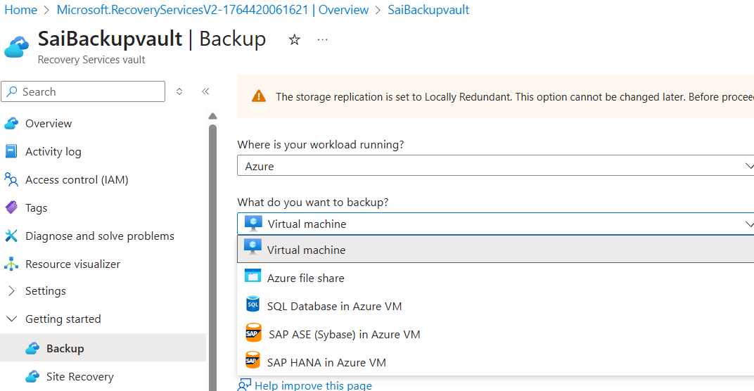

- After Backup click :-
- Policy Sub Type : standard
- Backup policy : you can add your own
- Virtual Machine : add your VM which you want to backup

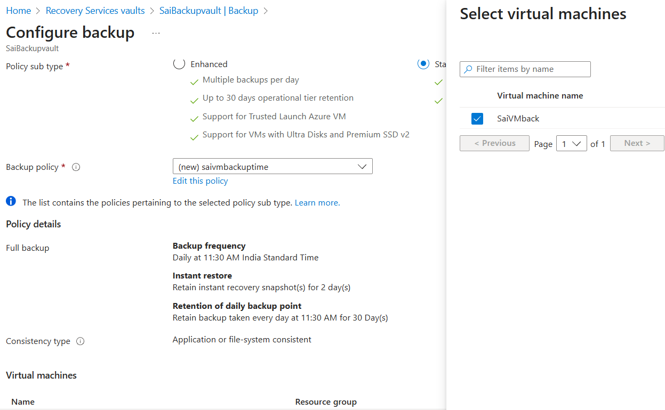

- Once backup done you can check here or You can do backup in another way
- Recovery service group -> Protected items -> backup items
- You can find the list.

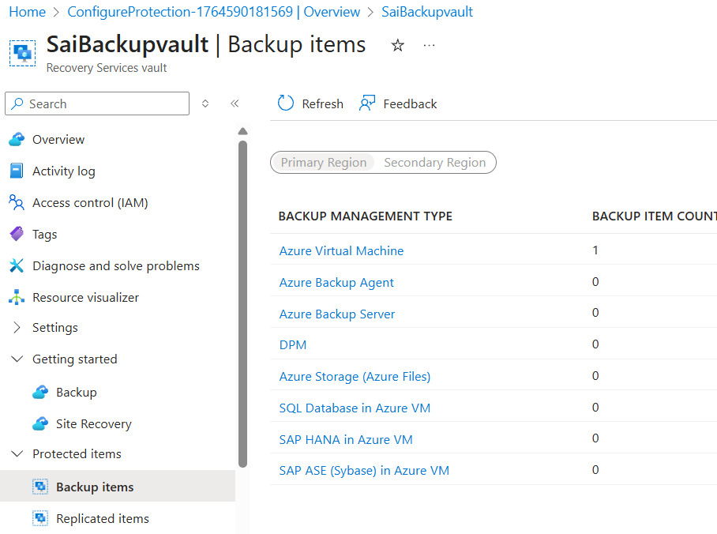

- Click on VM and add to add backup.
- If backup already done scroll right
- You can find view details

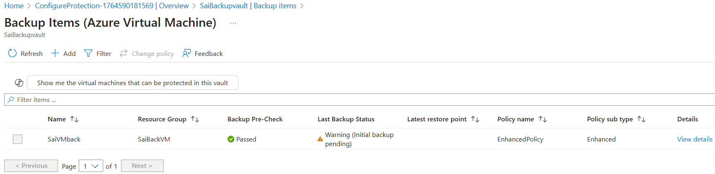

- Backup can be done

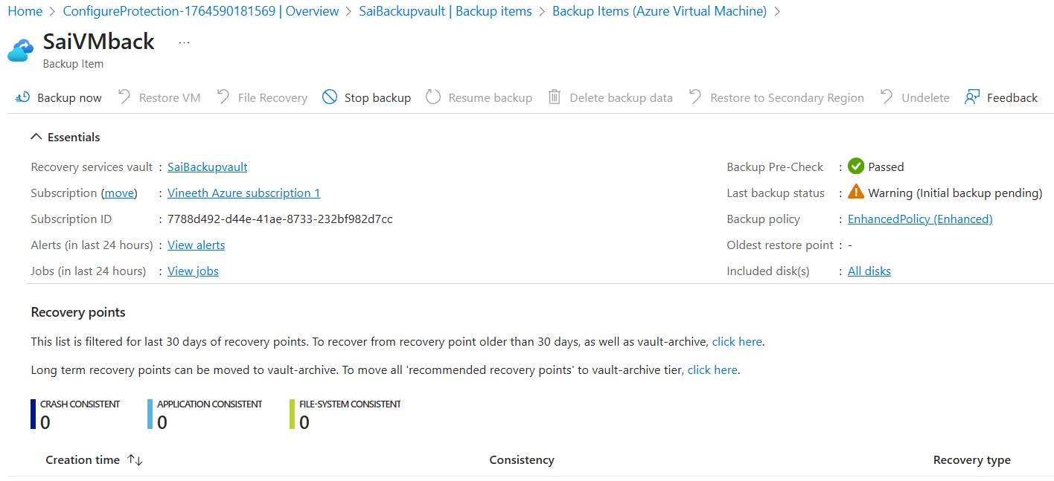

- For backup it takes 1 to 2 hours time
- Once backup done data would be until 14 days as protected as soft delete

- If you select backup now in VMs in Protected items -> backup items
- You can backup else it gets up as per schedule.

- RSV – RECOVERY SERVICE VAULT RESTORE
- RSV – Recovery
- Test Failover = Creating an isolated, temporary, test copy of your replicated virtual machines or servers from the Recovery Services Vault, without affecting production replication, production machines, or the recovery plan.
- You can check under : Protected items -> Replicated Items

- Click on it you can find test fail over.
- While doing test failover it looks like this

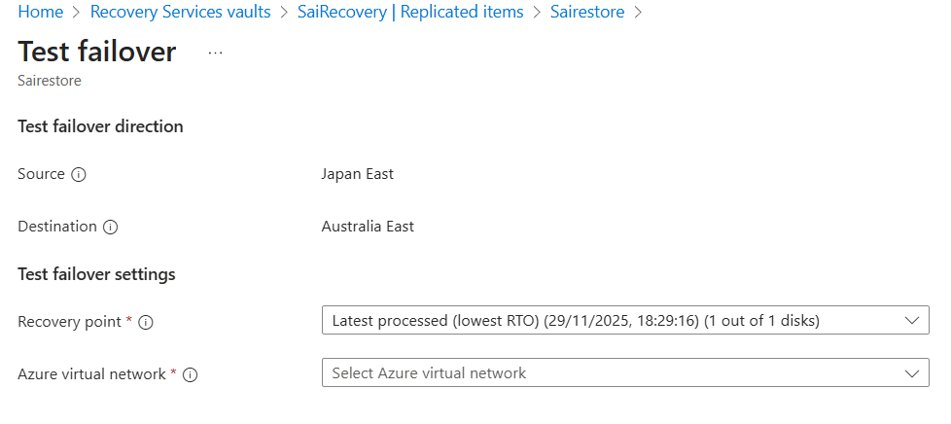
- After test failover one more VM gets created but with no NIC card
- On running VM you can not create a NIC card hence, stop VM

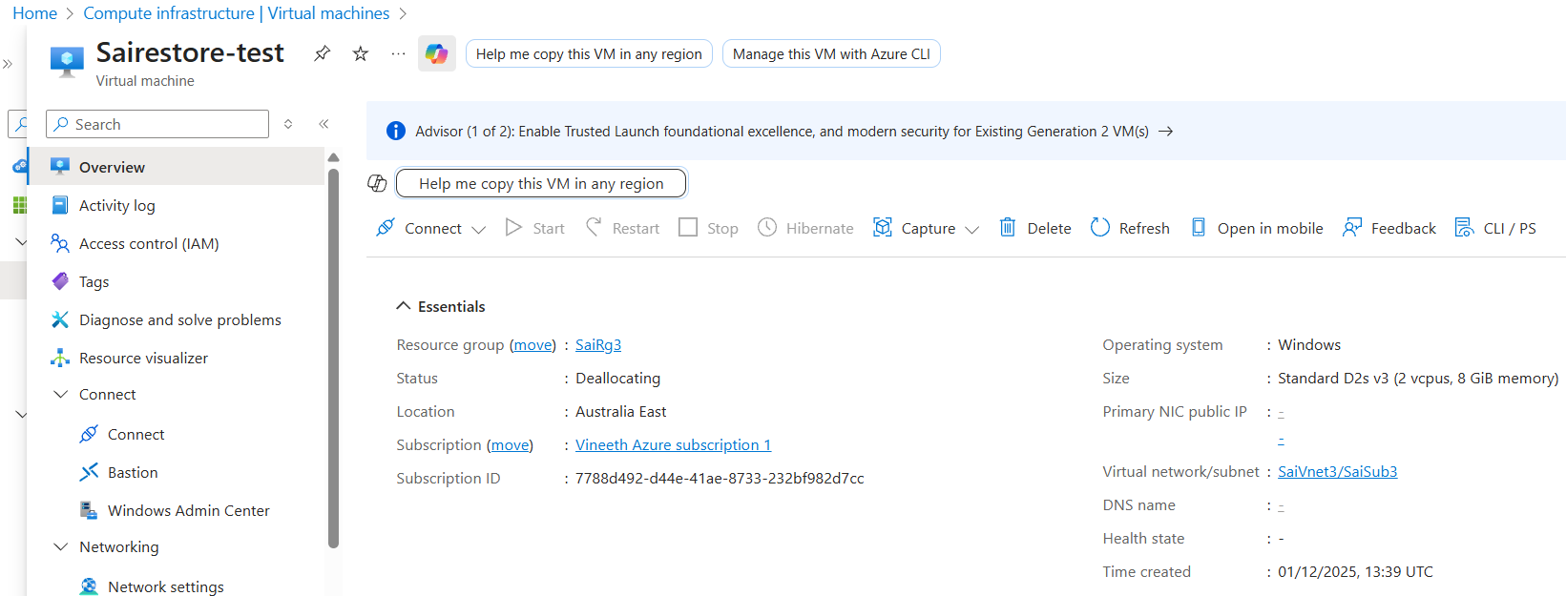

- Under network -> network settings click on enable NIC

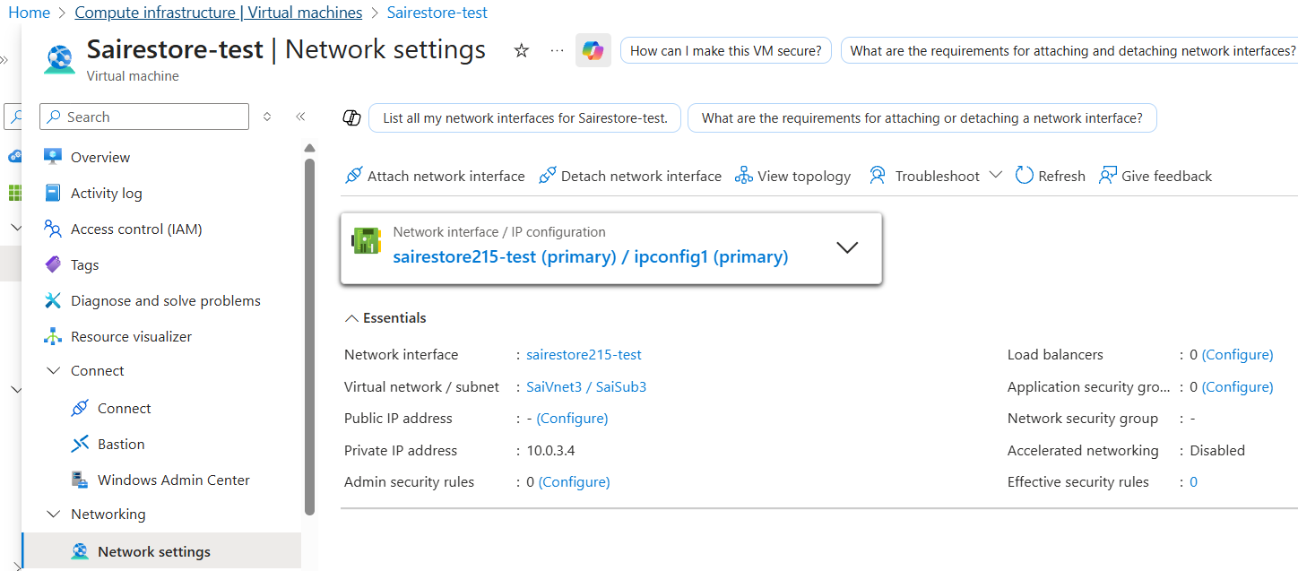

- After click on attach nic card -> option occurs as enable NIC

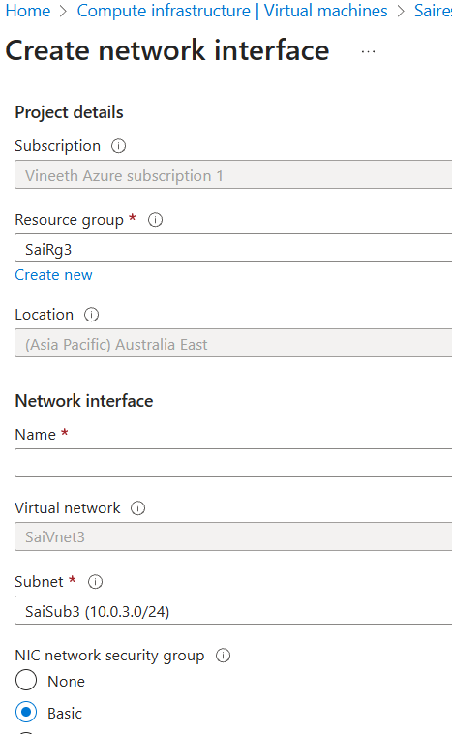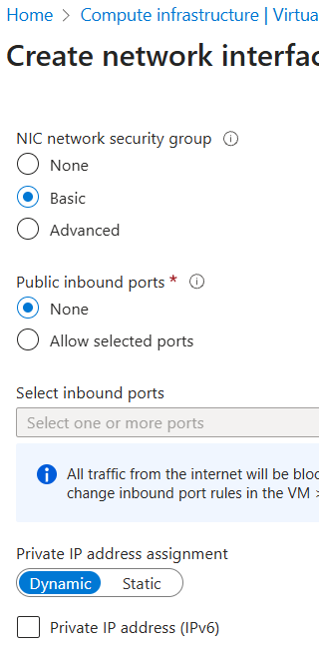
- To enable public ip
- Select nic card -> under settings -> IP config

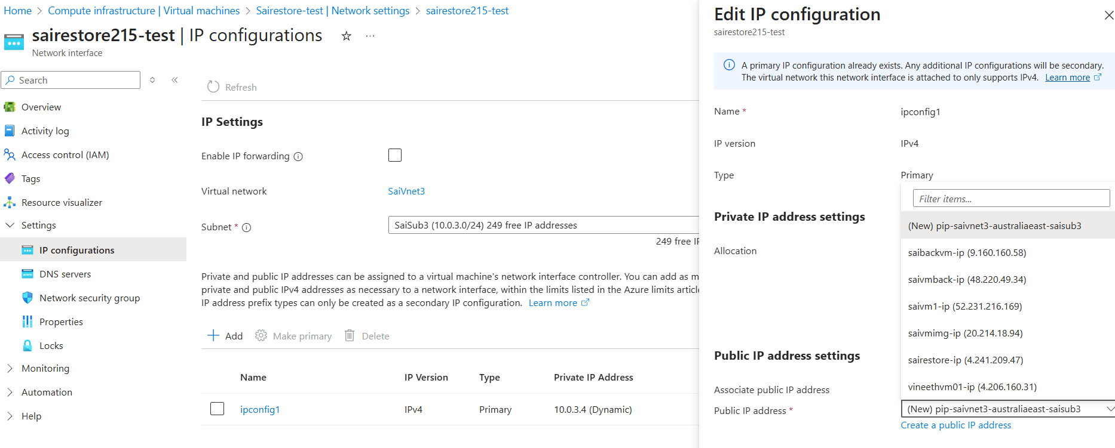

- Finally public IP address attached
- But no NSG and you need to create NSG for logging it
- Now run vm and check it.

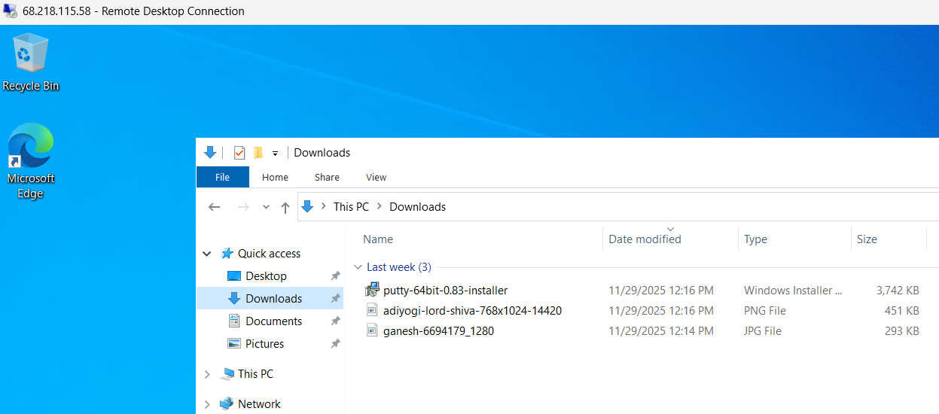

- Now clean up fail over
- You can clear under : Protected items -> Replicated Items
- Click on name and click on clear fail over
- Done

- Now do actual failover
- Enable the Shutdown vm before begging failover.
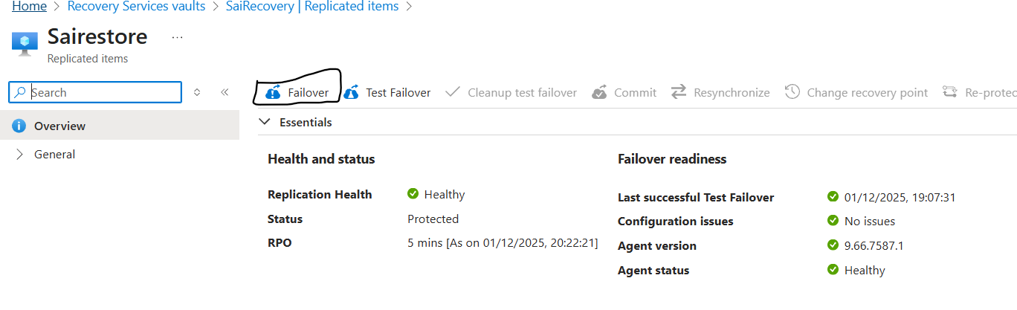

- Done failover you can check in replicated items failover

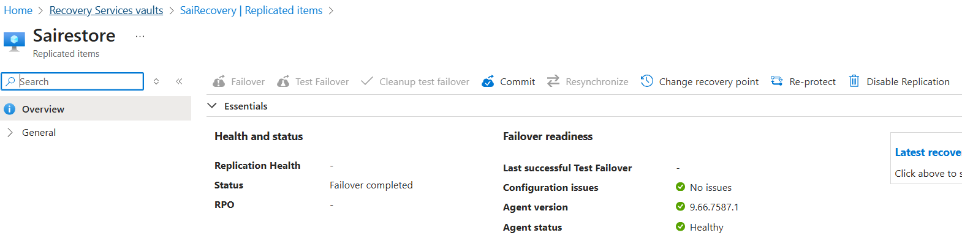

- In site recovery jobs

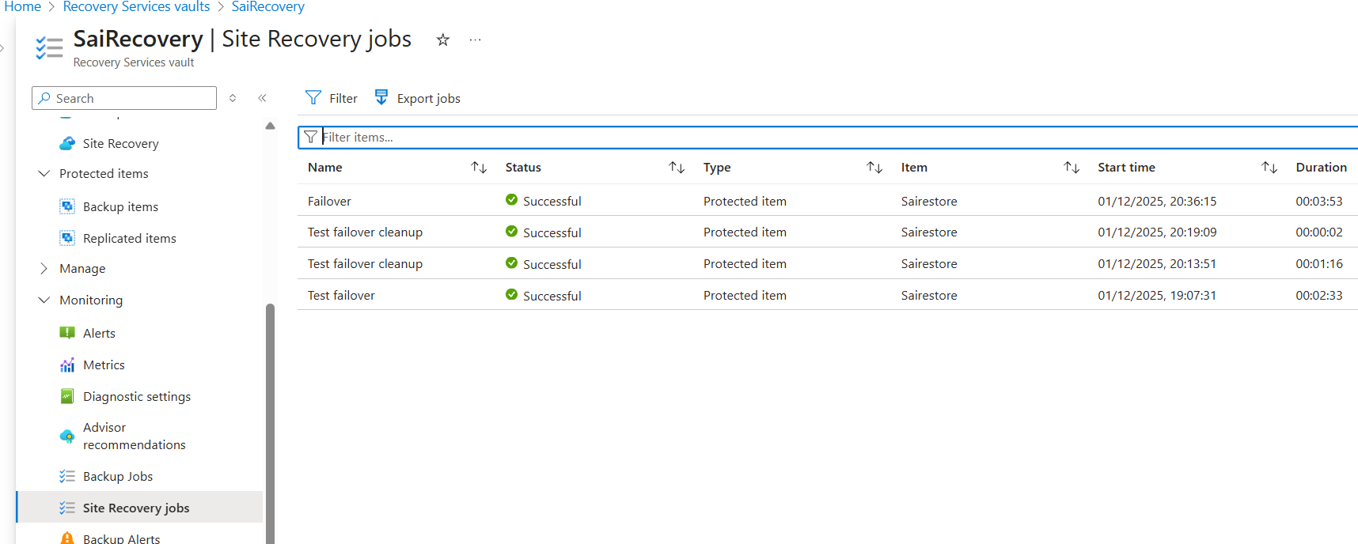

- Now disable and delete replication
- By clicking on 3 dots and disable replica

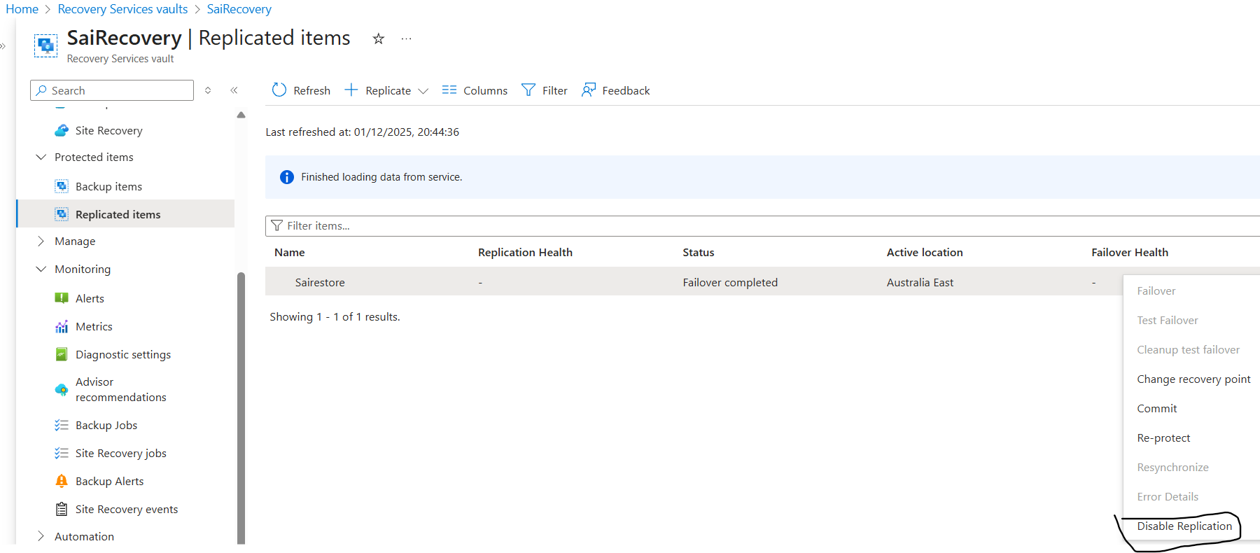

- Or

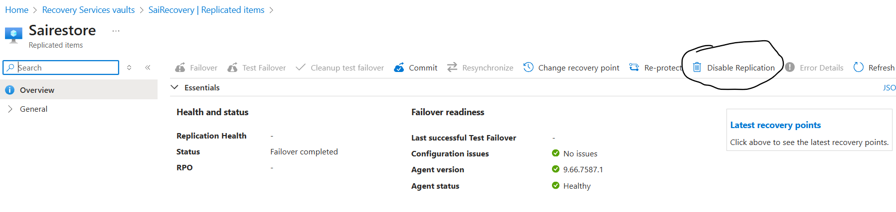

- Done
- Now delete replication or rg

- BACKUP VM level
- Now create storage account in same region
- Basics

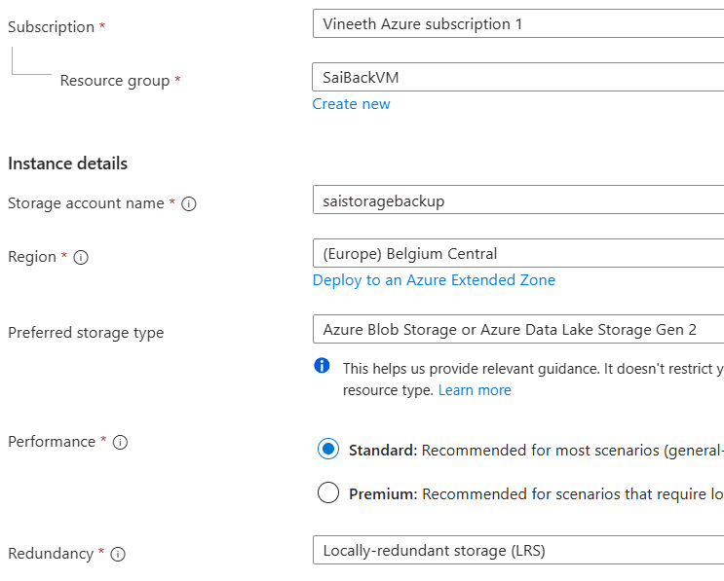

- Advance
- Access tier : hot

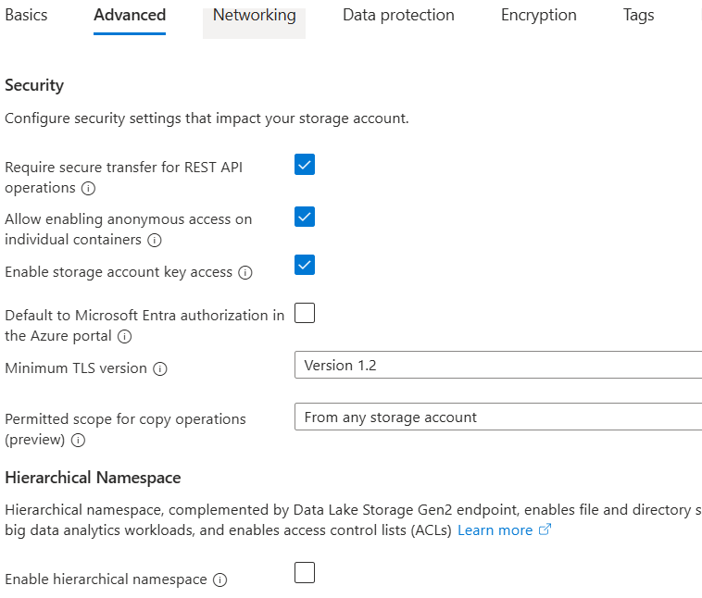

- Data protection

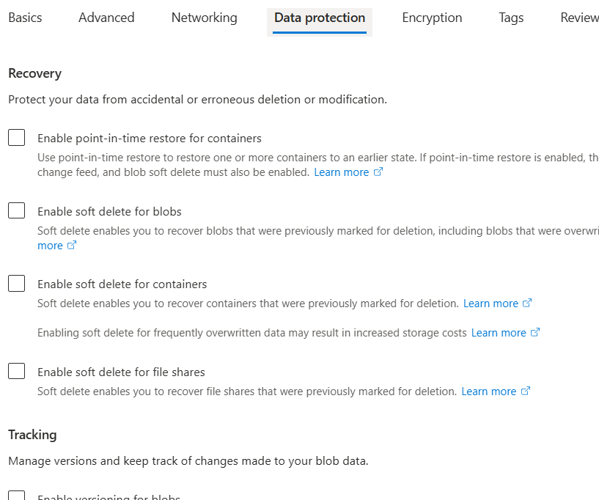

- Encryption :

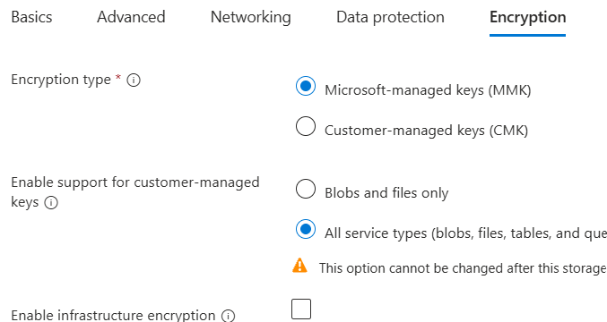

- Done

- Now check the backup job for backup update

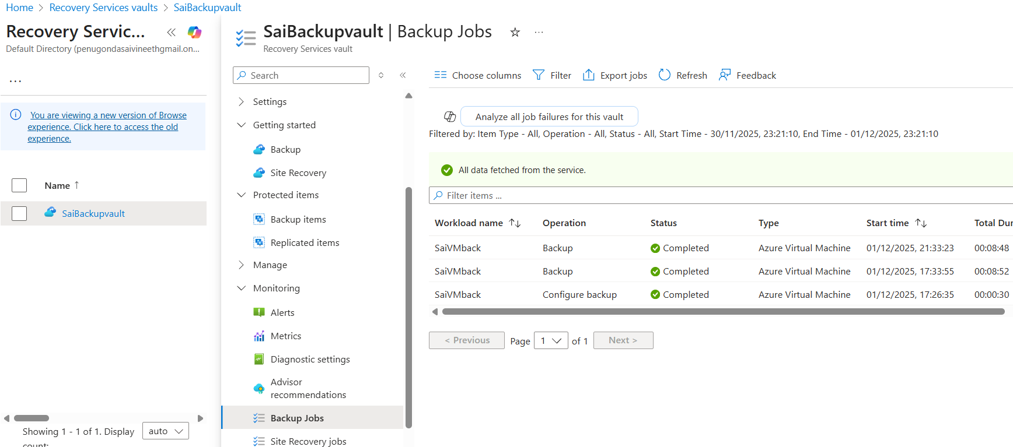

- From RSV, protected items -> backup items

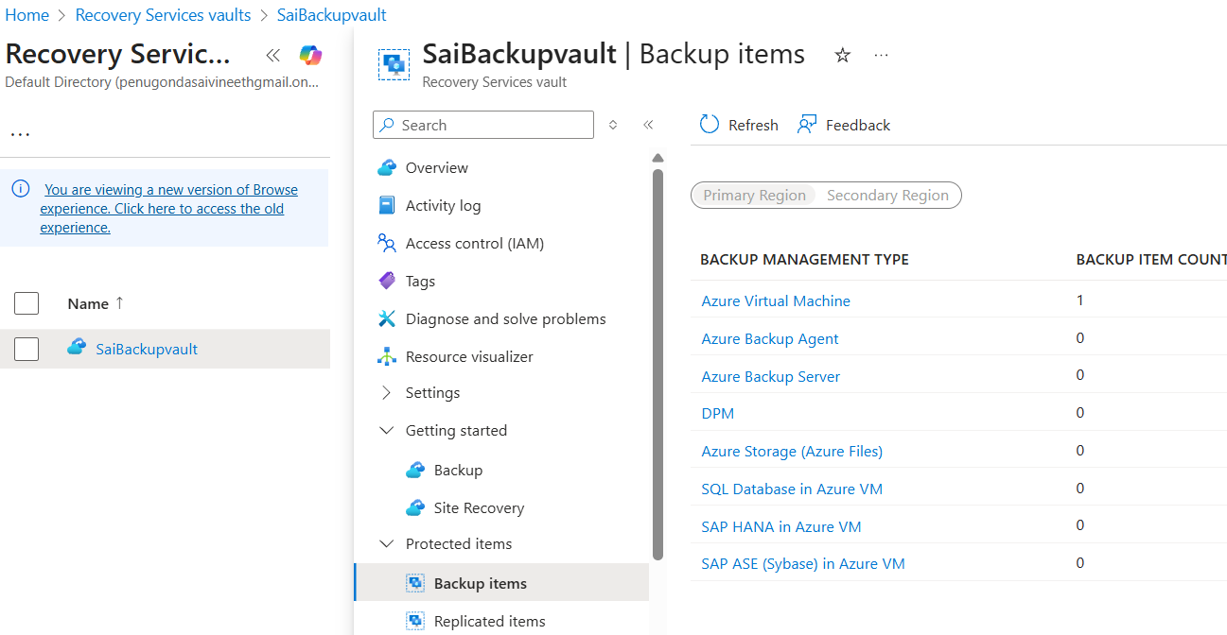

- Select Azure virtual machine
- View details
- Restore VM

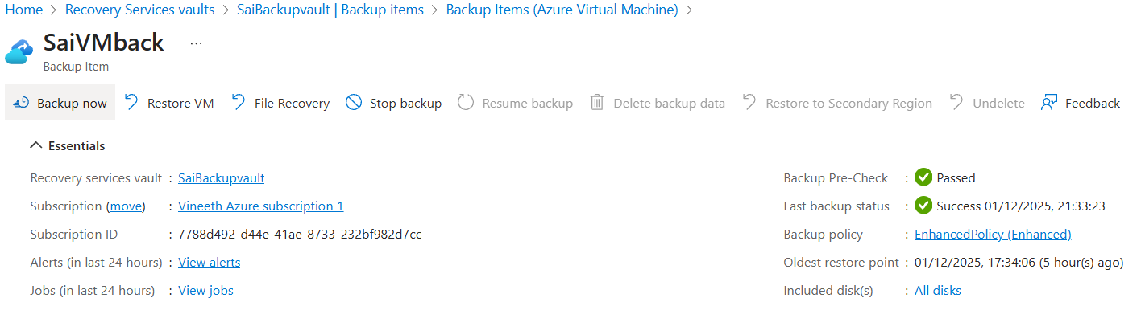

- After click on restore VM

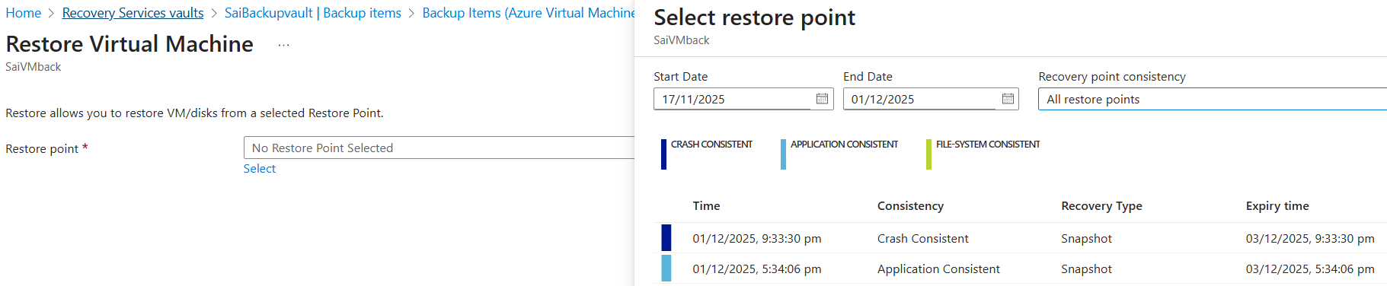

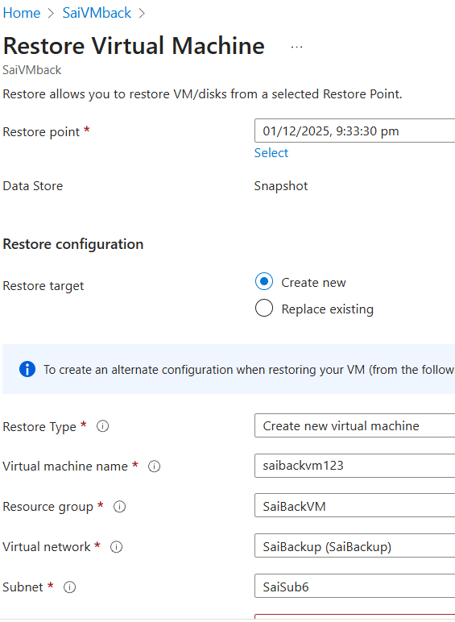

- Now go to monitoring -> backup jobs check status
- View details
- Now backup VM
- VM gets created and attach nsg and login to it to check

- BACKUP in FILE level
- Getting started -> Backups
- Where is your workload running : On Prem
- What do you want to backup : files and folders
- Click on prepare infrastructure

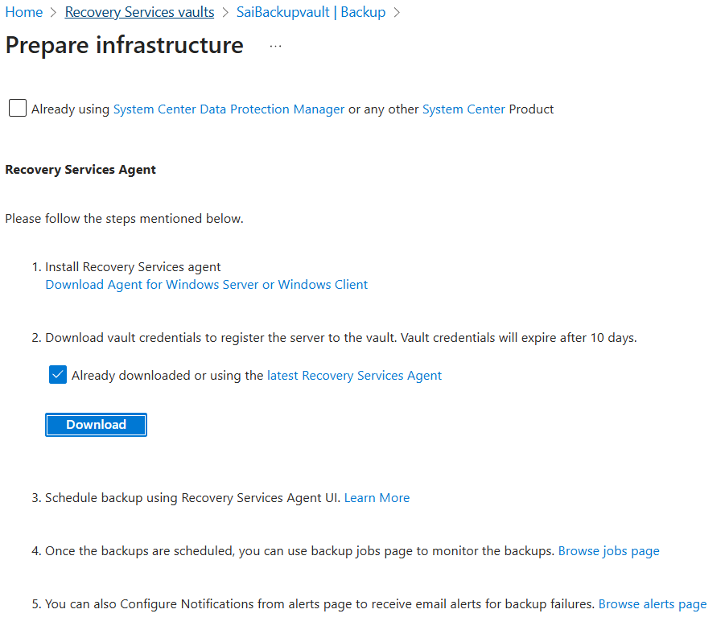

- Click on 1st link or click on download agent for windows for mars agent and
- Click on latest recovery services for mars password
- Copy mars agent and password to VM and install
- Vault credentials : browse or paste downloaded once
- Provide password
- Remove retension period
- Trigger back up now
- Select data and ok
- Now click on recover data
- Now you can observe data in my computer as restored
- Under protected items -> backup
- You can observe azure backup agent as some number

- AZURE SQL – STRUCTURED QUERY LANGUAGE
- Requirement
- Create RG, Vnet and subnet
- Create VM with Windows

- After creating VM
- Type and search sql server management studio download
- Click on install sql server management studio
- Click on SSMS 22 installer at how to install ssms
- Open file and install SSMS 22

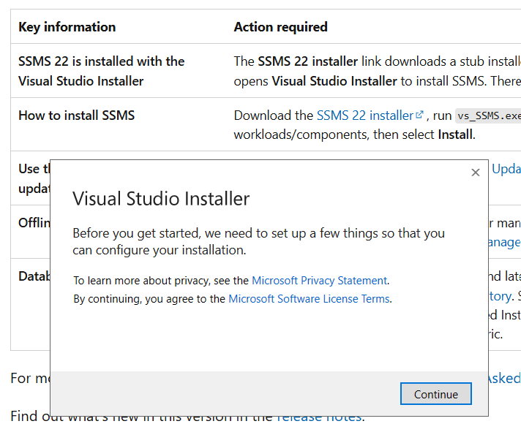

- Click on continue

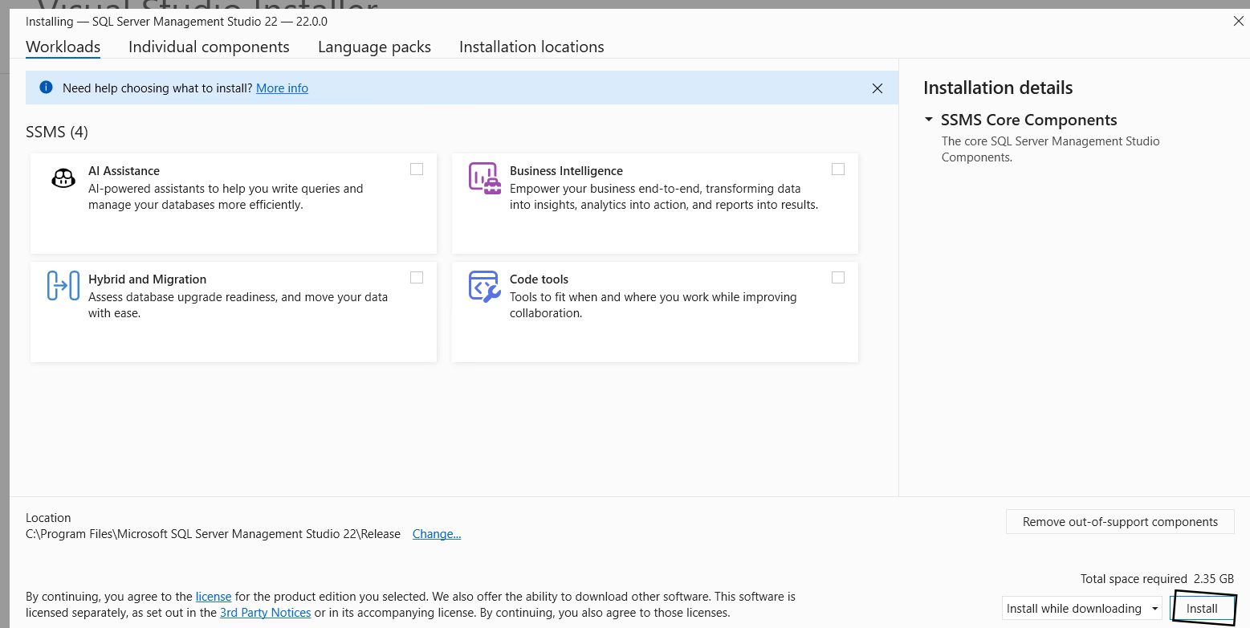

- Install

- From azure
- Type and select azure sql database
- Create

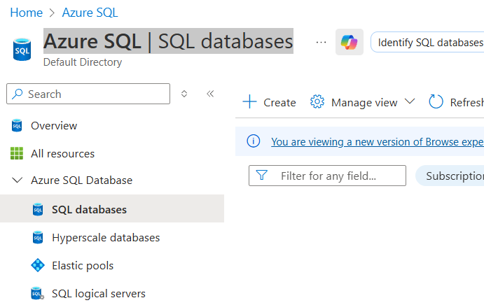

- RG : select your RG
- Name : any
- Server : create new
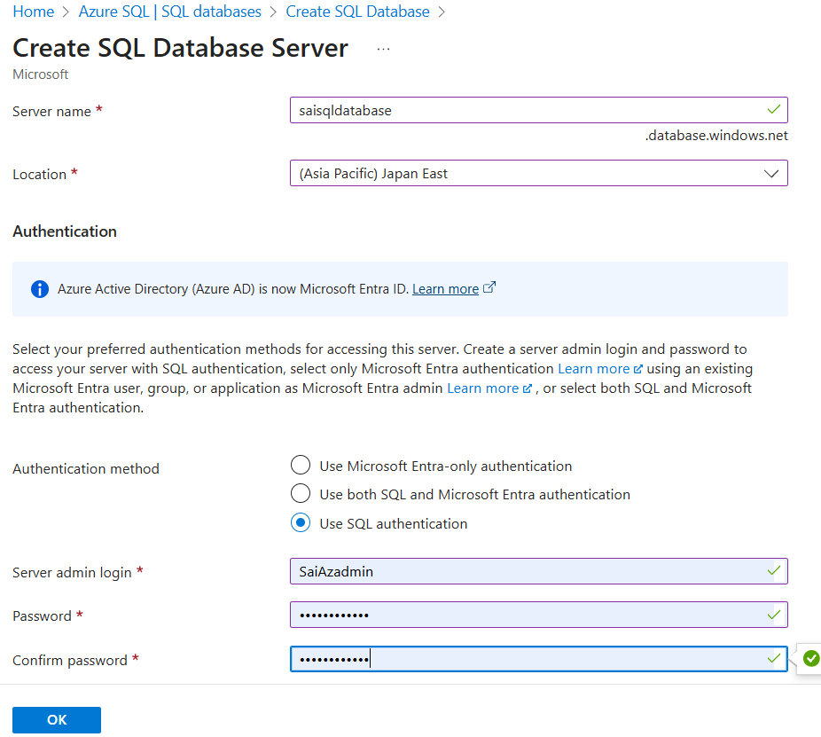

- Computer + Storage : configure database
  - Service tier : basic

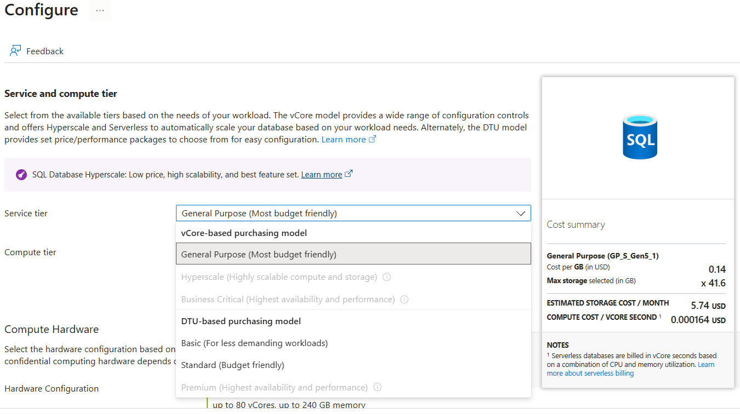

- Backup storage redundancy : LRS

Networking :
- Connectivity method : public method
- Allow Azure services and resources to access this server : yes
- Add current client IP address : yes

Security : leave as it is

Additional settings : use existing data : sample
- Review and create

- Connect sql server to vm sql
- Copy server name from azure sql server overview
- Launch sql server in vm
- Click on create later and add
- Box appears as connect

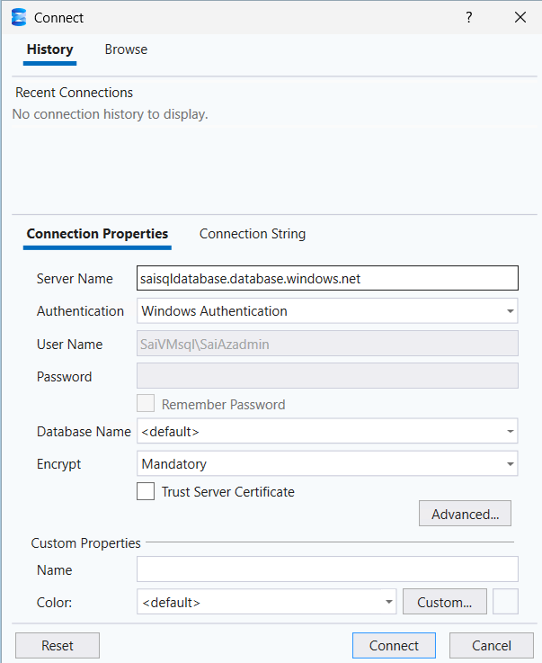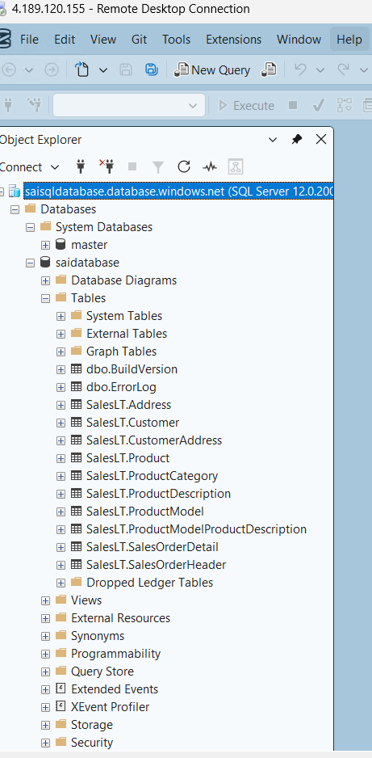

  - Paste server name in connect popup server name
  - Authentication : sql server authentication
  - Provide username and password
  - Connect now
  - You can find name server and expand database and tables to expand

- After opening
- File -> new file -> sql file

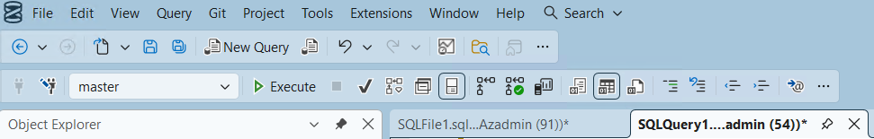

- This bar need to be activated then sql commands get execute. With new file
- After executing commands

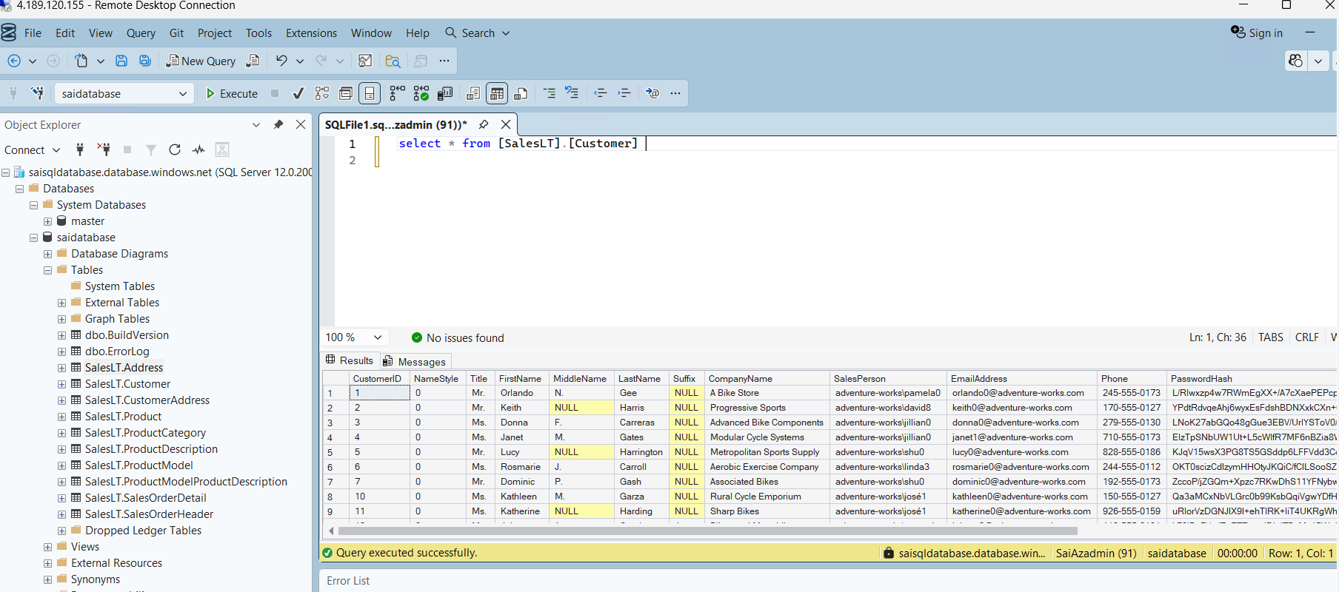

- Create SQL replica ( Same as existed xerox copy )
- From sql server -> data management -> Replicas
- Create Replica
  - Primary : default
    - RG : Sairg
    - Database name : Saidatabase
    - Region : japaneast
  - Secondary :
    - RG : Saireplica
    - Database name : create new ( same as primary db but different name and region) Australia
  - Networking : firewalls rules : Yes
  - Review and create
- Done

- After creating replica
- Connect database server to VM Windows sql
- By clicking on connect object explorer

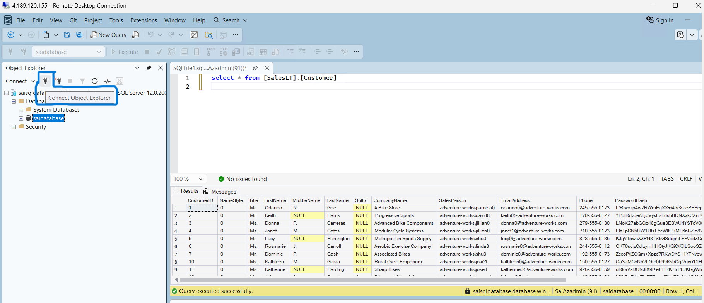

- Using server name and sql authentication same as 1st time connect or primary db method
- Expand database or right click on 2nd or replica database and select on new query

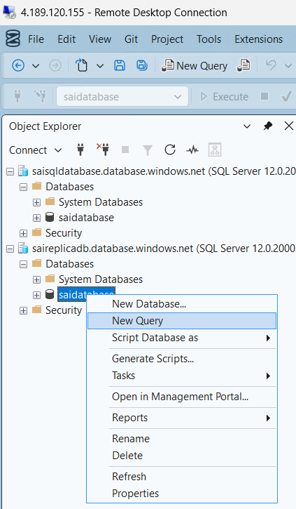

- Now you can execute commands

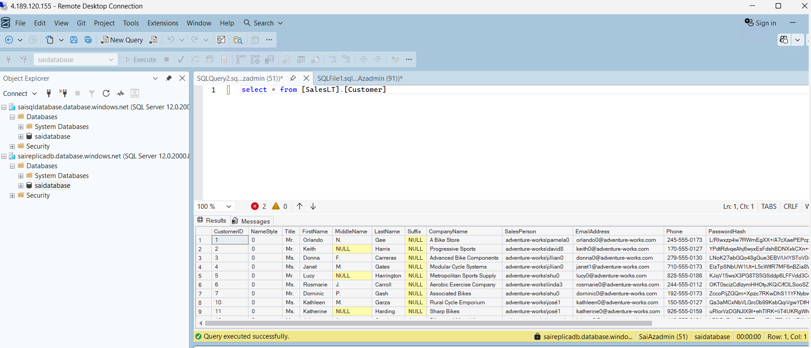

- If you execute command in sql server1 or primary server
- It gets execute it may be anything like adding delete, move and check command

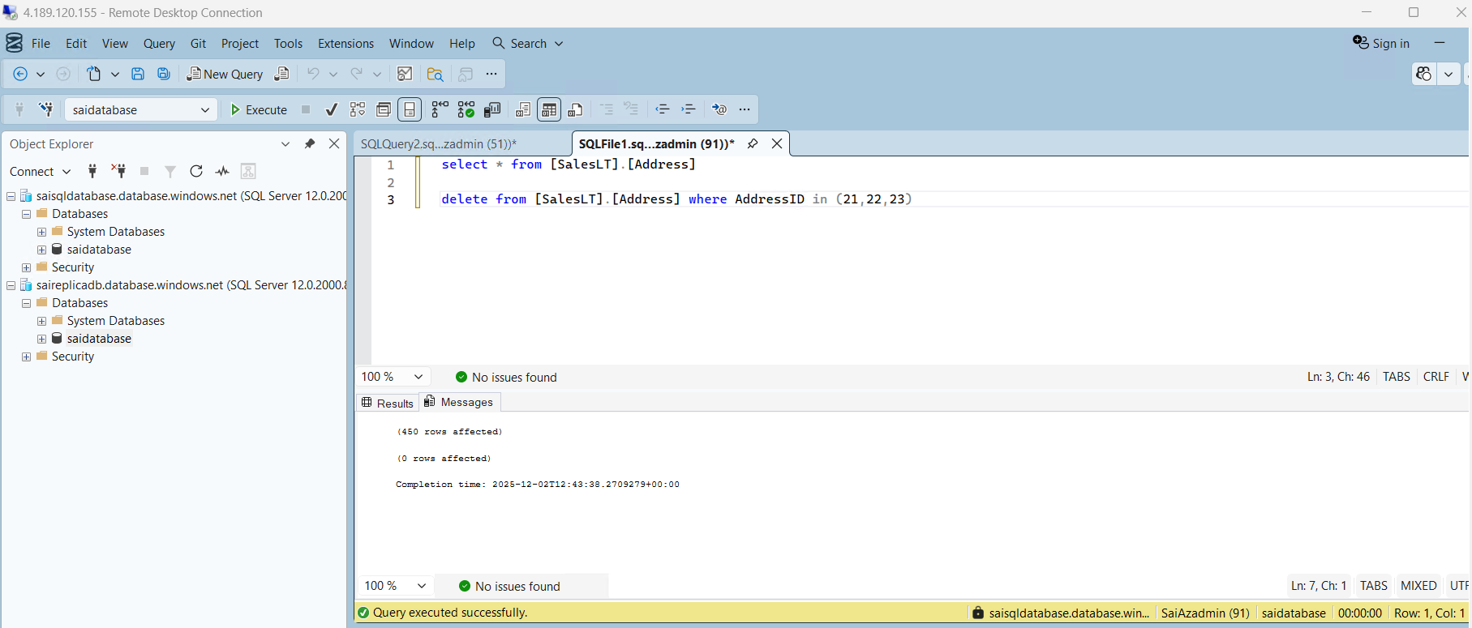

And
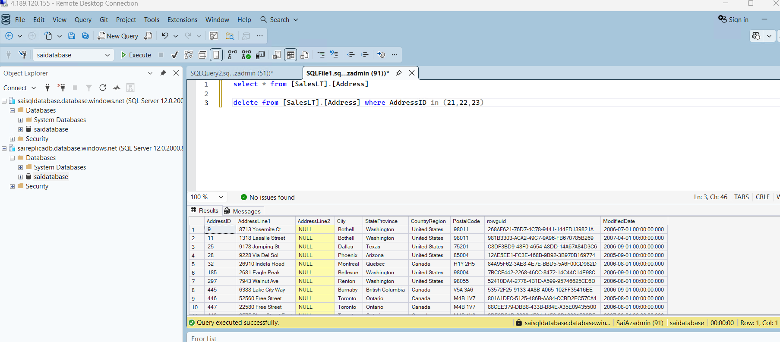

- But if you try to execute in replica or 2nd server
- Delete add wont execute
- Only check query gets execute because it is only read only

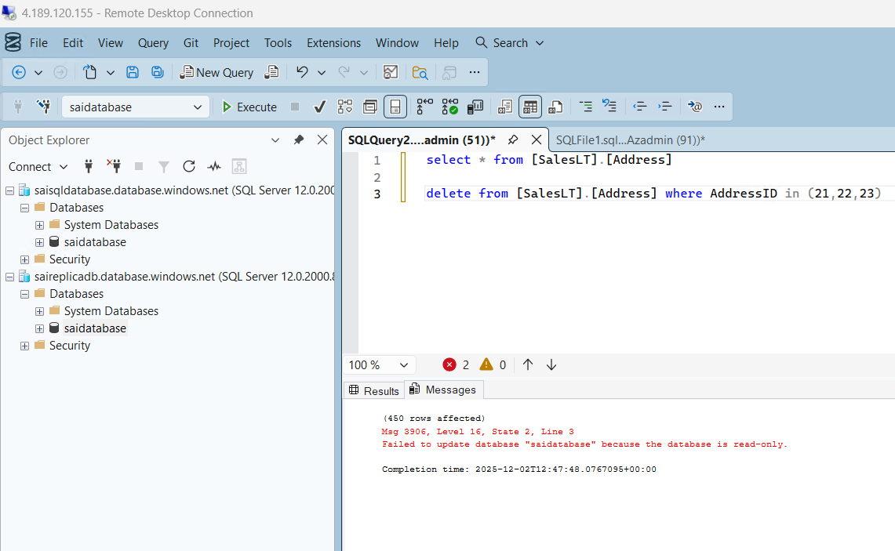

- Do failover to secondary server
- It gets immediate effect to execute commands in sql but in azure reflection takes time
- We can login only sql from vm but not to server in PaaS model as there is not permission.

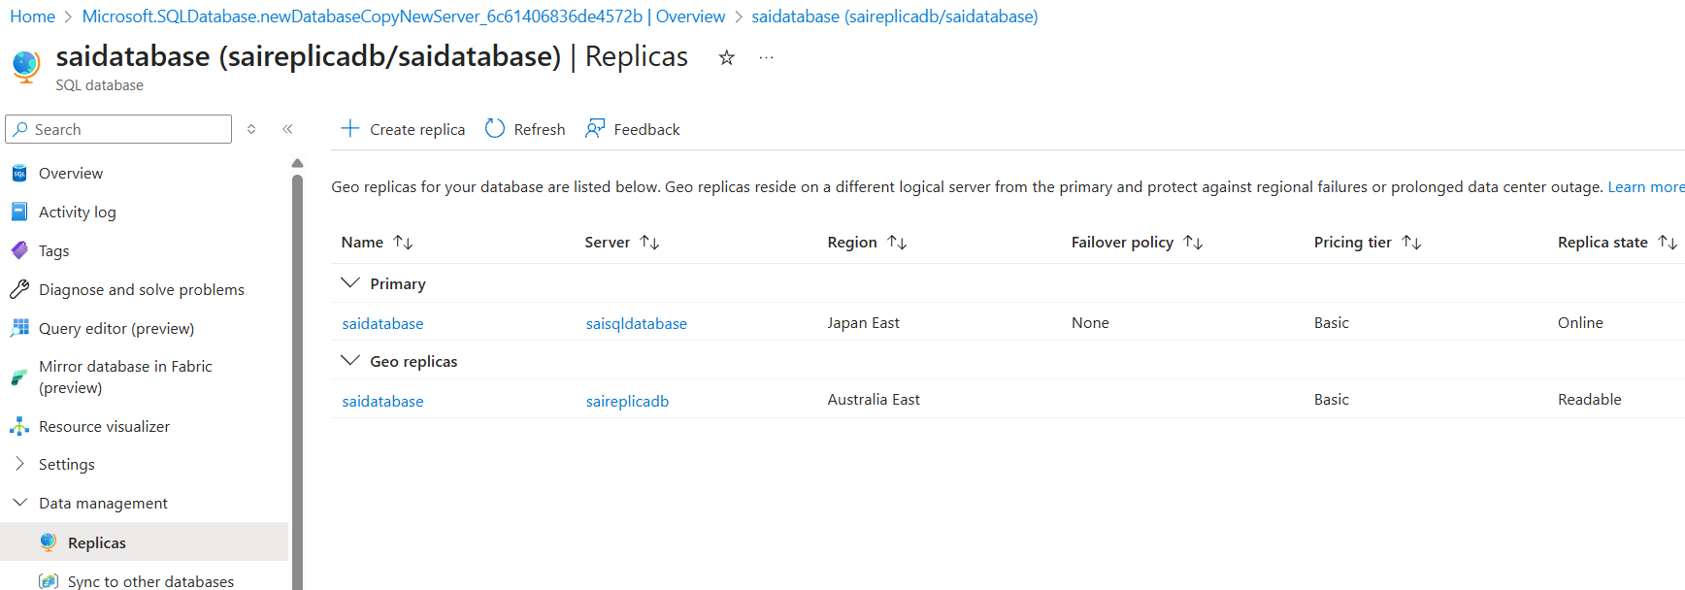

- Do forced failover from 2nd server

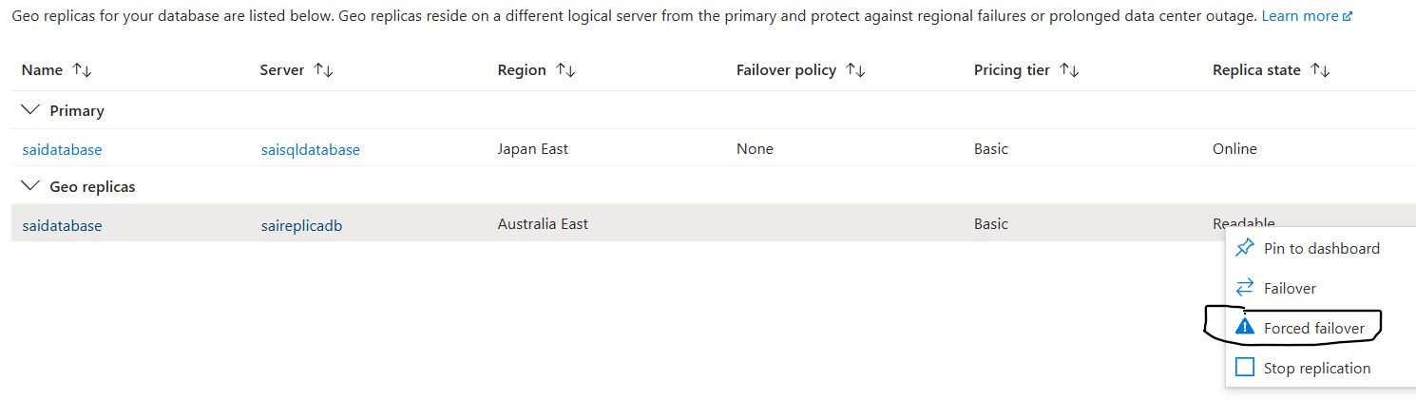

- So that 1st and 2nd server gets changed and permissions get reversed
- Now check only query codes can execute in 1st server
- You can not execute delete add as it is read only

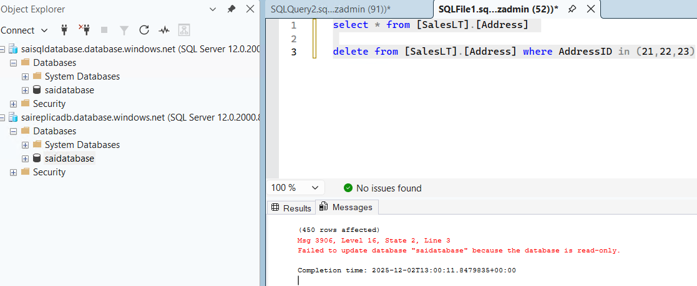

- Now delete can be performed from 2nd server as it becomes primary

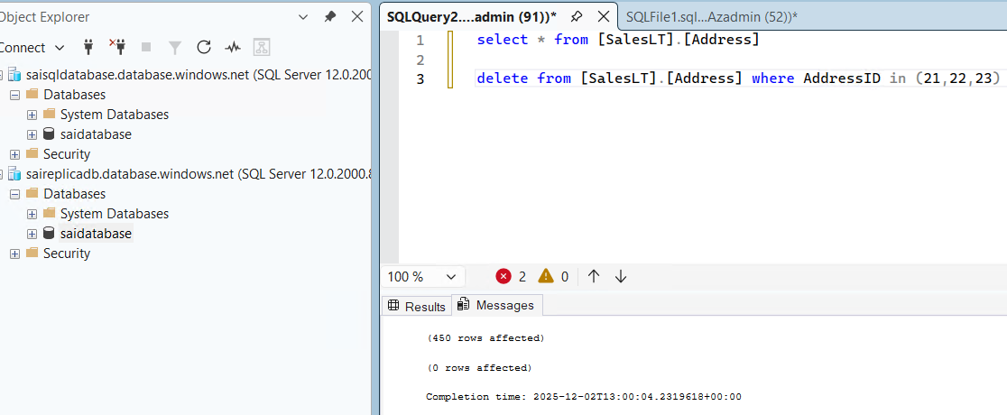

- You can also check backup

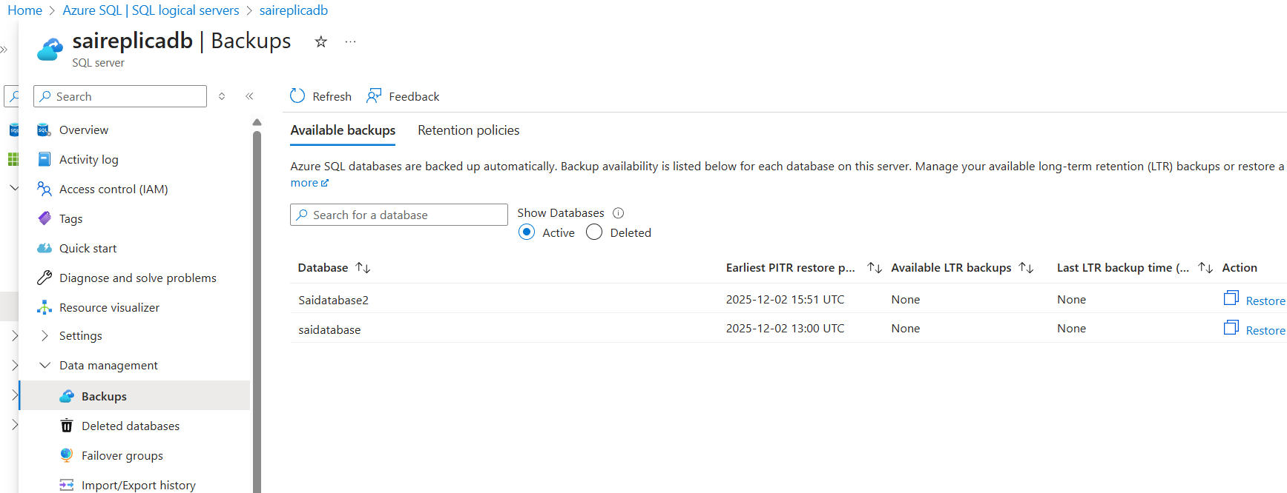

- Failover group
- Create database in same replica server

- RG : select your RG replica
- Name : any
- Server : create new

- Computer + Storage : configure database : Service tier : basic
- Backup storage redundancy : LRS

Networking :
- Connectivity method : public method
- Allow Azure services and resources to access this server : yes
- Add current client IP address : yes

Security : leave as it is

Additional settings : use existing data : sample
- Review and create

- Now we have 2 databases in server

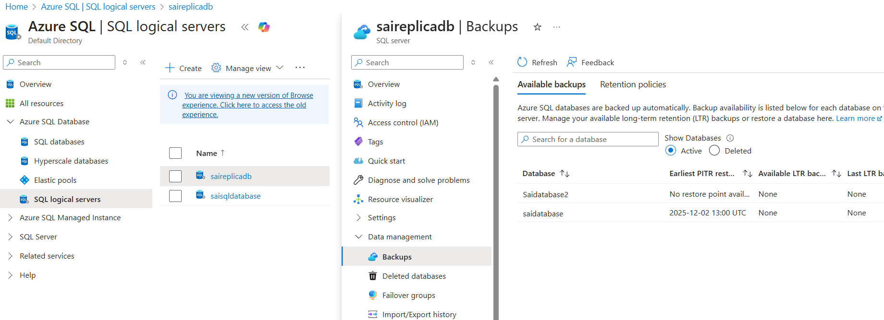

- Lets do failover group
- In select a database and data management -> failover group
- Click on add group
  - Failover group name : Failover
  - Server name select : create new
As you can not select same server

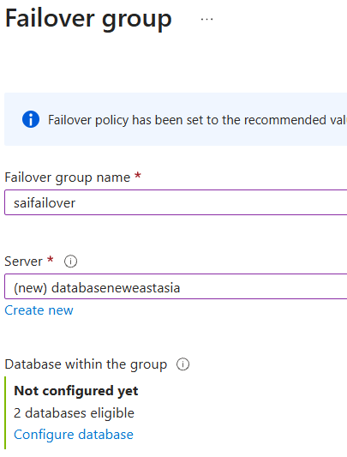

- Configure database : you can find multiple databases
As it is created new

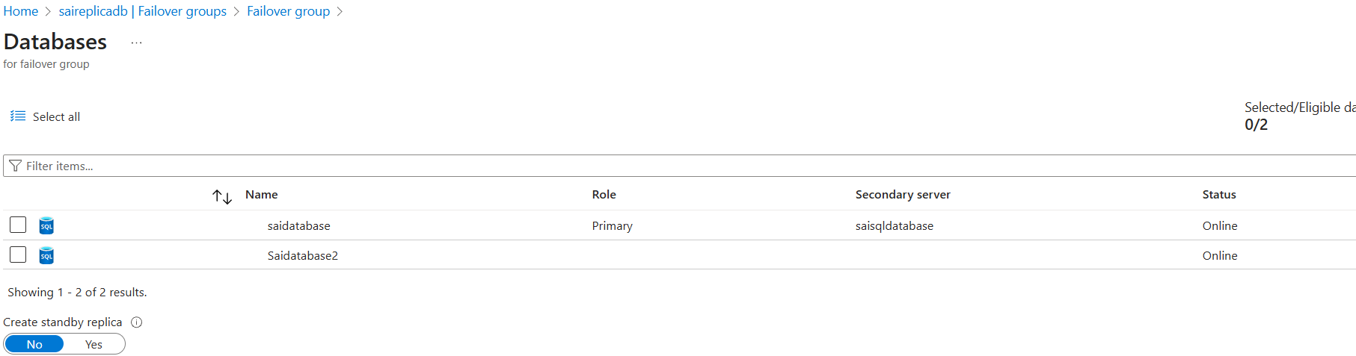

- After group replica done result is

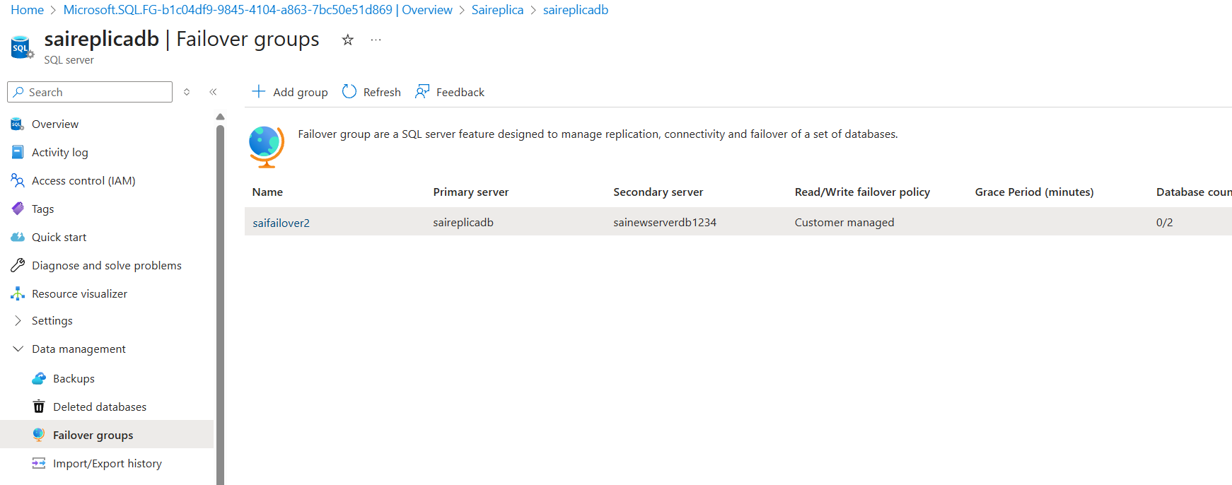

- From VM
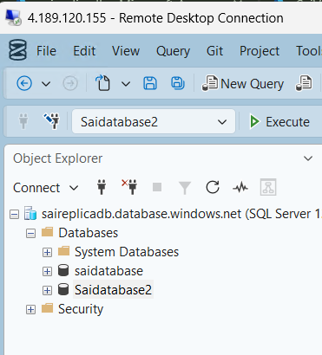

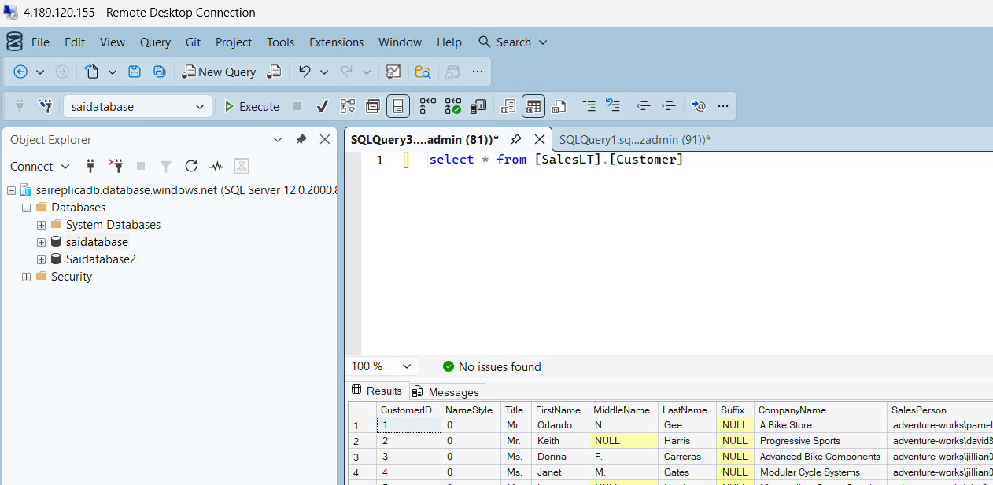

- HUB AND SPOKE
- Requirements
- Create RG, Vnets, subnet, firewall, Virtual machine and route table

- Try to create rg for hub ( firewall and route table ) and rg for spokes

- Subnet for Firewall
- While creating firewall select add subnet
- Subnet purpose : firewall
- Name : AzureFirewallSubnet ( it appears default ) /
If error counts while creating firewall select azurefirewallmanagement.

- Search firewall in search
- Create firewall 
  - Resource G : SaiRG or select your
  - Name : saifirewall
  - Region : east asia
  - Firewall SKU : standard
  - Firewall management : Use a Firewall Policy to manage this firewall
  - Firewall policy : create new : default firewall / standard
  - Choose a Vnet : use existing
  - Select vnet : select vnet where firewall present
  - Public ip address : provide new
  - Enable Firewall Management NIC : disable

- Create a virtual machine with windows in another RG and vnet

- Do vnet 1 to vnet2 peering

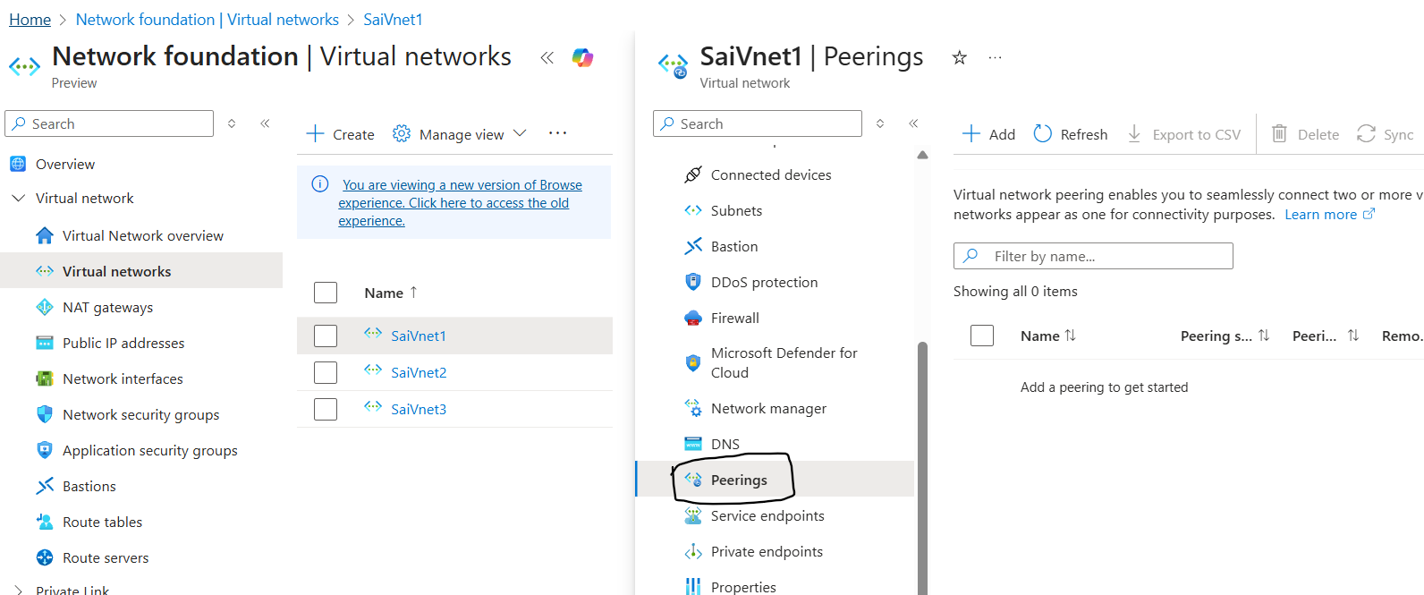

- Create a route table
- Create a route table with symbol 

- Create new in spoke rg
  - Just add route table name and leave rest as it is
  - Create
- Select route under settings
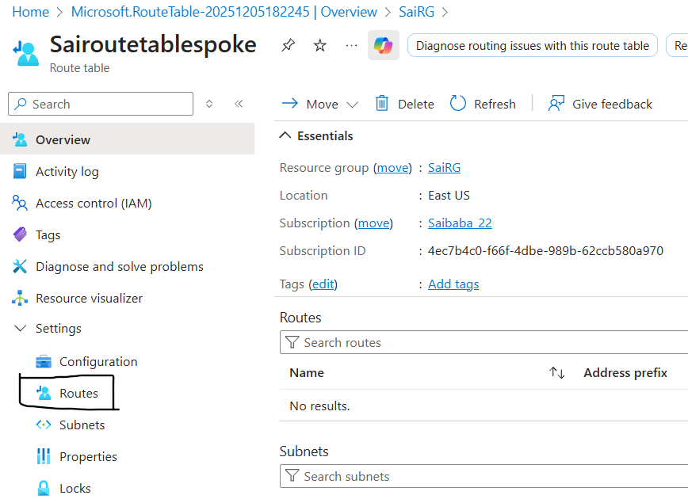

- Select route and click on add
  - Route name : any name
Destination type : IP Addresses
Destination IP addresses/CIDR ranges : 0.0.0.0/0
Next hop type : Virtual appliance
Next hop address : firewalls private ip

- Select subnet under settings
  - Add associate and add subnets where virtual machines present
In spoke RG, virtual machine should be present and peering need to be done from firewall vnet then only it shows vnet else, can not associate.

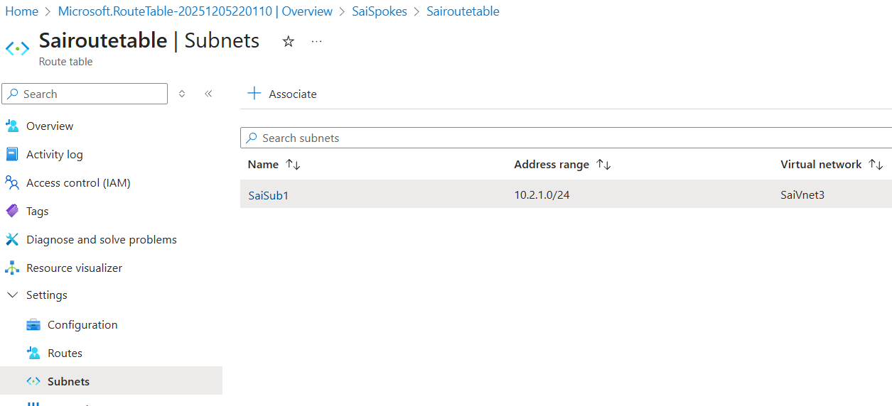

- Create a Virtual machine in hub RG
- If a default subnet present directly create vm with windows
- Else create subnets separate and create VM with windows

- Now open firewall
- Click on firewall policy from overview

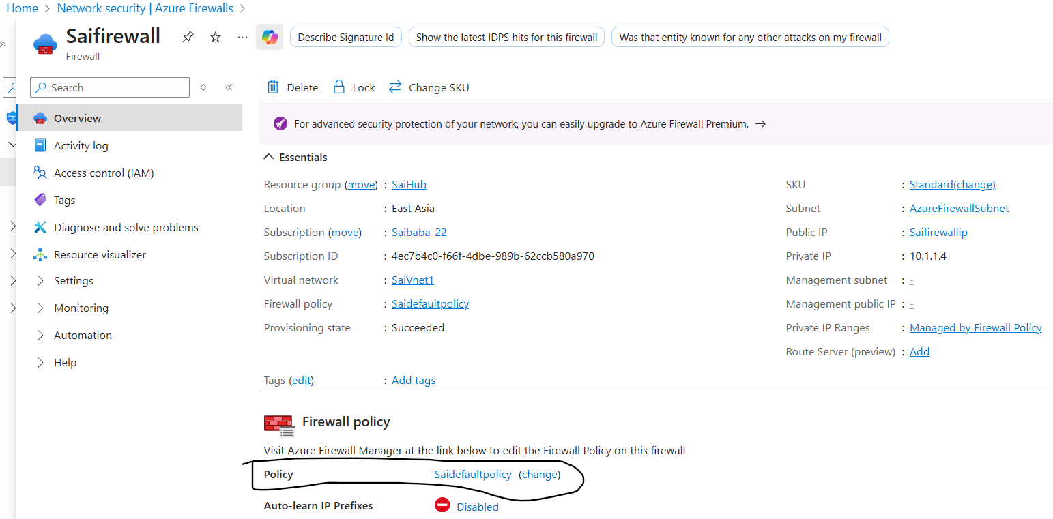

- Under rules -> network rules -> add a rule collection
  - Write a rule as from which ip address/VM is traffic allowed to which ip address/VM through which ports and protocol.

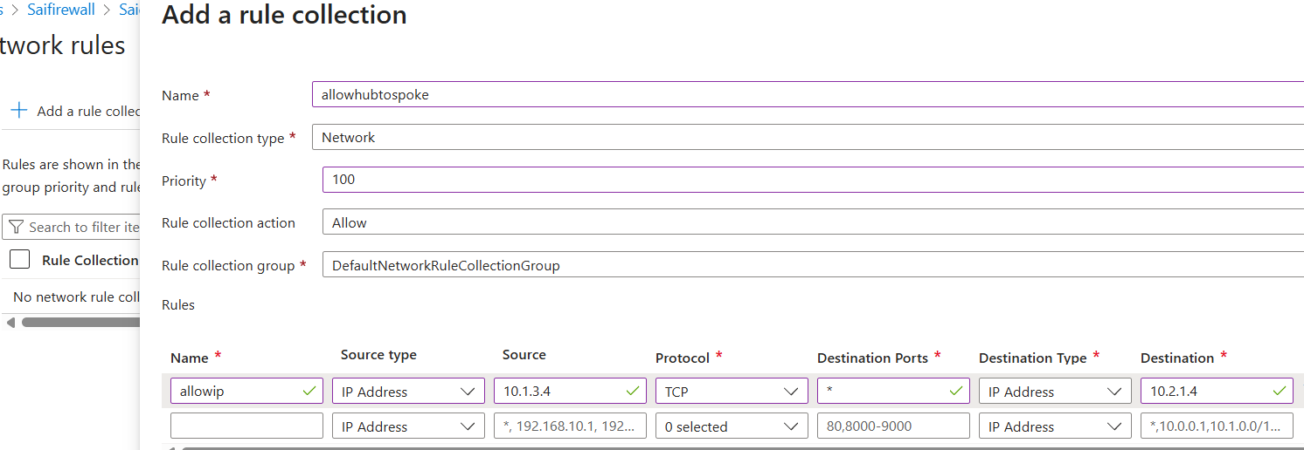

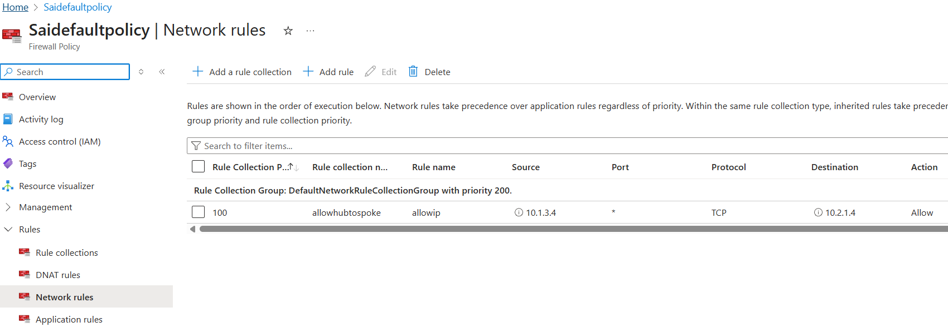

- Click on firewall policy from overview
- Under -> application rules -> add a rule collection

Write a rule as any Ip address/ip address group / VM can access can access application destination though provided ports.
If you want to allow particular port then provide number else * will allow all.

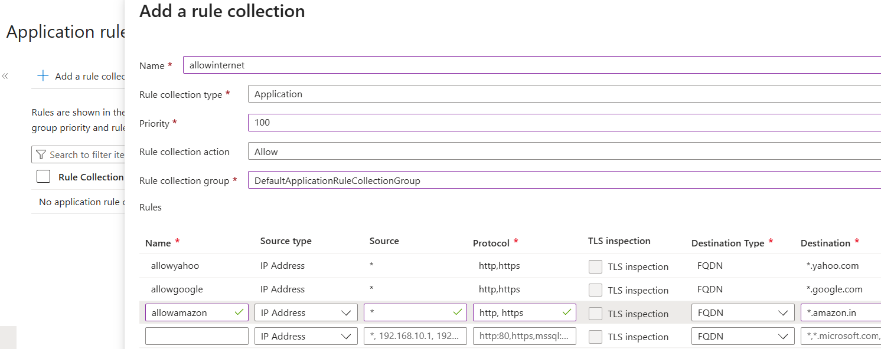

- And click on add

- Now login to VM windows from Firewall RG

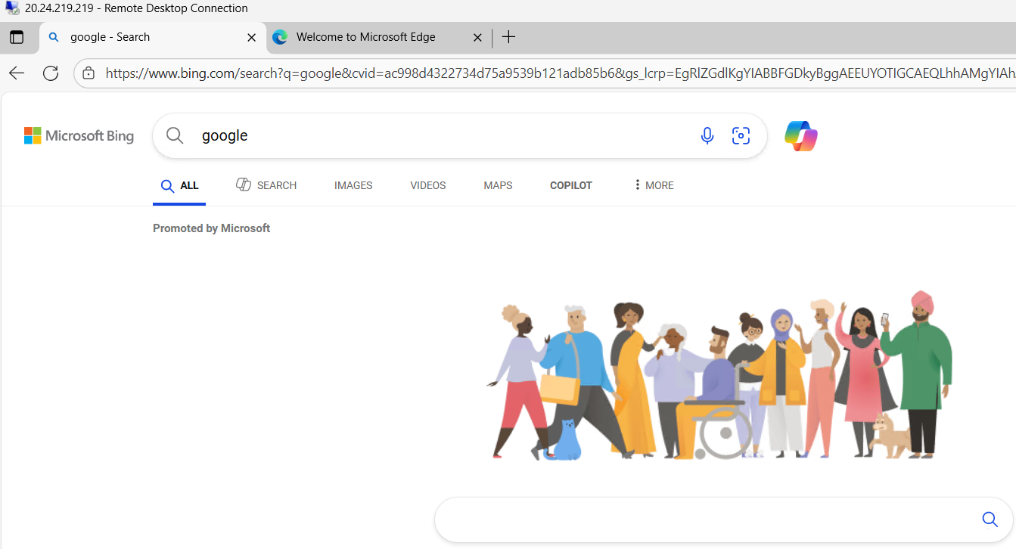

- Next from Firewall VM login to VM with windows from Spoke RG

- Login with private Ip address, don’t use public address it wont work

- After logging to Hub rg VM and from Hub rg VM to Spoke rg VM using private RG
- We have provided only access to these application
  - www.google.com

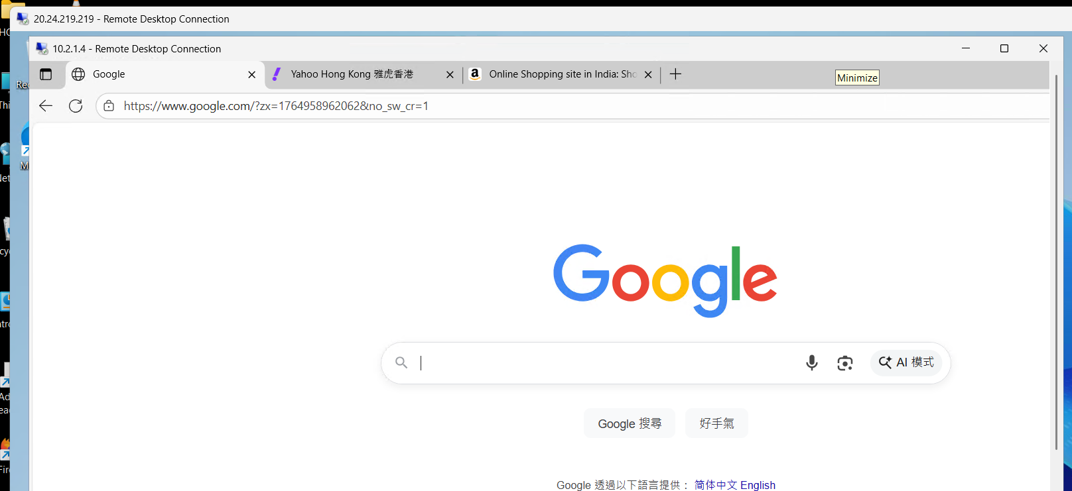

  - www.yahoo.com

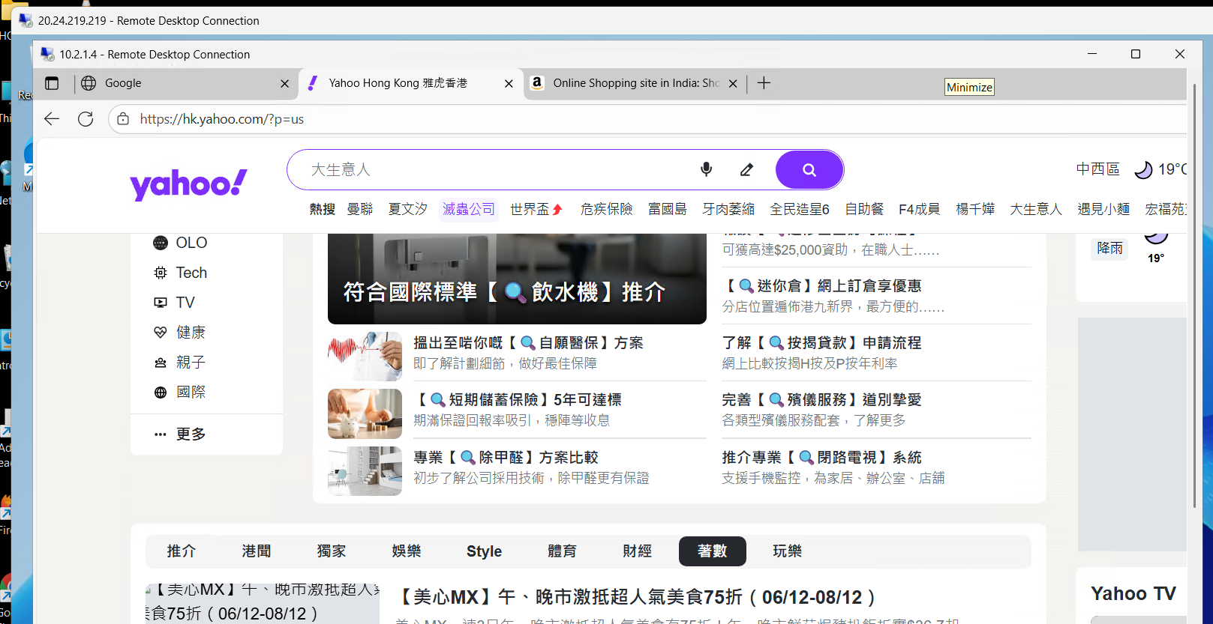

- www.amazon.in

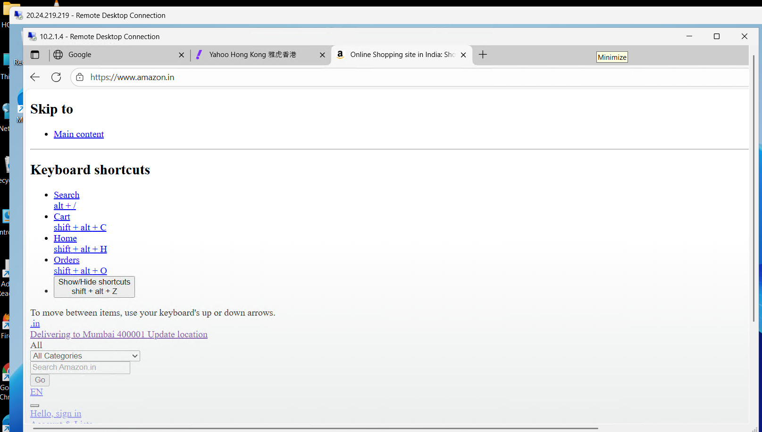

- We can access only these 3 applications as from application rules are written as allowed for these 3

- Dnat rules ( Destination Nating / Destination Network Address Translator ) rules
- Private ip address is converted to public ip address
- Name : any
Source type : IP address
Source : * ( any )
Protocol : TCP
Destination Ports : 50000
Destination (Firewall IP address) : firewall public IP address ( click on public ipname and check it will be )
Translated type : IP address
Translated address or FQDN : to which machine you want to login public IP address
Translated port : 3389

- Simple to understand
  - What ever incoming traffic from any where it will connect to
  - Virtual machine but not with VM IP, it uses firewall IP to connect and
  - It uses port as 50000 which is not allocated to any one as actual port is 3389
- Simply
  - Source : any
  - Destination actual : VM IP
  - But destination shown and used : Firewall IP
  - Destination port : 3389
  - Destination port used : 50000

- While connecting to VM use firewall ip with port ( ex : 172.56.12.45:50000)

- AZURE VPN

- AZURE WITH AWS VPN AND PING AZURE FROM AWS
- Infrastructure in Azure
- Create Resource Group : SaiVPN

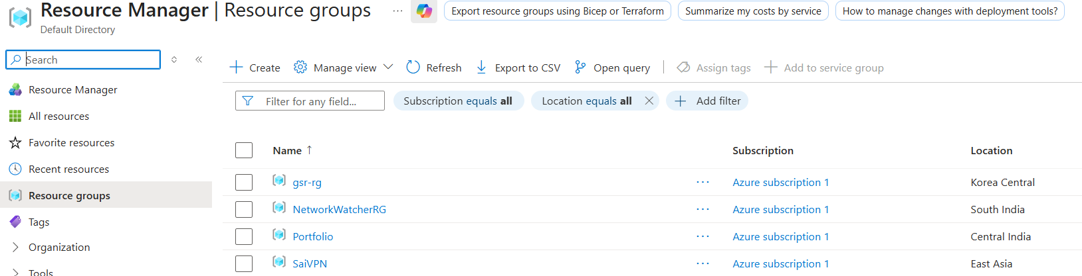

- Create Vnet : SaiVPNVnet

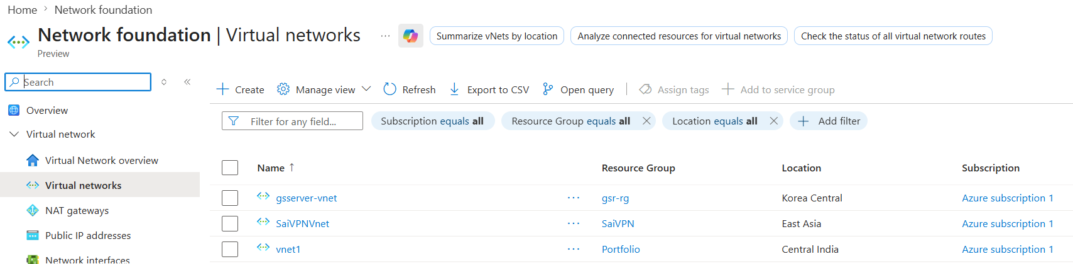

- Create Subnet in Vnet and while select subnet type as Dedicated gateway : GatewaySubnet and serversai

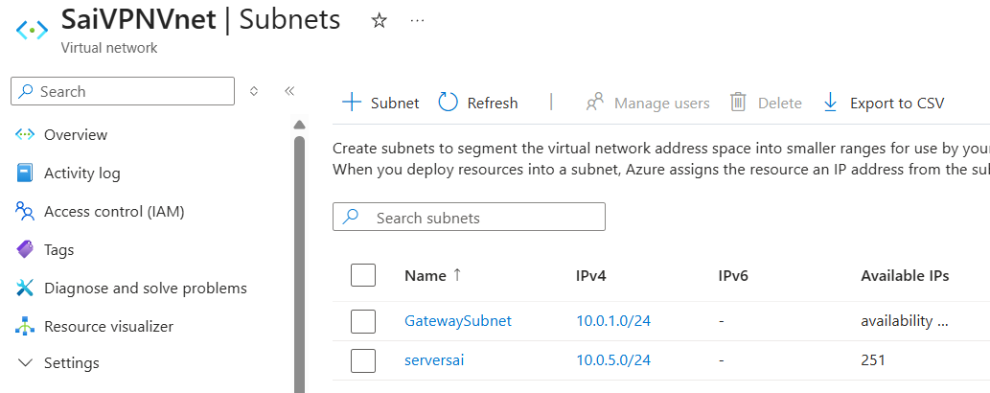

- Create a Virtual Machine : vpnserver

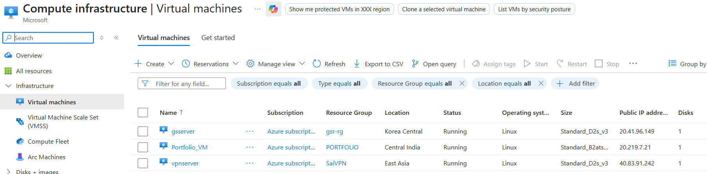

- Building Infrastructure in Azure Done

- Build infrastructure in AWS
- Create VPC :

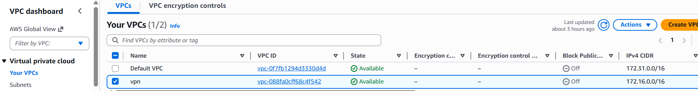

- Create subnet :

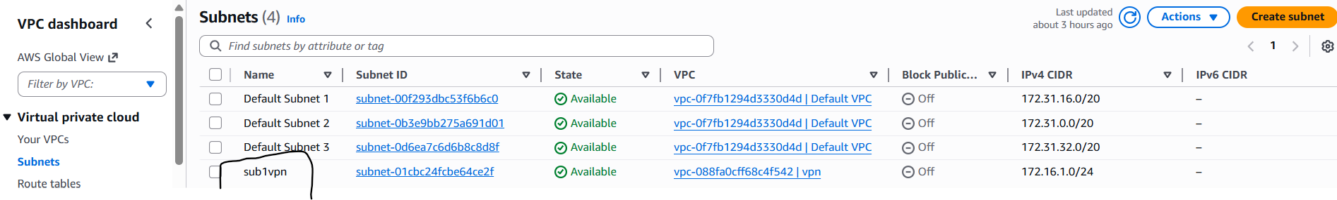

- Create Internet Gateway and attach to VPC

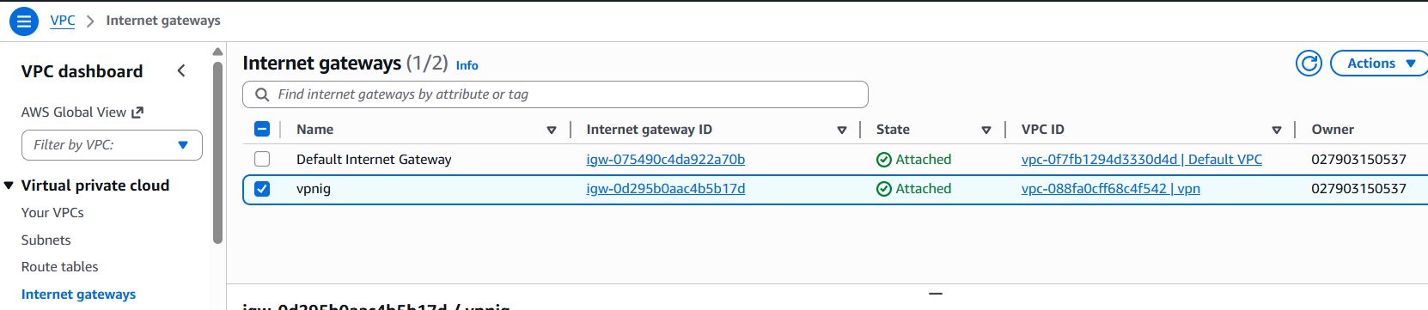

- Rename Route Table and edit Routes :

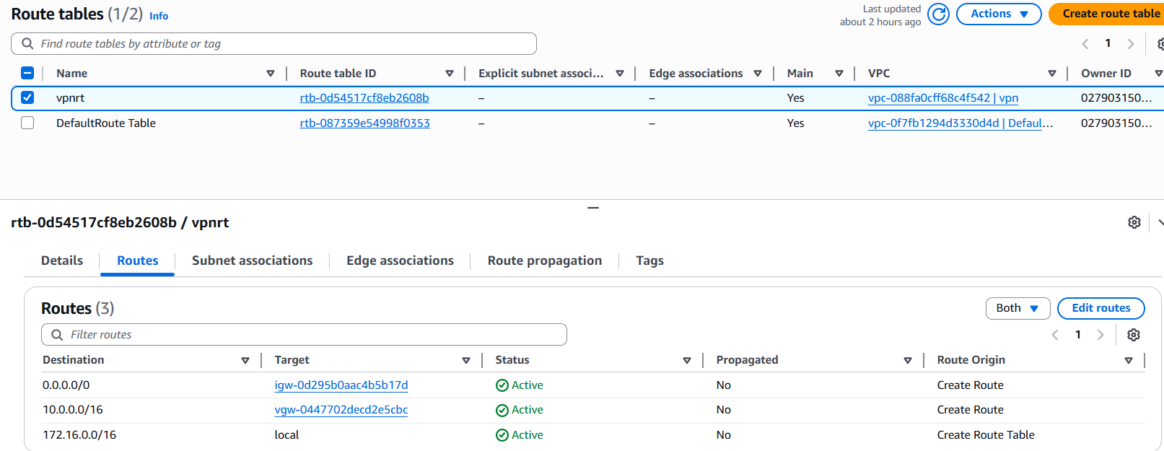

- Rename Security Group and edit Rules :

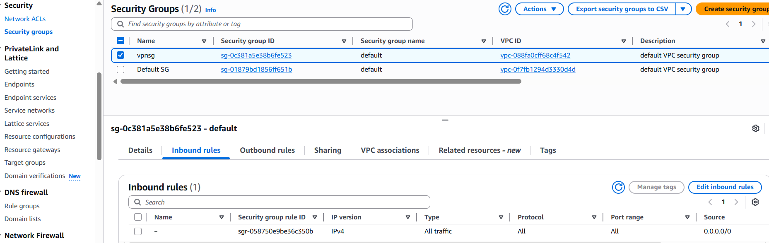

- Create EC2 :

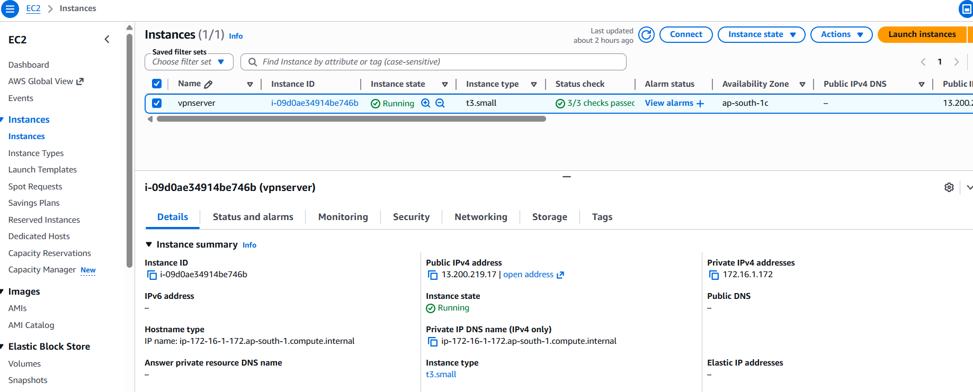

- VPN SETUP
- Start Building VPN setup in Azure Virtual Network – VPN Gateway
- As it is used in AWS VPN setup
- In Azure, Type in search bar Virtual Private gateway complete else it won’t show

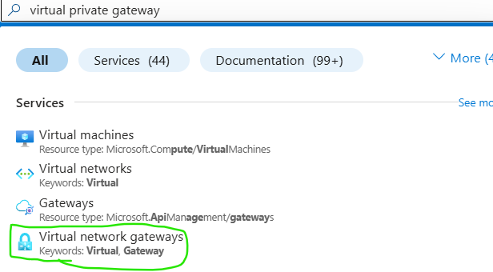

- Select Virtual Network Gateways

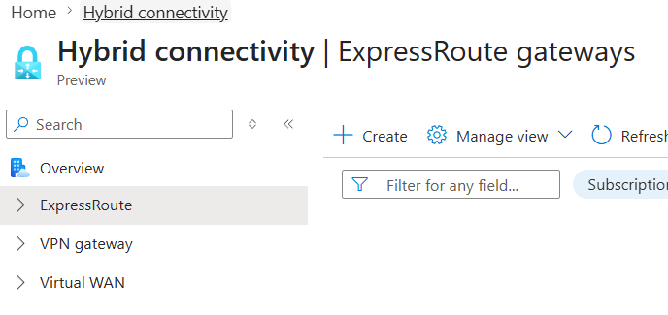

- From left bar select VPN gateway -> VPN gateway

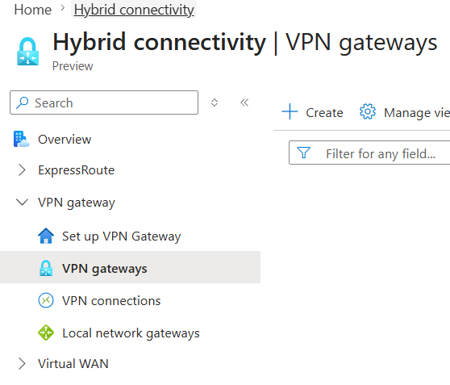

- Click on create
- Basic
  - Name : any
  - Region : East Asia
- Gateway Configuration :
  - Gateway Type : VPN
  - SKU : VpnGw1AZ
  - Virtual Network : select yours
  - Subnet : Default selected
- If Gatewaysubnet is not created before it shows error

- Public IP :
  - Public IP : Create new
  - Public ip address name : any
  - Enable active-active mode : Disabled
  - Configure BGP : Disabled
- Review and Create -> create

- Takes time to create 10 to 15 minutes

- AWS VPN Setup
- From VPC left bar
- Under Virtual Private network (VPN)
- You can find Virtual Private Gateways need for VPN

- Name : any
- Create

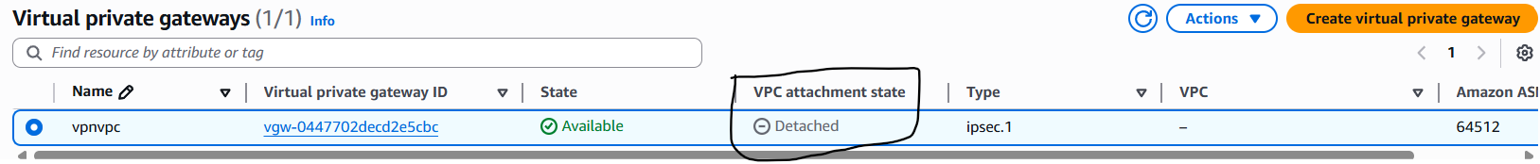

- Its clarly not attached to vpc

- Click on actions and attach vpc

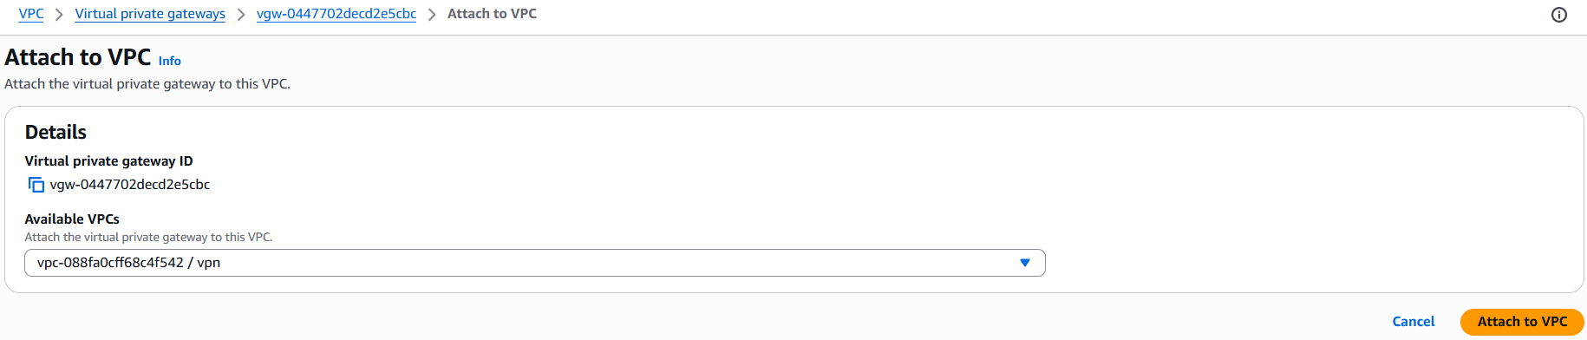

- Now vpc attached

- Customer Gateway
- From Left bar Under Virtual Private Network,
- Select Customer gateway

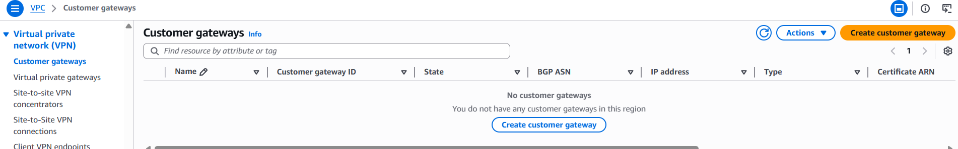

- Click on Create Customer Gateway
- Fill Details :
  - Name tag : azurevpn
  - BGP ASN : 65000 (default )
  - Ip address : provide azure vpn public ip
  - Certificate ARN : leave it
  - Device optional : choice
  - Create gateway

- After creating Customer Gateway

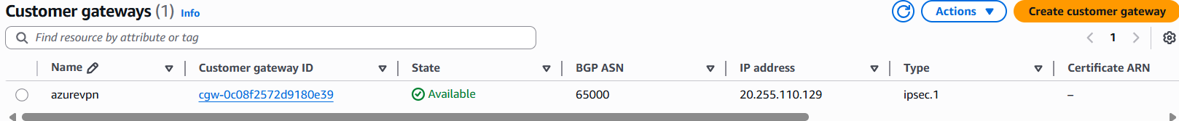

- Now SITE TO SITE VPN CONNECTIONS
- From left bar under Virtual Private Network (VPN)
- Select site to site VPN connections

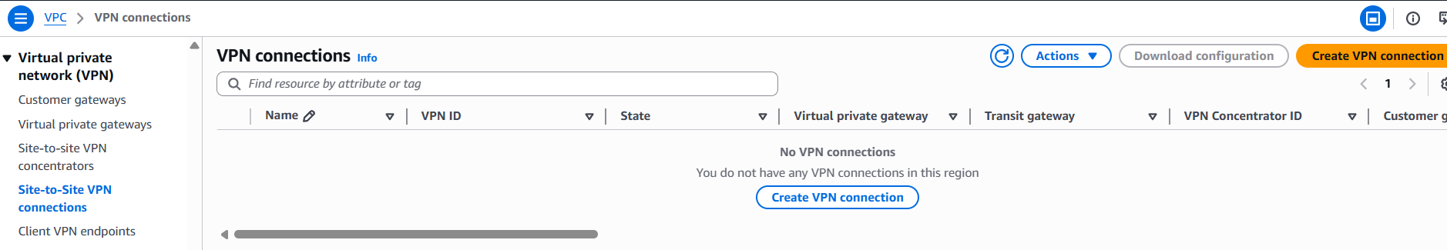

- Create VPN connection
- Fill details :
  - Name tag : any
  - Target gateway type : select virtual private gateway
  - Virtual private gateway : select id
  - Customer gateway : existing
  - Customer gateway id : select created id
  - Routing Options : static
  - Routing IP prefix : Azure VM’s Vnet range

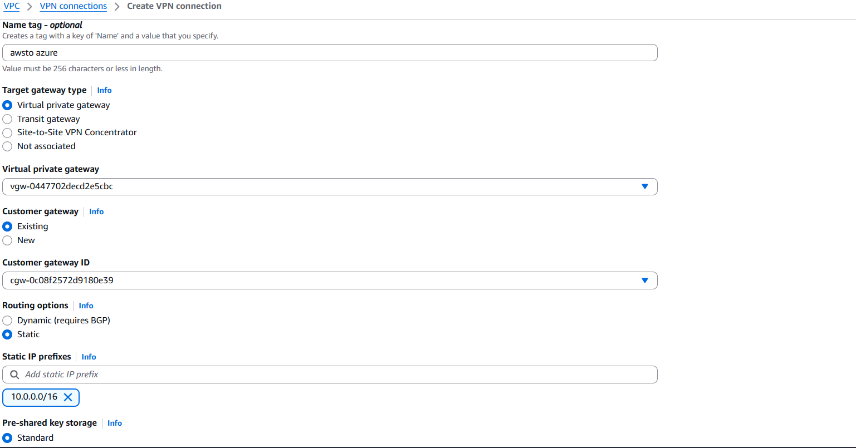

- After creating VPN connection

- Go to Route table and write rules
  - Destination : 10.0.0.0/16 | Target : Virtual Private Gateway | Tag : VPGid

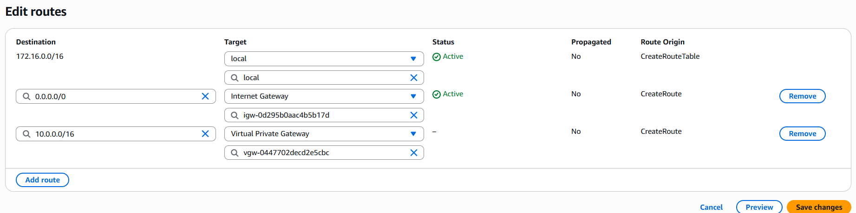

- Click on site to site connections and select connection
- Download configuration gets active, select it

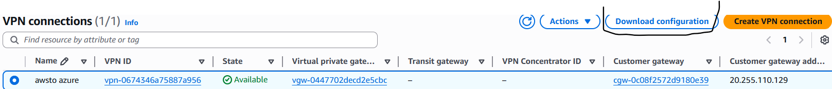

- Select details and download
  - Vendor : Cisco Systems, inc
  - Platform : ASA 5500 Series
  - ASA : 8.2+
  - IKE version : ike1
- Select download, a notepad is downloaded



- From Azure Setup Open VPN gateway and create connection
- Search Local Network Gateway and select it

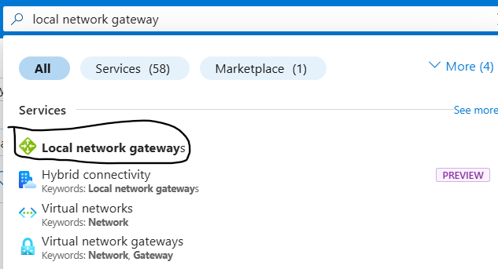

- Click on create
- Fill details :
  - Resource Group : SaiVPN ( select your resource group)
  - Region : east asia
  - Name : any
  - Public IP address : AWS VPN public ip

- Open downloaded Note pad and search tunnel-group xx.xx.xx.xx type ipsec-l2l
- The ip address is aws vpn ip

  - Address Space : AWS VPC private address range
- From AWS select VPC -> details -> copy IPv4 ICDR range

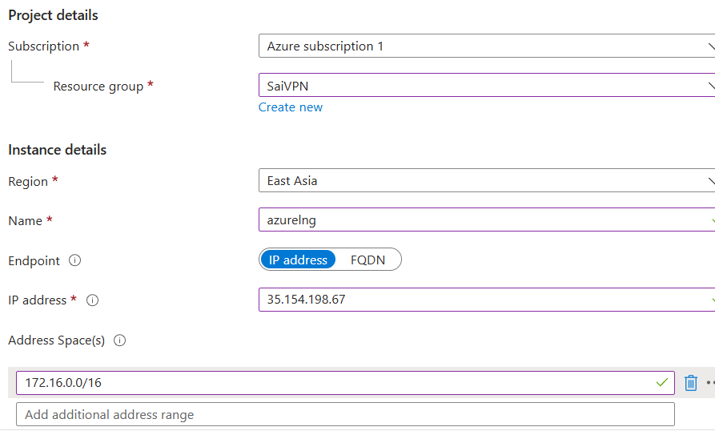

- Review and create -> create

- Now open VPN gateway from Azure
- Select VPN -> settings -> Connections

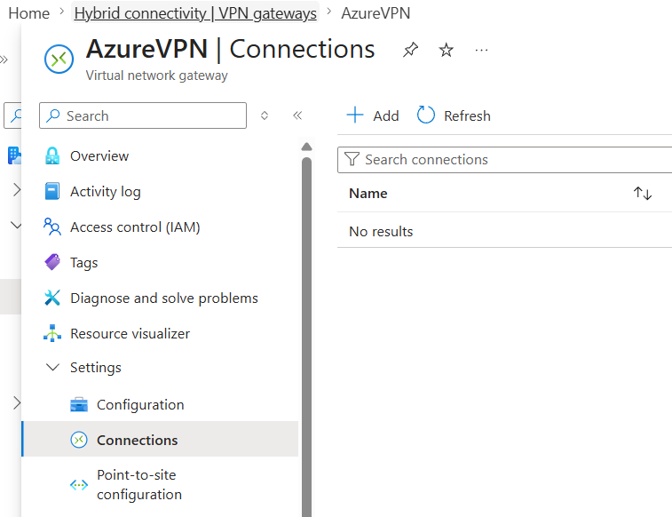

- Select add
- Basic :
  - Resource Group : SaiVpn ( select yours )
  - VPN Type : Site to site
  - Name : any
  - Region : east Asia
- Settings :
  - Virtual Network Gateway : select existing gateway
  - Local Network Gateway : select existing gateway
  - Authentication Method : shared key
  - Shared Key :
Find in notepad : search pre-shared-key that is key
  - Next
  - Review and Create -> Create
- Connection created but status is pending

- Now try to connect vm to ec2 and reverse Before status success
- From Azure to AWS

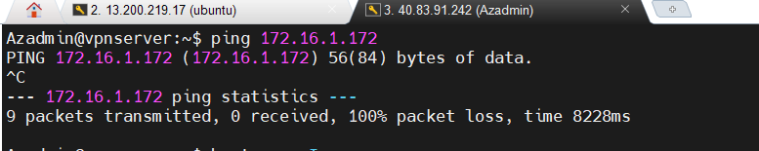

- From AWS to Azure

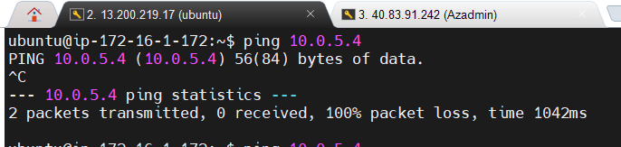

- Wait until the status becomes connected
- Now status is connected

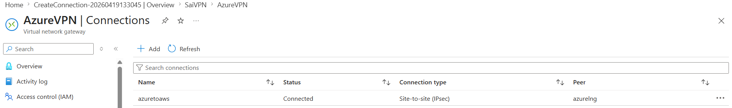

- After Success Now try to connect from Aws to azure and reverse
- From azure to AWS

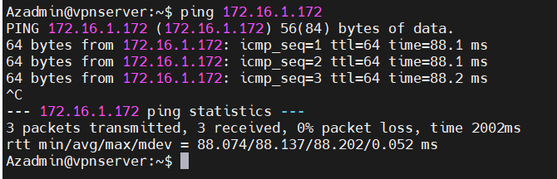

- From AWS to Azure

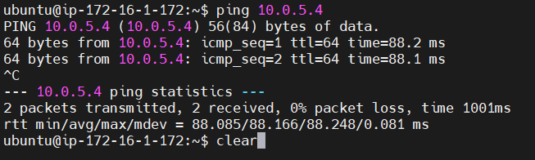

- TASK Create one more VPC and and ec2 ping from Azure vm to AWS ec2 2

- AZURE ACTIVE DIRECTORY
- Active directory is also known as Domain controller
- Single sign on is login with 1 credential ( username and password) to any server under company or domain
- name@tech.com/@info.com/@startek.com

- Requirements
- Create RG, Vnet, Virtual Machine
- Install active directory
- Create a user in entra ID and provide global admin privileges
- Install AD connect tool, sync between onprem AD with Entra AD

- Create VM with windows and login
- Download and paste AD connect tool
- Open cmd and type ipconfig /all and copy dns server ipaddress
- Open azure VM
  - Select network setting, Select nic
  - Select dns server under settings
  - Select custom and paste in box copy ipv4 address also and paste

- Go to godaddy.com
- Sign in
- Go to my account
- Go down and select one Domain and click on dns
- Select name servers

- In azure create dns zone
- You will get name servers 4
- Update name servers in godaddy

- Open VM with windows
- Click on add roles and features from server manager
- Installation type : next
- Server selection : next
- Server roles : select or click or enable Active Directory Domain Services
Add features : next
- AD DNS : next
- Confirmation : next
- Install
- After install you will find warning button
- Click on it and it will say “ Promote this server to a domain controller “
- Click on it
- Deployment configuration : add a new forest
open dns zone in azure copy and copy dns zone in azure and paste here in vm
Configuration : paste : next
- Domain controller options : provide password and confirm password : next
- Dns option : next
- Additional option : the netbios domain name must be automatically appear : next
- Paths : next
- Review option : next
- Prerequisities check : next
- Installation : install ( after install it gets restart leave it )

- Open file manager and right click on this pc select properties
- Advance system settings
- In computer name you will find work group name as WORKGROUP
Later it changes to domain name

- Open entra id in azure
- User -> add user
  - Basic :
    - Username : enter any name
    - Deselect : derive from principal user name
    - Display name : provide any name
    - Password : provide any password
  - Review and create
    - You will get user principal name : copy it
  - Create
- User id created but only as user
- Select the user
- Select assign a role from left option
- Add assignment
  - Search Global admin : select global administrator and add

- Open a new window
- Browse a portal.azure.com
- Now enter you created username and password from entra id
- Update password
- It uses MFA – multi factor authenticate and
- download and install microsoft authenticator app
- scan the qr code Shown
- select number from app

- Add a domain and check domain controller or not
- Entra di -> custom domain name -> add a custom domain name
In godaddy on the up of name server you can find domain name
Copy and paste here and add
- Then domain name opens with custom domain name
  - If you are a domain owner or not need to check with provided details
- Do to dns zone
  - Select name -> DNS management -> recordsets and add
- From Entra id
  - Create a TXT record
  - Copy host name or alias from custom domain name to
  - In dns click on add record set and paste
    - Name : @ ( hostname or alias name paste )
    - Type TXT record
    - Copy value from intra id and paste in dns record : TTL units : minutes
    - Paste copied code in value
    - Verify it
    - If domain verify crtly sync is good or else need to do again

- Login to VM with windows
- Use your created domain credentials
- ( you can observe computer name as domain name )
- From file manager
  - Right click on my pc and click on properties
  - Advance system settings
  - And system name shows as domain name

- Create users
- Press start button
- You can find active directory users and computers : click on it
- Click on users
- Right click any where : new user
  - Provide any name in first name
  - User login name : user1 attached to domain name with ( @azureb28.xyz)
  - Next provide password
  - Click enable on user must change password at login
  - Finish
- Install ad connect tool
  - Click on agree and continue
  - Use express settings
  - Use microsoft entra id which you have provided global priviledges
  - Sign in to microsoft page using created credentials
  - Use new password to login
  - Provide local admin details
  - Configure and install
  - Exit

- Open server manager
  - From local server
    - You can find enhanced security configuration select it make it off
    - ( it makes web traffic block so)

- From VM system open active directory user and computers
- Check the users you created are present or not
- Same you can check in
- Azure entra id : users : check created users present or not

- Now login to portal.azure.com with created credentials
- You can see it as a new account

- Provide access from Sub
- IAM : add role assignment : priviledge : owner
- Add role : select account
- High priviledge review and assign

- AZURE MONITORING

- Requirements
- Create a RG, Vnet with Subnet, VM with windows
- Create a Log analytics work space ( Monitoring tool )
- Create storage account

- Monitor for windows
- Create a RG, Vnet with Subnet, VM with windows
- You can observe no monitor extension is available under
VM -> Settings -> Extensions + Applications

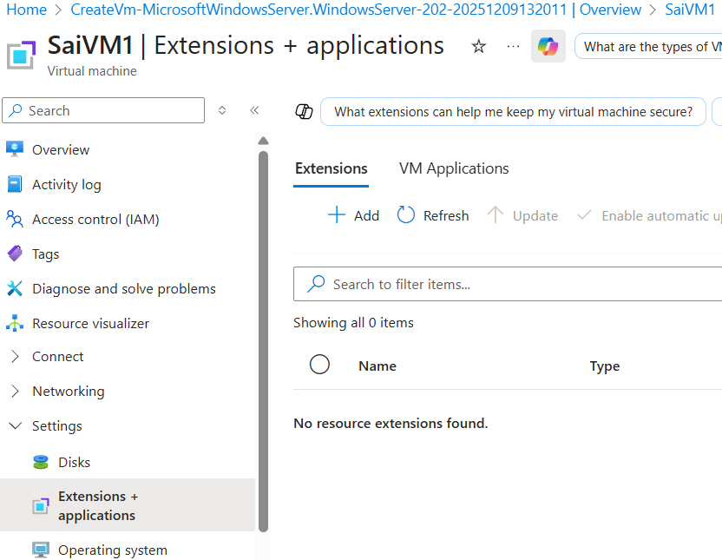

- Create Log analytics work space 
- Select RG name
- Provide log analytics name
- Select region

- Create a Monitor
- Type monitor in search bar and select with icon 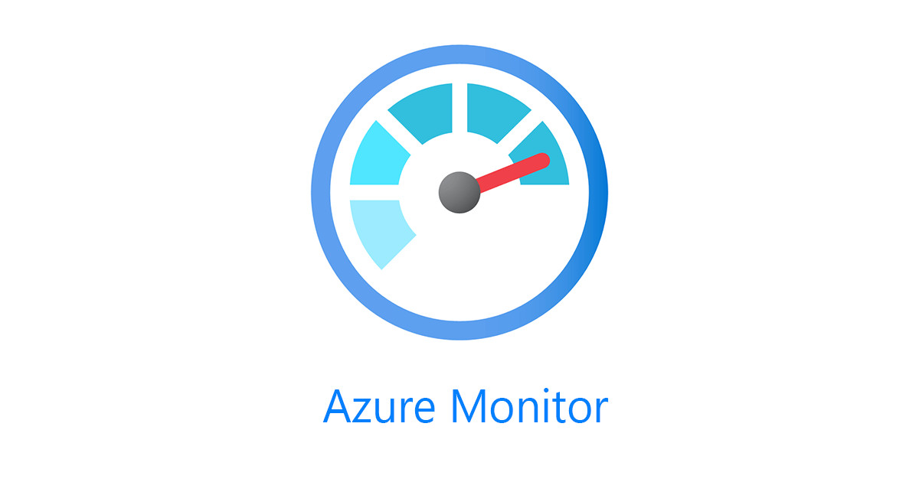
- Select VM Insights

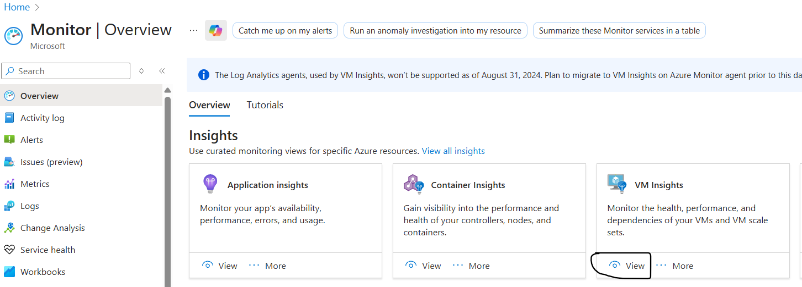

- Select configure insight

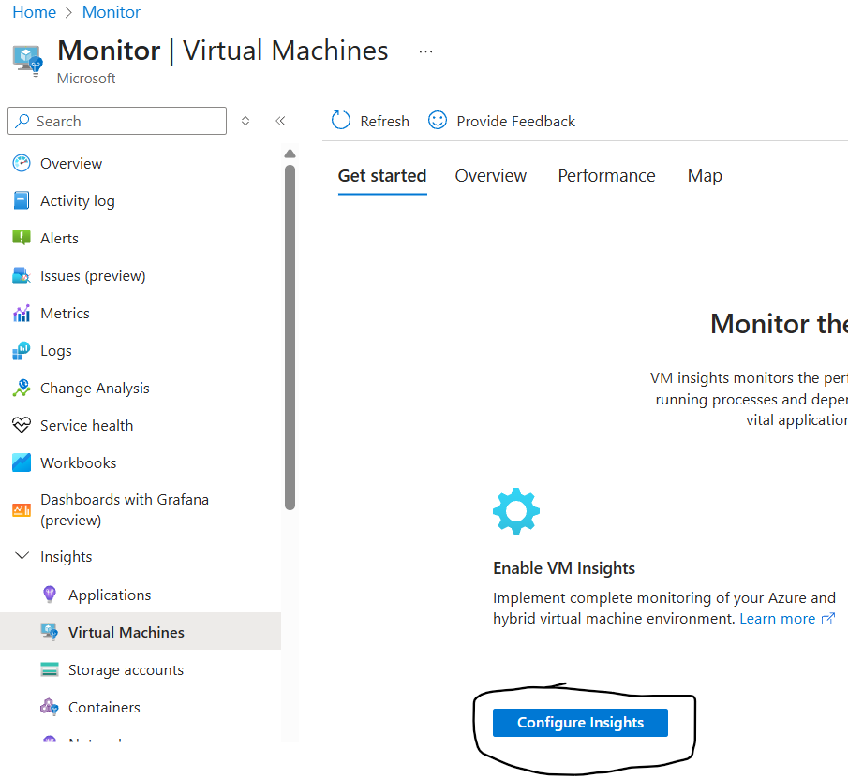

- After clicking on configure insight

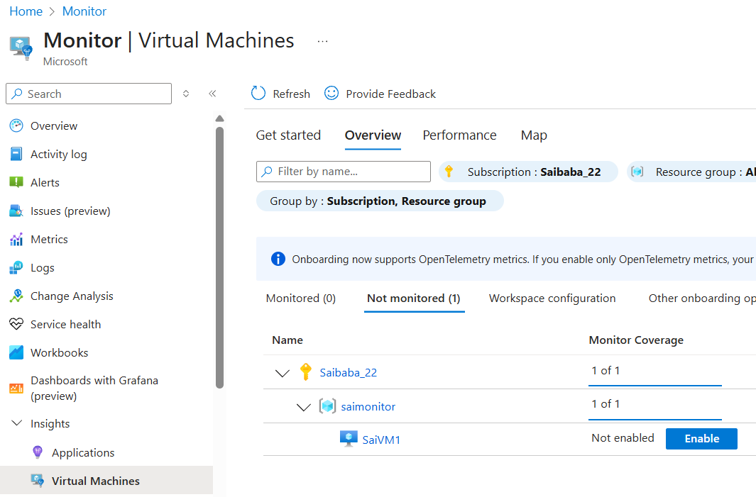

- You can find entire Virtual machines created in your subscriptions and various RG and Vnets

- Click on Enable

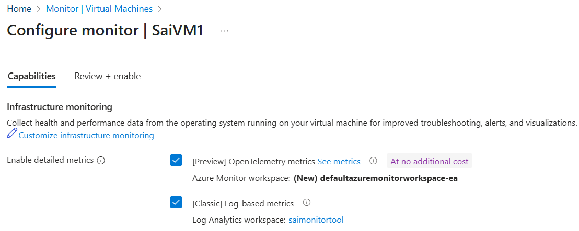

- Click on review and create
- You can find metrics collected in review and create tag
Metrics collected:filesystem usage, disk usage, disk operation time, disk operations, memory usage, network io, cpu time, network dropped, network errors, system uptime
- Click on review and create and enable it

- Once Monitor tool is enabled
  - You can check in Monitor -> Insights -> Virtual Machines -> Monitored

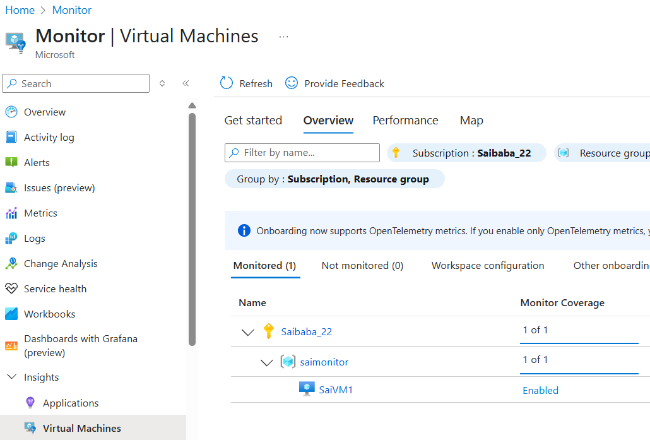

  - And you can observe in Virtual Machines -> settings -> Extension + Applications

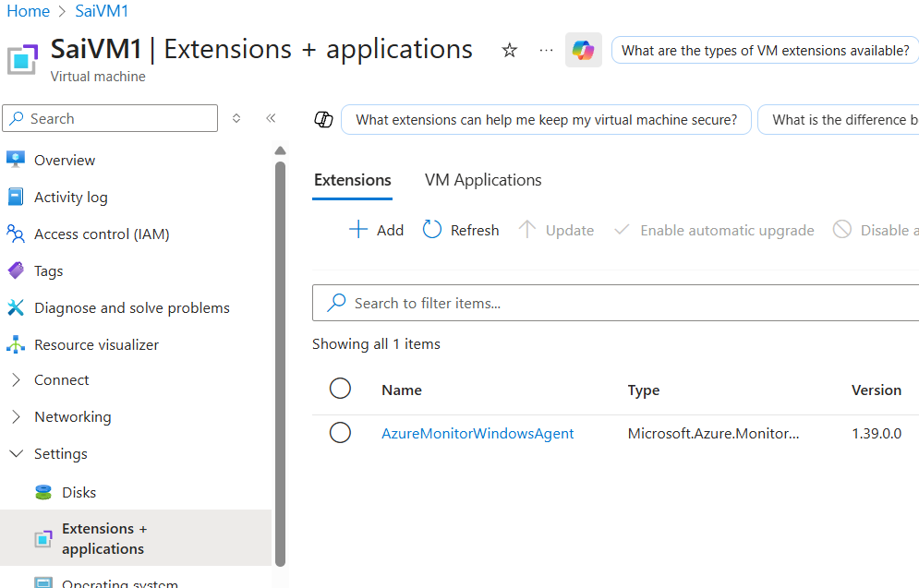

- Lets create Alerts
- In virtual machine -> Monitoring -> Alerts

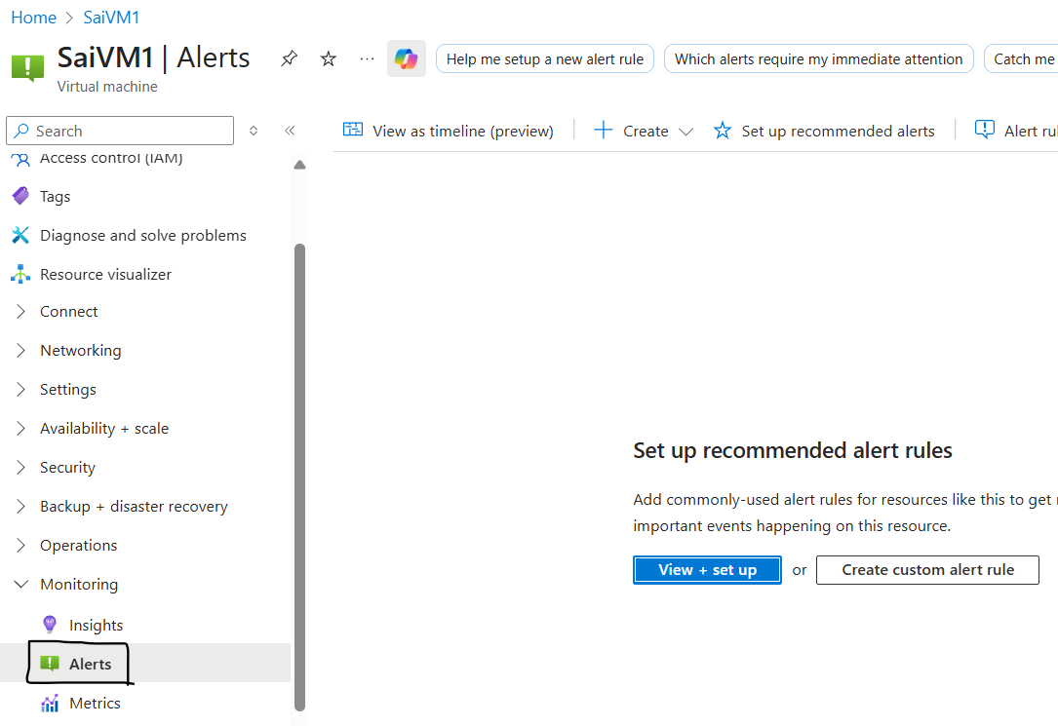

- Click on create Custom alert rule
  - Scope : Select VM
  - Condition : Signal name : percentage CPU
  - Action : create Action Group
Basics :
    - RG : select your RG :( Saimonitor )
    - Region : Global ( automatic )
    - Action group name : vmaction ( give any )
    - Display name : vmaction (give any name )
Notifications :
    - Notification type : you can observe 2 options
Email Azure Resource Manager Role
Email/SMS message/Push/Voice ( Select this )
      - Tick Email box and enter your email or
      - Tick SMS and enter your country code and number
      - Done or add
    - Enter any name or email name

- Once email is added you will receive email like this

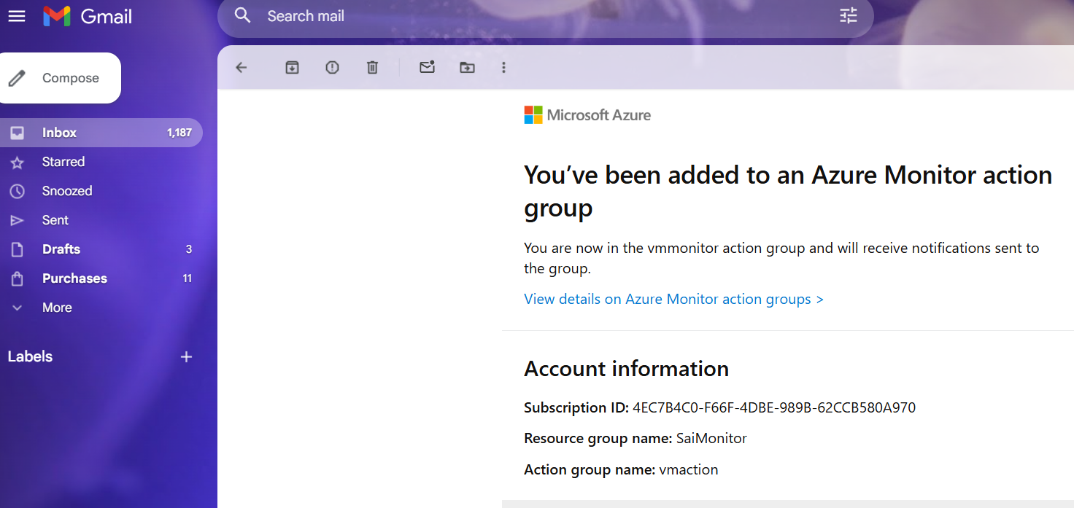

Actions :
    - Select noting and go to review and create

- After creating alert rule
- Details : alert rules details :
  - RG : Saimonitor ( select any RG )
  - Severity : 0 – Critical, 1 – Error, 2 – Warning, 3 – Informational , 4 – Verbose,
Select 3
  - Alert rule name : type any ( cpu performance )
  - Alert description : provide any description
- Click on review and create and create

- Create a custom rule : Scope : select VM
- Condition :
  - Threshold type : Static _/ , Dynamic
  - Aggregation type : Average,
  - Value is : Greater than ( give any depends on use )
  - Threshold : 10 ( give any value )
When to evaluate
  - Check every : 1 minute
  - Lookback period : 5 min
- Actions : select group : select the created group
- Details : alert rules details :
  - RG : Saimonitor ( select any RG )
  - Severity : 0 – Critical, 1 – Error, 2 – Warning, 3 – Informational , 4 – Verbose,
Select 3
  - Alert rule name : type any ( cpu per )
  - Alert description : provide any description
- Done and review and create

- After creating alerts now check
- VM -> monitoring -> alerts -> alert rules -> click on alert rule
metric alert rule -> alert rule configuration -> action

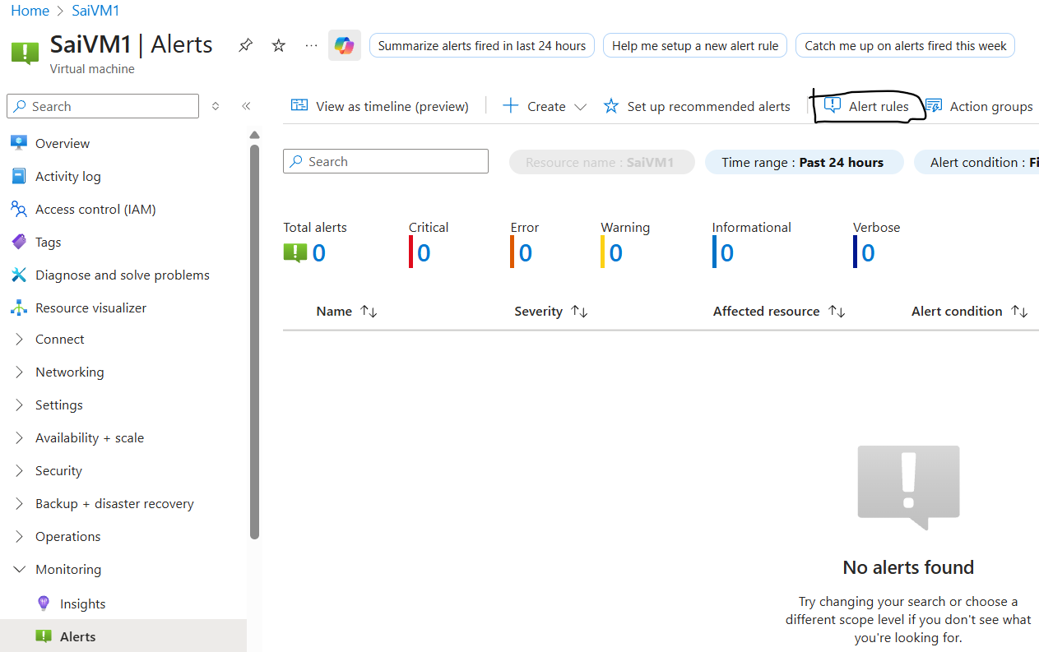

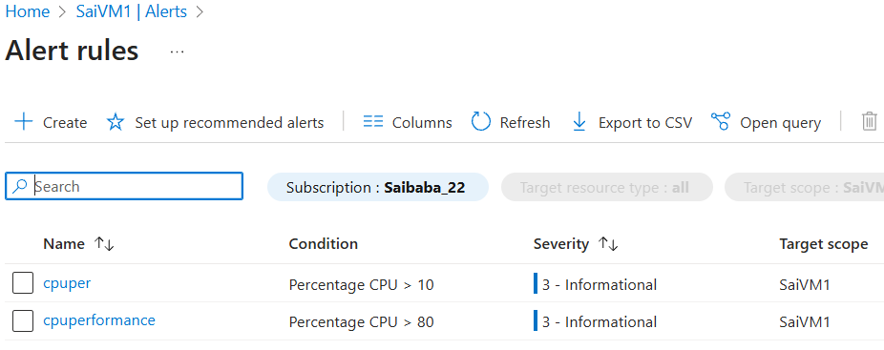

- Now login to VM with windows
- Open MS edge and search any thing or play any video in youtube
- Now check in VM -> Monitor -> alerts

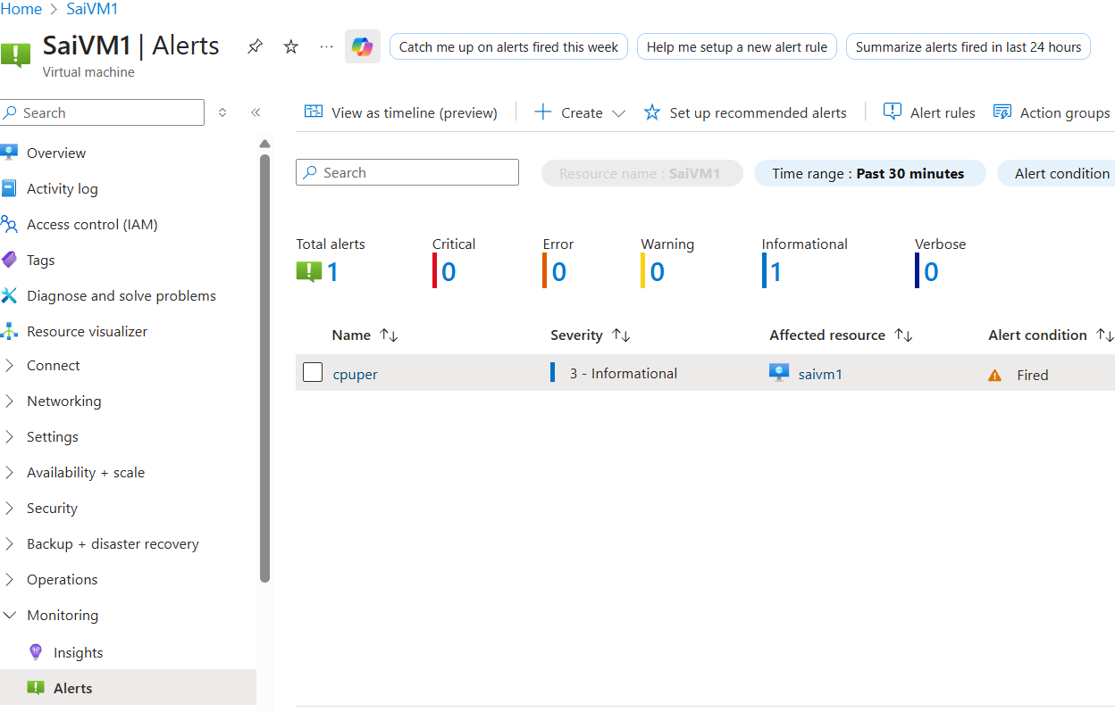

- If you click on alert name it will show you under summary

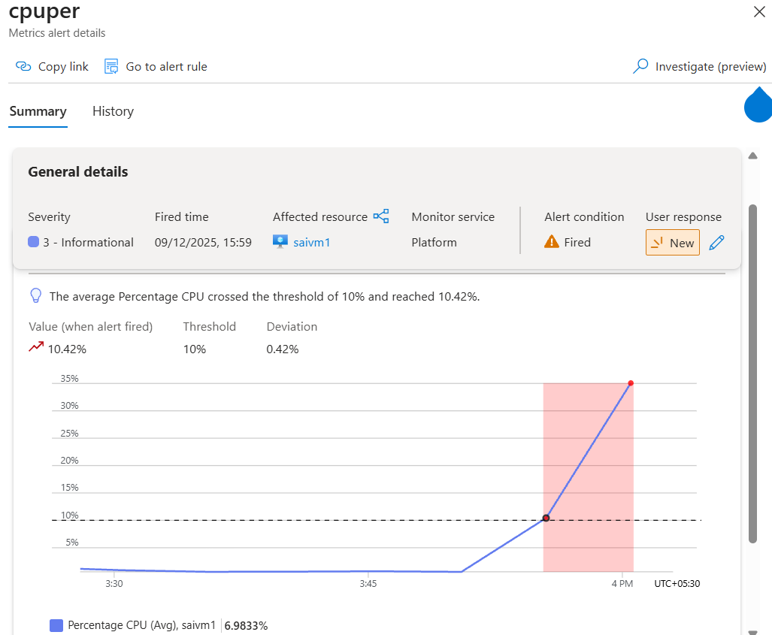

And History

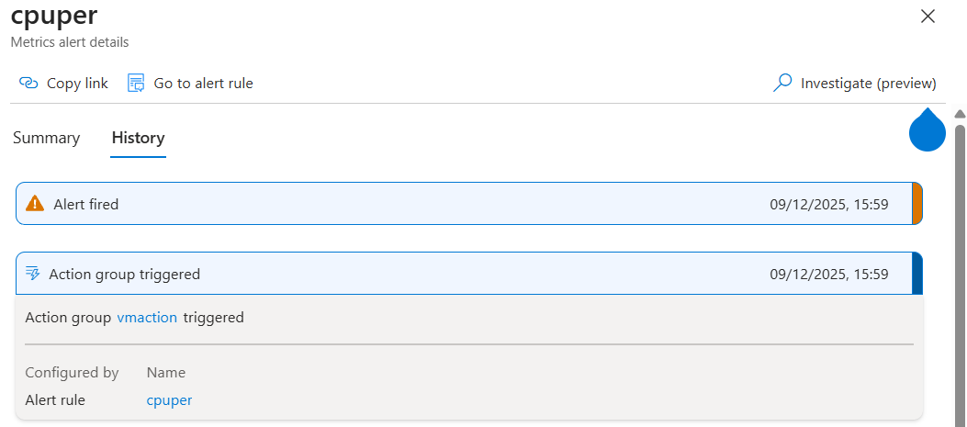

- From Monitor -> settings
data collection rules

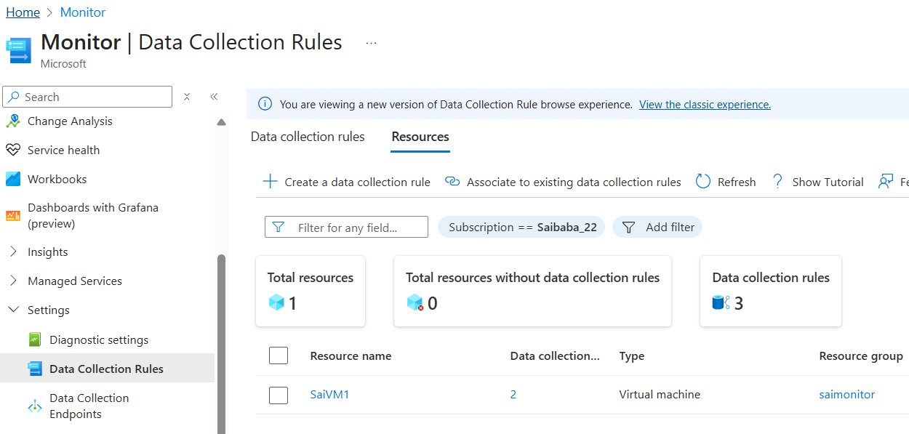

- Settings -> monitoring coverage preview

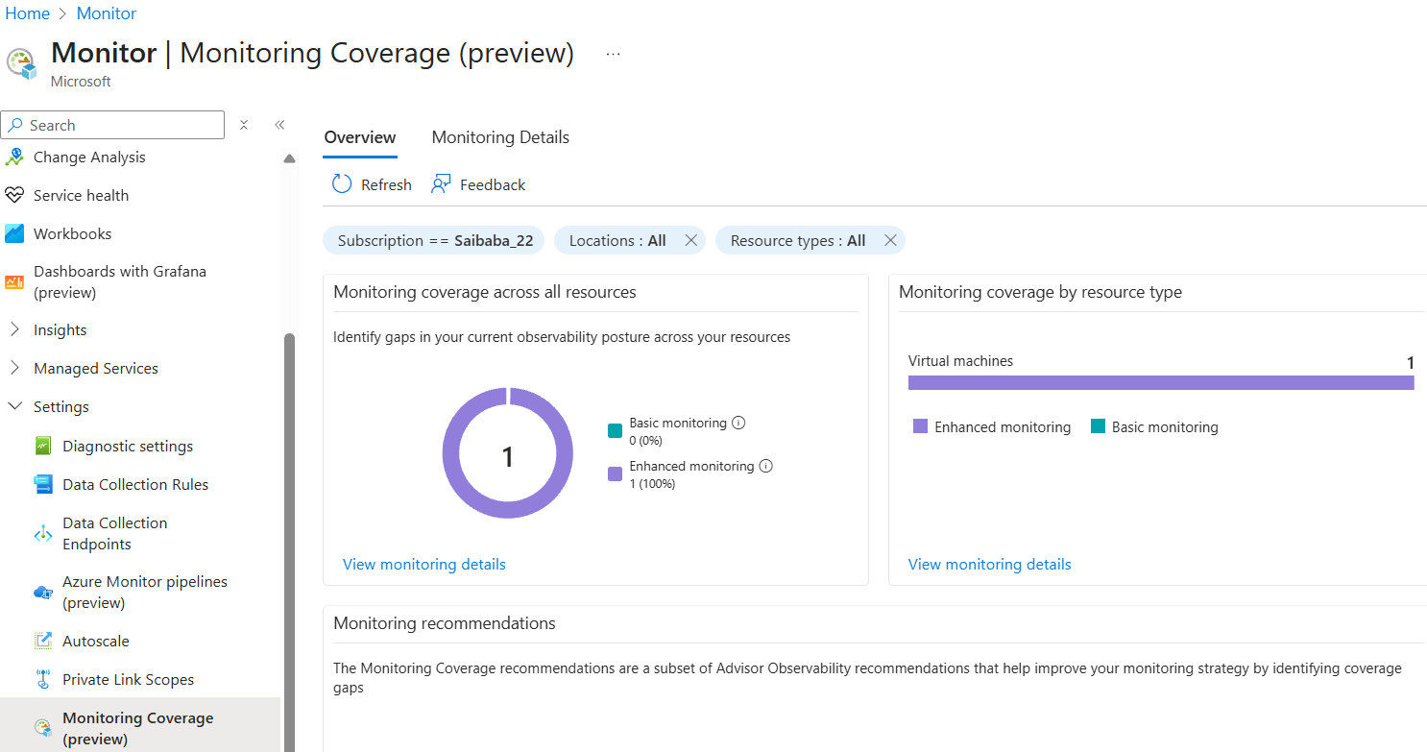

- From Email
- From and to receiver shown as

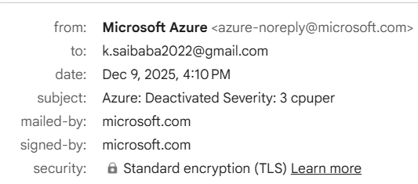

- after triggering mail

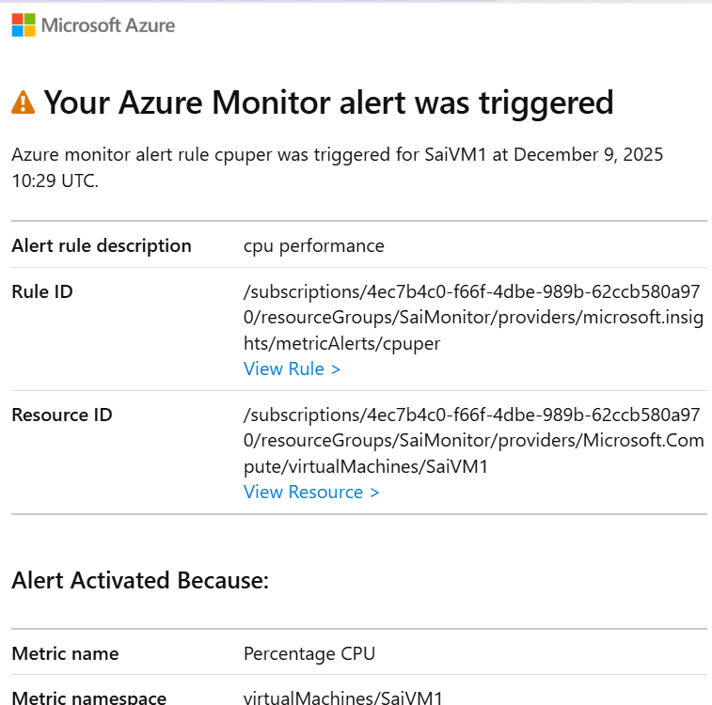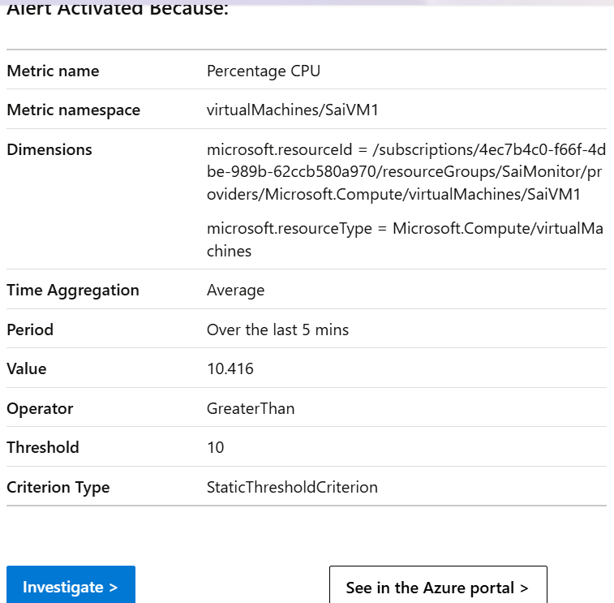

- From mail after resolving issue

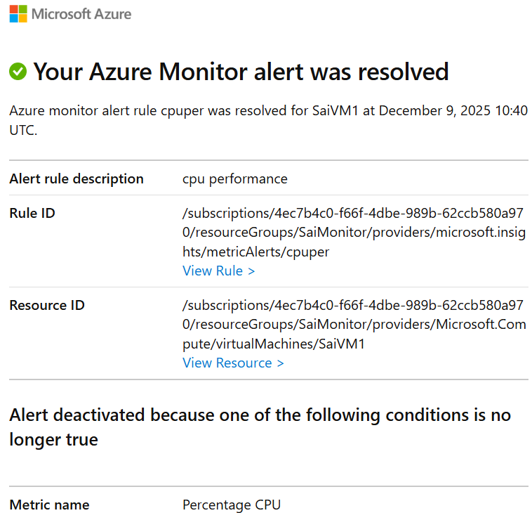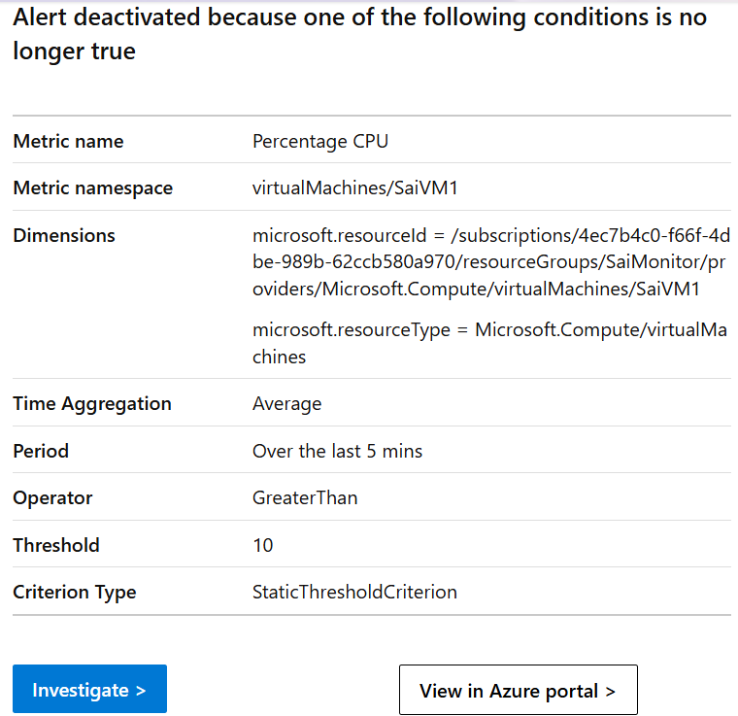

- To configure diagnostic settings for guest level monitoring
- Create a storage account
- After creating
- Virtual machine -> monitoring diagnostics settings ->
Once storage account activates -> select your storage account ->
enable guest level monitoring
  - Performance counters : select basic counters
  - RAM, disk, memory, network, asp.net, sql server
  - Select all so that we can check and add metrics according to requirement
And you can edit metrics
- Done

- defaultresourcegroup-ea
- MA_defaultazuremonitorworkspace-ea_eastasia_managed
- New RG are created default and delete them also

- AZURE LOGIC APPS
Logic Apps does not work in free trial, user must have pay as you go model

- Logic Apps
- To automate work flow

  - Ex : you want to order a product in amazon then put or place an order
  - Internal it will update automatic to SAP team, once done
  - Logistics department gets update to deliver

- To make automation we have lot of tools
- We have logic apps in azure

- If some one upload data to cont 1 then copy to cont 2 and delete from cont 1 automatic

- Requirement
- Create storage account and add 2 containers
- Create logic apps
  - Select work flow service plan
  - Select RG : any rg
  - Provide any name unique
  - Disable : Try a secure unique default hostname
  - Networking : Provide public access in monitoring
  - Monitoring : Enable monitoring instance : No
  - Review and create
- Warning : Free trial subscription is not supported for Workflow Service Plan. Please select a different subscription.

- Logic apps work in backend as json mode format
- We will work in gm mode drag and drop for automation
- Just know trigger points
- No need of any coding

- After creating logic apps
- Task I : copy and delete
- Click on create and
- Give storage or any name and add
- After creating work flow select it and Open
- Add a trigger ( any file added or modified in cont1 will be moved or copied to cont 2)
- Search as blob
- Click on when a blob is added or modified ( cont 1 related )
  - Connection name : any name
  - Authentication : access keys
  - Storage account name : provide account name
  - Access keys : provide storage account access keys
  - Create new
  - Parameter :
    - Storage account name : select your account
    - Container : select cont 1
    - How often go and verify : for every 25 min ( depends on requirements )
    - Done

- Add an action
- Control :
  - Click on fx ( function ) : dynamic content : list of file name
  - Ends with .zip
  - Done
- If yes ( cont 2 related )
  - Blob : copy blob
  - Parameter : provide storage account name
    - Source url : fx – list of file path
    - Destination path : cont 2
- Yes condition 2
  - Add an action : search blob
  - Delete blob
  - Parameter
    - Storage account name : provide storage account name
    - Blob : dynamic content : list of files path
- No
  - Add an action : blob : delete blob
  - Parameter : storage account : select account name
    - Blob : click on fx ( dynamic function )
    - List of files path
- Save it
- Now run it and upload document

- Now upload zip file and try it

- Trigger mail when file uploaded
- Go to logic apps -> open logic app or click on name -> workflows -> work flow
- Create : email or give any name : stateful -> add
- Click on Email : add a trigger blob
- Select when blob is added or modified
  - Parameter :
    - Storage name : select storage account
    - Blob : select cont1
- Click on + and type Email : send a email
  - Create connection will appear : sign in
Use Microsoft account ( either @outlook or @hotmail )
Or already present account select it
    - To : your mail
    - Subject : type any ( this is new document with name
Click on fx and select list of file name
    - Body : this is new document w document with name
( Click on fx and select list of file name ) with the size of the file and document format
    - Done or add
- Now run it and try

- Now upload files and try
- After triggering mail it will look like this

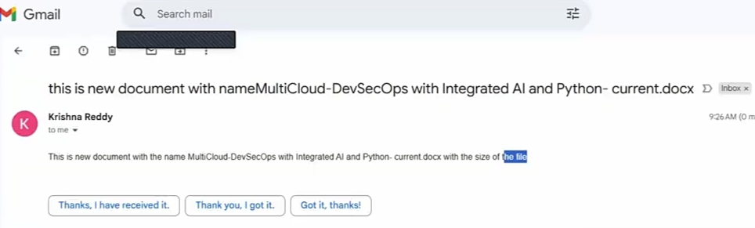

[ Sir given Task ]
- In azure
- Create a VM with windows and install Active directory
- Create a VPN

- In AWS
- Create VM with windows
- Create VPG now

- Try to make connection between 2 VMs using private IP
- Create users in VM from azure and join AWS VM also
- So that created users from Azure VM can login from AWS VM
- Ex : Azure VM private ip is 10.1.1.4 and If you ping from AWS VM as vm.techmm.com
Then it should show 10.1.1.4

- Login to AWS VM with windows, login and open file manager, right click on my pc or my computer, properties -> System properties - change -> provide domain name -> asks for credentials -> provide active directory credentials and VM gets joined

- to check azure vm is working properly or not
- Azure monitor is divided by 3 parts
  - Agent , azure monitor or vm and log analytics workspace
- Monitoring tool
- One agent is installed
- Agent is divided into 2 types
- Metrics and logs will be collected
- Logs records : critical and warning logs
- Metrics records
  - VM memory details
  - Cpu
  - Disk
  - Network

- Stored in Log analytics workspace
- Log analytics workspace is a type of db stores details and uses kql to retrive data
- It is a 3rd party tool
- Alerts are also important
- When alert rise msg is triggered to incident management and it comes to notice

Backup :
Image level backup
File level backup

Site recovery : Disaster recovery

After replication enabled – disk will replicate

You need to create RSV at target location, resource group, Vnet and subnet
Storage account gets created automatic

2types of backup
Schedule backup
Complete state takes a snap and upload to rsv
Retension period is 30days

Ondemand backup

Service endpoint
Private end point

Access types :
portal
access keys => admin level
sas key ( shared access signature ) : restrict access

rbac : role to role
identity : resource to resource

azure storage explorer

Connect using Access Keys
Download MS Azure Storage Explorer
Click on connect or plug symbol which is side
Storage account or service
Account name and key
Display name : anything
Account name : storage account name
Account key : ( from azure staorage account under security and networking click on access keys
Show key )
Next
Connect

You can Upload files through upload option.
And download files

Connect using SAS keys
Download MS Azure Storage Explorer
Click on connect or plug symbol which is side
Storage account or service
SAS
Display name and service access signature
From Storage account in azure :
Under security and networking
Shared access signature
Allowed service L blob, tier, queue
Allowed resource types :
Allowed permissions : read, write delete list create add
Blob version program :
Allowed blob index permissions : write and filter
Schedule time if needed
Provide IP address :
Allowed protocols Https only
Generate SAS key

Interview question :
Key : application to application
String key : connection string for database

Key 1 and key 2 for periodic changes
If key 1 expires use key 2 AND ROTATE KEY 1 for reuse

After creation copy blob service url

For resource to resource
Create VM with windows
From azure click on identity under security
Status as ON and status

From
Account storage
Click on access control IAM from left
Add a role
Role :
Privileged admin roles ,
Owner :
Members :
Assign access : managed identity
Select members
Select subscrip
Managed identity : your VM
Click on Submit
Conditions : allow user to assign all roles
Resign + assign : done

Same for RBAC just at role incase of owner preview will be added

File share : max capacity 100TB
New Add :
Access tier : transaction optimized
At backup tag disable if not needed
If you want you can edit qota to edit storage size

Click on connect to upload complete disk
Select os type
Copy code

Open VM powershell
And paste it
After it would show storage account in file manager

Queue :
Table : create and share end point

Life Cycle management
Data migration

